

COURSE PROJECT REPORT
Subject: SWD392

– Hanoi, Fall 2026 –

Table of Contents
Record of Changes 3
I. Overview 4
I.1 Project Information 4
I.2 Project Team 4
II. Requirement Specification 4
II.1 Problem description 4
II.2 Major Features 5
II.3.1 Context Diagram 6
II.3.2 System Context Diagram 8
II.4 Nonfunctional requirements 8
II.5 Functional requirements 9
II.5.1 Actors 9
II.5.2 Use Cases 10
II.5.2 .1 Use Case Diagram(s) 13
II.5.2.2 Use case descriptions 16
II.5.3 Activity diagram 32
III. Analysis models. 40
III.1. High-level class diagram (structural models) 40
III.2 Interaction diagrams 40
III.3 State diagrams (Behavioral models) 41
IV. Design specification 42
IV.1 Integrated Communication Diagrams 42
IV.2 System High-Level Design 42
IV.3 Component and Package Diagram 42
IV.3.1 Component Diagram 42
IV.3.1 . Package Diagram 43
IV.4 Implementation Class diagram 44
IV.5 Database Design 44
V. Implementation 45
V.1 Map architecture to the structure of the project 45
V.2 Map Class Diagram and Interaction Diagram to Code 45
VI. Applying Alternative Architecture Patterns 46
VI.1 Applying the ………….. (ex: Service-Oriented Architecture (SOA)) architecture 46
VI.2 Applying Service Discovery Pattern in the service-oriented architecture 46

Record of Changes
Date | A*  M, D | In charge | Change Description
28/9/2026 | A | HungND | I.1 Project Information, I.2 Project Team
28/9/2026 | A | HungND | II.1 Problem description, II.2 Major Features
29/9/2026 | M | HungND | II.1 Problem description, II.2 Major Features
29/9/2026 | M | AnhNT | I.1 Project Information, II.2 Major Features
29/9/2026 | M | NamNH | II.2 Major Features
30/9/2026 | M | HungND | II.2 Major Features
30/9/2026 | A | HungND | II.3 Context Diagram, II.4 Nonfunctional requirements, II.5 Functional requirements
30/9/2026 | M | AnhNT | II.5.2.2 Use case descriptions ( Pet Owner )
30/9/2026 | M | AnhNT | II.5.2.2 Functional Description: UC-BOOK-01 Book Appointment
30/9/2026 | A | AnhNT | II.5.2.2 Functional Description: UC-BOOK-03 Cancel Appointment, UC-BOOK-04 Reschedule Appointment, UC-PET-01 Add Pet
30/9/2026 | A | AnhNT | II.5.3 Business Rules: BR-06 Cancellation Time Limit
30/9/2026 | A | AnhNT | II.5.3 Activity Diagram: Book Appointment, Cancel Appointment, Reschedule Appointment, Add Pet
1/10/2026 | A | HungND | II.3 Context System, III Analysis models
2/10/2026 | M | HungND | II.3 Context System,II.4, II.5, II.5.3, III Analysis models
7/10/2026 | A | QuangTM | II.5.2.2 Functional Description: UC-BILL-01, UC-BILL-02, UC-HR-01, UC-HR-02, UC-HR-03  II.5.3 Activity Diagram: UC-BILL-01, UC-BILL-02, UC-HR-01, UC-HR-02, UC-HR-03
8/10/2026 | M | HungND | II.5.2.2 Functional Description: UC-AUTH-01 to UC-AUTH-05, UC-AI-01; II.5.3 Activity Diagram: AI-01
19/10/2026 | A | HungND | III.3 State Diagrams
20/10/2026 | A | QuangTM | III.1.1. Describe the object lifecycle (1.1.5, 1.1.6, 1.1.7)
25/10/2026 | A | QuangTM | III.2.1 Sequence Diagrams (2.1.1, 2.1.2, 2.1.3, 2.1.4, 2.1.5)
28/10/2026 | A | QuangTM | III.2.2 Communication Diagrams (2.2.5, 2.2.6, 2.2.7, 2.2.8, 2.2.9)
*A - Added M - Modified D - Deleted

I. Overview

I.1 Project Information
- Project name: Pet Hospital Management System
- Project code: PHMS
- Group name: SWD392-G6
- Software type: Web

I.2 Project Team
Full Name | Role | Email | Mobile
Nguyen Thi Hanh | Lecturer | hanhnt84@fe.edu.vn | N/A
Nguyen Duy Hung | Leader | ndhung.work@gmail.com | 0359928446
Nhac Tuan Anh | Member | banhbaonhone@gmail.com | 0359533823
Nguyen Hoang Nam | Member | hoangnamnmg@gmail.com | 0386873929
Tran Minh Quang | Member | quangtmhe180906@fpt.edu.vn | 0359825701
Nguyen Manh Trung | Member | trungnmhe180209@fpt.edu.vn | 0223456789

II. Requirement Specification

II.1 Problem description
In Vietnam, particularly within developing peri-urban educational and technology hubs (such as the Hoa Lac High-Tech Park area, Thach That, Hanoi), numerous veterinary facilities continue to execute their daily operations through manual, fragmented workflows. An empirical on-site field survey conducted at local clinics (notably 'Phòng Khám Thú Y 24h', located at 172 Thon 3, Tan Xa, Thach That, Hanoi) revealed that daily clinical procedures rely almost entirely on physical paper logbooks, paper index cards, uncoordinated telephone appointments, and manual cash handovers without any centralized software platform.
Critical Operational Pain Points: This traditional manual approach induces critical operational bottlenecks:
1. Misplacement of Longitudinal Medical Records: Paper records are routinely misplaced, damaged, or disconnected across repeat consultations, depriving veterinarians of vital longitudinal health trends, adverse drug histories, and vaccination timelines.
2. Appointment Schedule Overlaps: Uncoordinated telephone bookings create double-booking conflicts, extended waiting times, and unbalanced workloads across clinical shifts.
3. Emergency Intake Delays (Triage Gaps): Walk-in patients in critical, life-threatening conditions (e.g., severe hemorrhage, respiratory collapse, acute trauma) are delayed behind standard check-ins due to the absence of a digital triage escalation protocol.
4. Unorganized Human Resource Management: Staff rosters and leave requests are managed through informal chat groups (e.g., Zalo), leading to unattended shifts and sudden Veterinarian absences during pre-booked slots.
5. Inaccurate Billing and Untracked Finances: Manual tallying of consultation fees, laboratory procedures, and pharmacy items leads to pricing errors, unrecorded transactions, and revenue leakage.
Market Landscape and Competitor Analysis: A comprehensive comparative analysis of existing commercial software in Vietnam highlights major shortcomings:
- Manual Scheduling and Rigid Role Management: Solutions such as lichkham.vn rely on manual Veterinarian shift creation without flexible role delegation, placing a heavy administrative burden on clinic management.
- Opaque Booking and Lack of Patient History Tracking: Existing platforms (e.g., lichkham.vn, pethealth.vn, thuytayninh.vn) prevent pet owners from viewing full historical medical records, limiting visibility to same-day visits or fragmented Zalo/SMS notifications.
- Cluttered Interfaces and High Friction: Legacy systems suffer from cluttered desktop interfaces, while mobile apps (e.g., Fviet VietNam) exhibit high registration friction and server instability.
- Absence of Automated Payments and Financial Analytics: Local platforms lack integrated dynamic VietQR/VNPay payment gateways and automated invoice balancing, leaving managers without real-time revenue visibility.
- Localization and Accessibility Barriers: Foreign veterinary systems (e.g., FastVet.net, g.vet, Provet Cloud) lack Vietnamese linguistic localization, local regulatory compliance, and regional banking gateway support.
- Absence of AI-Assisted Operations: No deployed software provides round-the-clock conversational AI guidance to evaluate pet symptoms, advise on home care, and route acute cases to the clinic.
The PHMS Unified Solution: To resolve both the operational bottlenecks observed in local clinics and the functional deficiencies of existing commercial software, the Pet Hospital Management System (PHMS) is engineered as an integrated, role-based web platform specifically tailored for Vietnamese veterinary hospitals. PHMS seamlessly unites internal clinical roles (Receptionist, Veterinarian, Staff(Nurse / Technician), Clinic Manager / Admin) and external clients (Pet Owners) into a synchronized ecosystem. The platform provides end-to-end digital lifecycle coverage: customer self-service booking, emergency triage with automatic queue priority, electronic medical records (EMR), laboratory testing workflows, digital prescription dispensing, automated consolidated billing (Cash and VNPay / VietQR), staff shift and leave management, executive business analytics, and a 24/7 AI health advisory assistant powered by the Google Gemini API.

II.2 Major Features
FE-01: User Authentication Access Control: Supports customer self-registration, secure login/logout, password recovery via email OTP, profile updates, and role-based access control across 5 primary roles.
FE-02: Pet Profile Management: Manages comprehensive pet profiles (species, breed, date of birth, weight, allergies, identifying markings); supports pet classification rules and routine care catalogs.
FE-03: Online Booking Appointment Scheduling: Enables pet owners to select services, designated veterinarians, dates, and vacant time slots; provides receptionists with queue management tools, approval workflows, and reminder emails.
FE-04: Emergency Reception Priority Triage: Enables receptionists to register unscheduled walk-in emergencies, assign triage severity levels (Level 1: Critical, Level 2: Urgent, Level 3: Standard), and prioritize cases at position #1 in veterinarian queues.
FE-05: Examination Electronic Medical Records : Allows veterinarians to record vital signs (temperature, weight, heart rate), enter clinical findings, specify diagnoses, formulate treatment plans, and finalize tamper-resistant digital records.
FE-06: Paraclinical Laboratory Workflow: Supports veterinarians in issuing diagnostic test orders; provides nurses with a dedicated Lab Queue to process tests, enter results, and upload diagnostic imaging files.
FE-07: Digital Prescription Pharmacy Inventory: Generates digital prescriptions linked to EMR records, verifies real-time stock levels in the clinic pharmacy, issues dosage instructions, and prepares medication dispensing.
FE-08: Consolidated Billing Online Payment: Aggregates consultation fees, diagnostic lab procedures, and prescribed medications into a unified invoice; supports counter cash payments or dynamic VietQR/VNPay online transactions verified via webhook.
FE-09: Human Resource Shift Scheduling: Enables clinic managers to schedule weekly duty shifts for clinical personnel; supports staff leave requests and automatically locks conflicting shift slots upon manager approval.
FE-10: Operational Dashboard Customer Feedback: Presents real-time analytics on hospital revenue, monthly patient throughput, and veterinarian performance; collects post-visit client ratings and qualitative reviews.
FE-11: AI Health Advisory Chatbot: Integrates Google Gemini AI to provide pet owners with round-the-clock symptom guidance, initial first-aid directions, nutritional advice, and booking recommendations.

II.3.1 Context Diagram
The Context Diagram represents the highest-level operational view of the Pet Hospital Management System (PHMS) as a centralized software system interacting with internal user roles and external services.
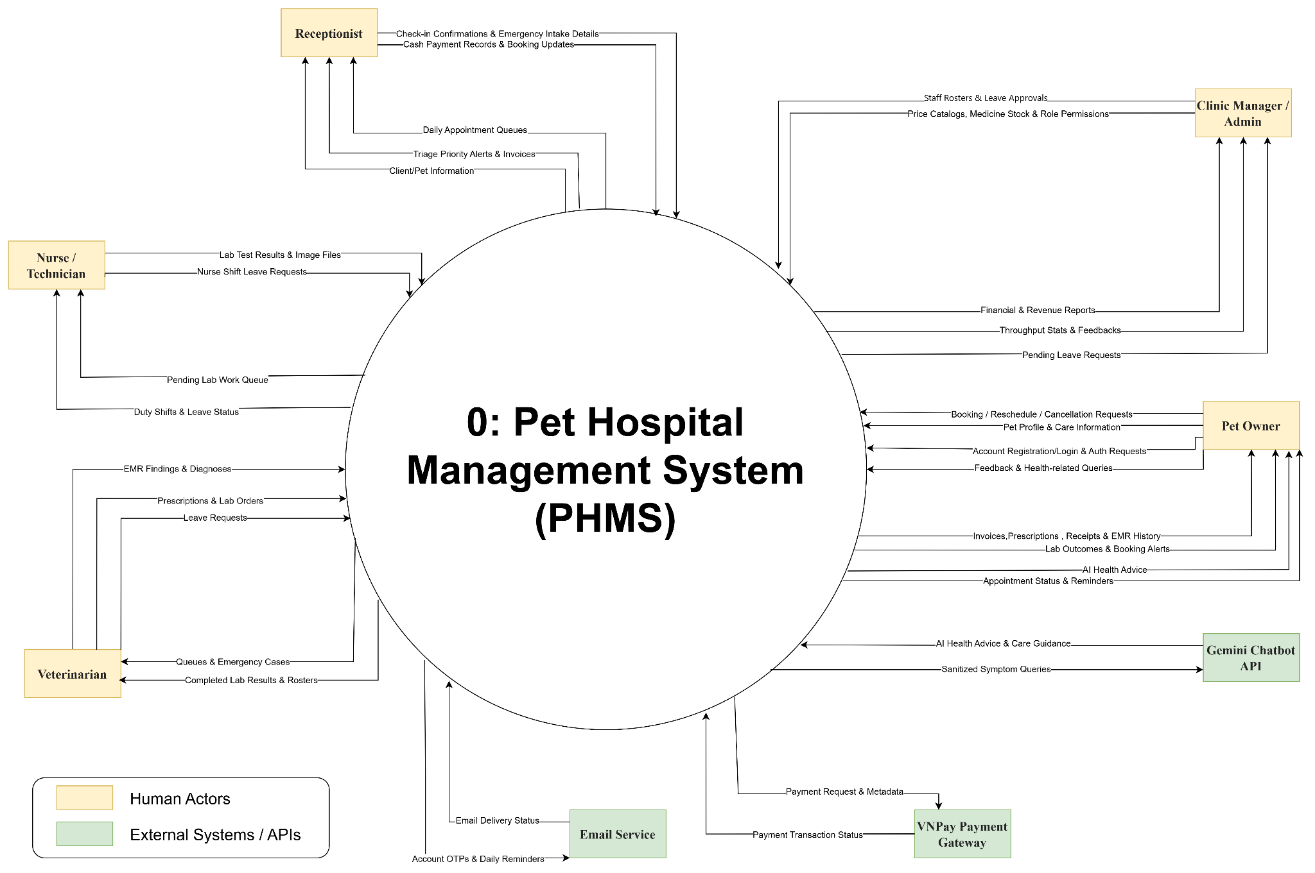
- Pet Owner: Transmits account registration/login credentials, pet profile details, pet classification and care service selections, appointment booking/rescheduling/cancellation requests, service feedback, and health-related queries. Receives appointment status confirmations, automated reminders, pet medical history (EMR), lab outcomes, prescriptions, invoices, payment receipts, and AI-generated health advice.
- Receptionist: Submits appointment approvals, cancellations, rescheduling, customer check-in confirmations, and no-show flags. Creates walk-in emergency intake records and assigns emergency triage severity levels. Generates consolidated invoices, collects cash payments, and initiates VietQR/VNPay online payment transactions. Receives appointment queues, emergency triage alerts, client/pet profiles, and billing summaries.
- Veterinarian: Receives assigned examination queues and prioritized emergency cases.
Submits clinical examination findings, vital signs, formal diagnoses, treatment plans, EMR updates, laboratory test orders, and digital prescriptions. Receives completed laboratory test results and diagnostic imaging attachments. Views personal work schedules and submits leave requests.
- Staff(Nurse / Technician): Receives pending laboratory test orders through the dedicated Laboratory Work Queue (Lab Queue). Submits laboratory test results, numerical values, textual findings, and diagnostic image files. Receives assigned work schedules and submits leave requests.
- Clinic Manager / Admin: Manages staff accounts and RBAC access permissions, work schedules, service catalogs, drug/pharmacy catalogs, and medical inventory. Maintains pet classification rules and care catalogs. Reviews and approves/rejects staff leave requests. Receives operational dashboards, revenue reports, patient throughput statistics, and customer feedback.
- VNPay Payment Gateway (External): Receives secure online payment transaction requests and payment metadata from PHMS. Returns cryptographic transaction status callbacks (IPN webhooks) to update invoice payment states idempotently.
- Email Service (External): Receives outbound email payloads from PHMS to deliver account verification OTPs, password-reset credentials, and automated daily appointment reminder notifications to Pet Owners.
- Gemini Chatbot API (External): Receives natural-language symptom, care, and nutrition queries with sanitized pet metadata from PHMS. Processes context and returns automated AI-generated health advice.

II.3.2 System Context Diagram

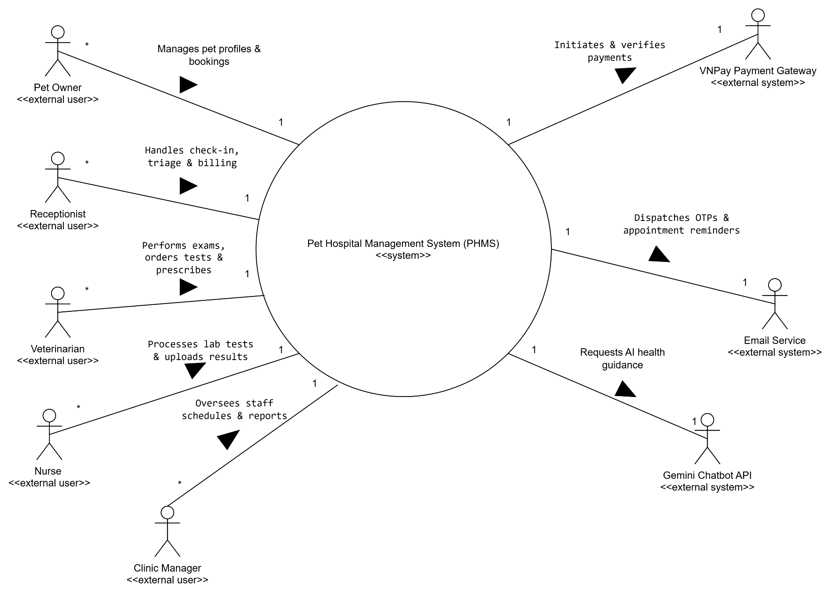

II.4 Nonfunctional requirements

# | Feature | System Function | Description
NF-01 | Performance | API & Page Response Times | The system shall provide responsive interactions, with standard API requests completing within 1.5 seconds under a load of 100 concurrent requests. The initial portal page shall load within 2.5 seconds under standard network conditions. AI-assisted requests shall return a response or timeout within 8 seconds.
NF-02 | Security | Data Encryption & Auth | The system shall protect user credentials and sensitive EMR data against unauthorized access, data interception, injection attacks, and malicious scripts. All communications containing sensitive information shall be transmitted through secure HTTPS connections.
NF-03 | Availability | System Uptime | The system shall be available 24 hours a day, 7 days a week, with a minimum uptime of 99.5% per month. Scheduled maintenance shall not exceed 3.6 hours per month and shall be performed during off-peak hours (01:00 AM–05:00 AM ICT).
NF-04 | Scalability | Concurrent Load Handling | The system shall support at least 200 concurrent active users during peak usage while maintaining a transaction error rate of less than 0.1%.
NF-05 | Usability | Responsive Interface | The system shall provide a responsive and usable interface across supported devices, including screens with a minimum width of 375px for Pet Owners and 1280px for Clinical Staff workflows.
NF-06 | Reliability | Automated Backup & Recovery | The system shall automatically back up the database daily at 01:00 AM ICT and support data recovery with a Recovery Point Objective (RPO) of no more than 1 hour and a Recovery Time Objective (RTO) of no more than 2 hours.
NF-07 | Daemon | Appointment Reminder | The system shall automatically check upcoming appointments daily at 08:00 AM ICT and send reminders to relevant users for appointments scheduled on the following calendar day.
NF-08 | Integration | VNPay Webhook Idempotency | The system shall process VNPay payment notifications reliably and securely, ensuring that duplicate payment notifications do not result in duplicate transaction processing.

II.5 Functional requirements

II.5.1 Actors

# | Actor | Description
ACT-01 | Pet Owner | Registers account; manages pet profiles; books, cancels, and reschedules appointments; views EMRs, lab results, prescriptions, and invoices; submits feedback; consults AI chatbot.
ACT-02 | Receptionist | Manages front-desk queues; approves bookings; checks in clients; marks no-shows; performs walk-in emergency intake with Level 1-3 triage; generates unified invoices; collects payments.
ACT-03 | Veterinarian | Manages regular and emergency queues; conducts physical examinations; records vital signs, findings, diagnoses, and treatment plans in EMR; orders lab tests; writes prescriptions.
ACT-04 | Staff(Nurse / Technician) | Accesses Laboratory Work Queue; performs lab procedures; records quantitative/qualitative results; uploads diagnostic images; marks lab orders complete.
ACT-05 | Clinic Manager / Admin | Supervises clinic operations via executive dashboard; manages employee accounts and RBAC permissions; builds weekly rosters; approves leave; maintains catalogs and inventory.
ACT-06 | VNPay Gateway | External payment service provider processing online transactions and delivering cryptographically signed IPN callbacks.
ACT-07 | Email Service | External mail transport server handling outbound account verification OTPs, password reset links, and appointment reminder emails.
ACT-08 | Gemini Chatbot API | External LLM API supplying automated 24/7 pet health symptom advice, first-aid guidance, and care tips.

II.5.2 Use Cases

ID | Use Case Name | Primary Actor(s) | Secondary | Sub-system Module
AUTH-01 | Register Account | Pet Owner | Email Service | Auth & Pet Profile
AUTH-02 | Login / Logout (RBAC) | All Authenticated Users | None | Auth & Pet Profile
AUTH-03 | Reset Password via OTP | All Authenticated Users | Email Service | Auth & Pet Profile
AUTH-04 | View Profile | All Authenticated Users | None | Auth & Pet Profile
AUTH-05 | Update Profile | All Authenticated Users | None | Auth & Pet Profile
PET-01 | Add Pet Profile | Pet Owner, Receptionist | None | Auth & Pet Profile
PET-02 | Update Pet Profile | Pet Owner, Receptionist | None | Auth & Pet Profile
PET-03 | Soft-Delete Pet Profile | Pet Owner, Receptionist | None | Auth & Pet Profile
PET-04 | View Pet List | Pet Owner, Receptionist | None | Auth & Pet Profile
BOOK-01 | Book Appointment Online | Pet Owner | Email Service | Booking & Scheduling
BOOK-02 | Manage Booking Queue | Receptionist | None | Booking & Scheduling
BOOK-03 | Cancel Appointment | Pet Owner, Receptionist | None | Booking & Scheduling
BOOK-04 | Reschedule Appointment | Pet Owner, Receptionist | None | Booking & Scheduling
BOOK-05 | View Appointment List | Pet Owner | None | Booking & Scheduling
BOOK-06 | View Appointment Note | Pet Owner | None | Booking & Scheduling
BOOK-07 | Dispatch Daily Reminders | Email Service | None | Booking & Scheduling
EMG-01 | Emergency Triage Intake | Receptionist | Veterinarian | Emergency & EMR
EMR-01 | Conduct Examination & EMR | Veterinarian | None | Emergency & EMR
EMR-02 | View Medical Record List | Pet Owner | None | Emergency & EMR
EMR-03 | View Medical Record Detail | Pet Owner | None | Emergency & EMR
LAB-01 | Issue Paraclinical Lab Order | Veterinarian | Nurse | Paraclinical Lab
LAB-02 | Process Lab Order & Results | Staff(Nurse / Technician) | Veterinarian | Paraclinical Lab
PRES-01 | Write Digital Prescription | Veterinarian | None | Emergency & EMR
BILL-01 | Consolidate & Pay Invoice | Receptionist, Pet Owner | VNPay | Billing & Payment
BILL-02 | View Invoice Details | Pet Owner | None | Billing & Payment
HR-01 | Manage Weekly Shift Rosters | Clinic Manager / Admin | Staff | HR & Scheduling
HR-02 | Submit Staff Leave Request | Veterinarian, Nurse | Clinic Manager / Admin | HR & Scheduling
HR-03 | Approve / Reject Leave | Clinic Manager / Admin | System (Automated Rule) | HR & Scheduling
REV-01 | Submit Post-Visit Feedback | Pet Owner | Clinic Manager / Admin | Catalogs & Analytics
AI-01 | Consult Gemini AI Advisor | Pet Owner | Gemini AI | AI Health Advisory

II.5.2.1 Use Case Diagram(s)
5.1. Ucs for User Authentication (AUTH-01, AUTH-02, AUTH-03, AUTH-04 AUTH-05)
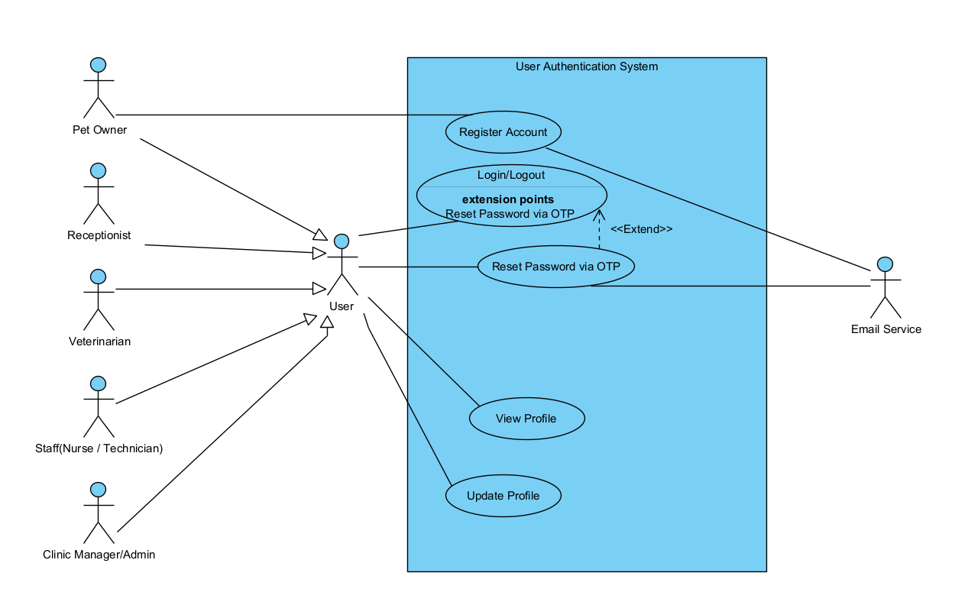

# | Use Case | Primary Actor | Secondary Actor | Major Feature | UML Relationships & Extension Points | Use Case Description
AUTH-01 | Register Account | Pet Owner | Email Service | FE-01 | • Association: Pet Owner — Register Account  • Association: Register Account — Email Service | Allows new pet owners to create an account with email verification.
AUTH-02 | Login/Logout | User (Inherited by: Pet Owner, Receptionist, Veterinarian, Staff(Nurse / Technician), Clinic Manager/Admin) | None | FE-01 | • Association: User — Login/Logout  • Extension Point: Reset Password via OTP | Authenticates users and establishes role-based session access permissions.
AUTH-03 | Reset Password via OTP | User (All Authenticated Users) | Email Service | FE-01 | • Extend: Reset Password via OTP --<<Extend>>--> Login  • Association: User — Reset Password via OTP  • Association: Reset Password via OTP — Email Service | Replaces an existing or forgotten password with a validated new credential via an OTP sent through the Email Service.
AUTH-04 | View Profile | User (All Authenticated Users) | None | FE-01 | • Association: User — View Profile | Displays the personal details of the authenticated user.
AUTH-05 | Update Profile | User (All Authenticated Users) | None | FE-01 | • Association: User — Update Profile | Updates personal details including contact number and address.

5.2.1 UCs for Pet Owner

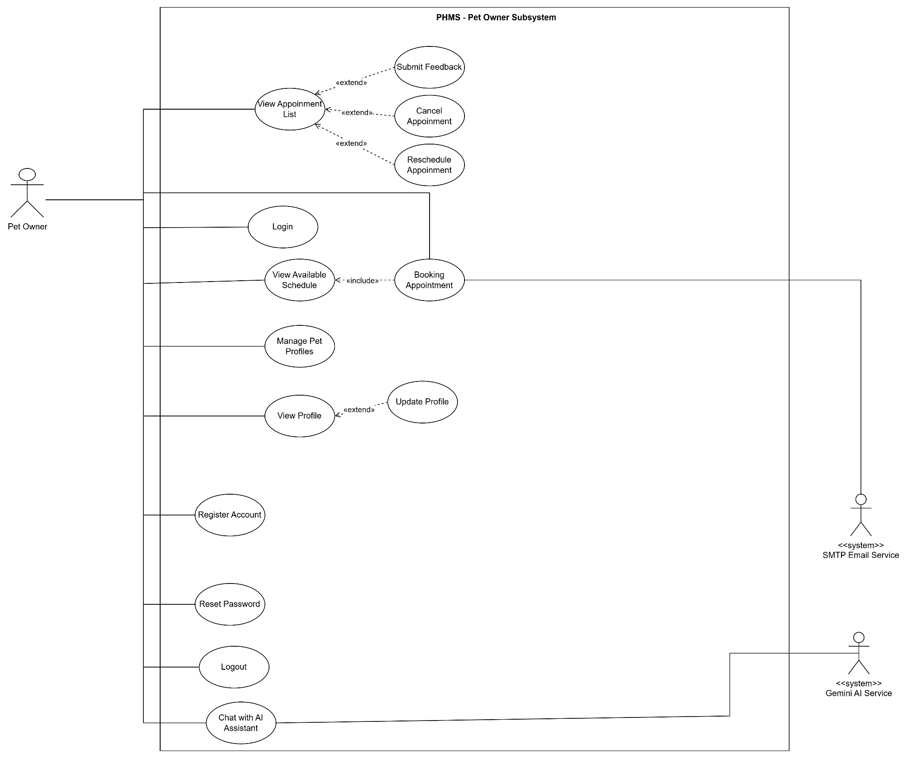

5.2.2 UCs for Receptionist

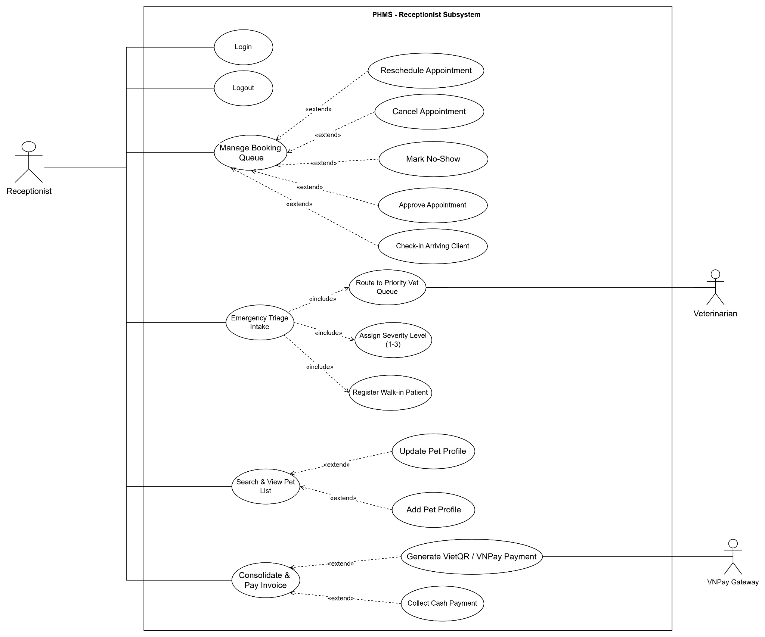

5.2.3 UCs for Veterinarian

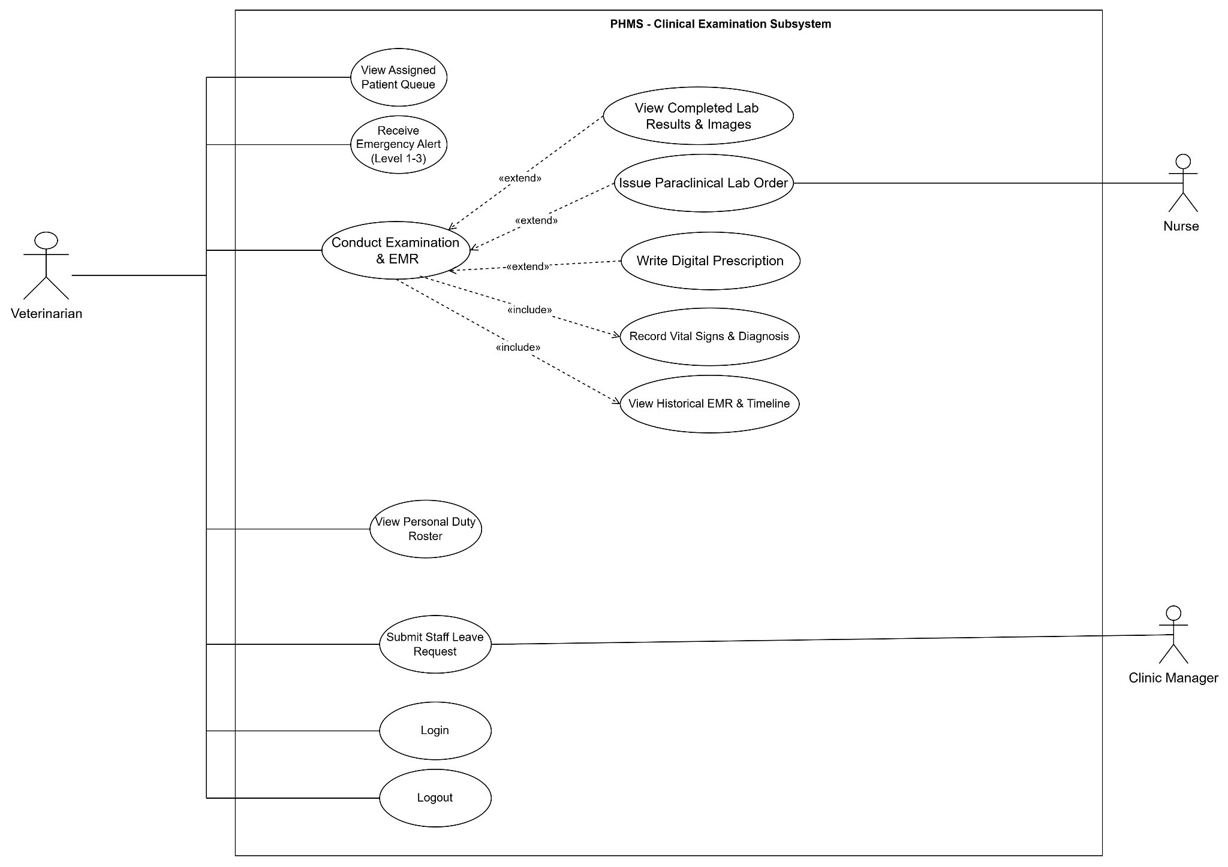

5.2.4 UCs for Staff(Nurse / Technician)

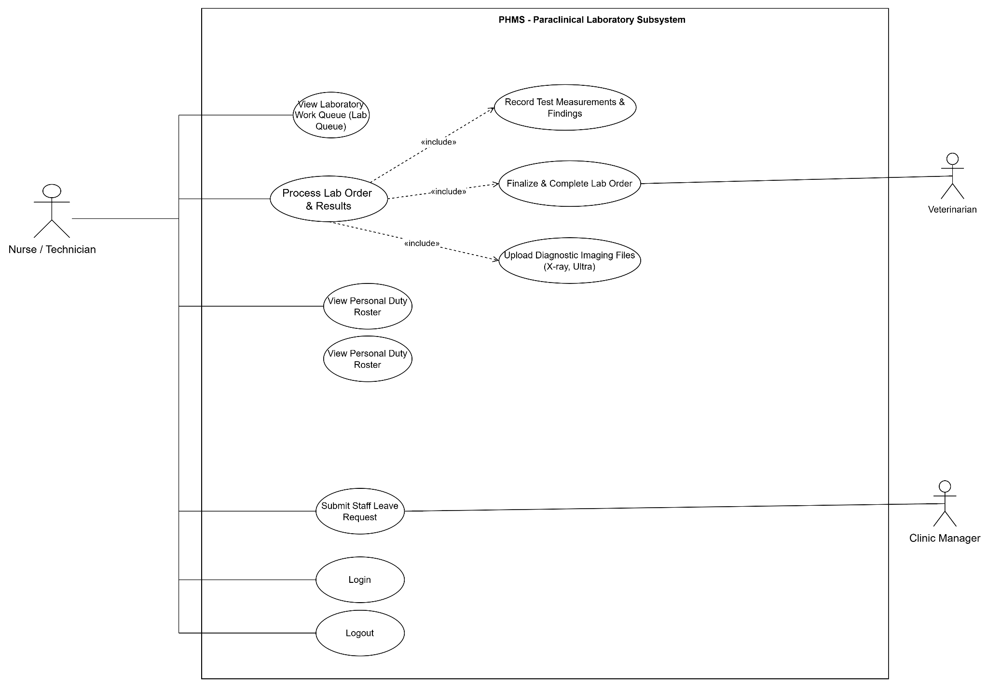
5.2.5 UCs for Clinic Manager

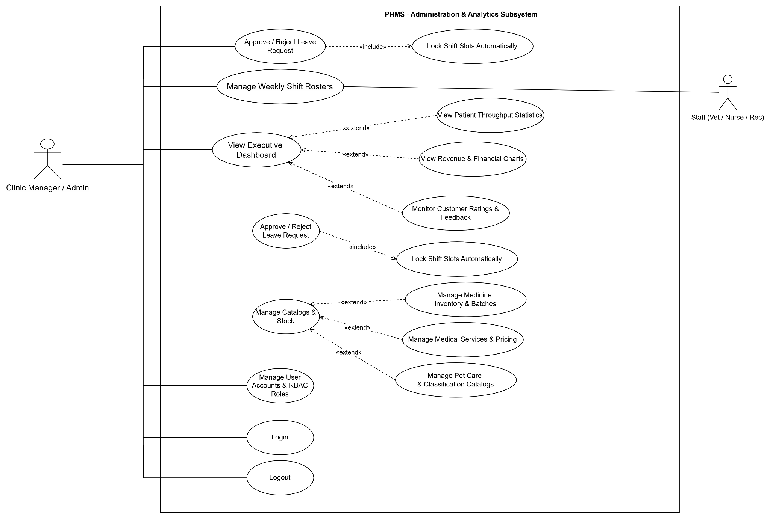

II.5.2.2 Use case descriptions

ID | Use Case | Actors | Major Feature | Use Case Description
AUTH-01 | Register Account | Pet Owner , Email Service | FE-01 | Allows new pet owners to create an account with email verification.
AUTH-02 | Login / Logout | All Authenticated Users | FE-01 | Authenticates users and establishes role-based session access permissions.
AUTH-03 | Reset Password via OTP | All Authenticated Users | FE-01 | Replaces existing password with a validated new credential.
AUTH-04 | View Profile | All Authenticated Users | FE-01 | Displays the personal details of the authenticated user.
AUTH-05 | Update Profile | All Authenticated Users | FE-01 | Updates personal details including contact number and address.
PET-01 | Add Pet | Pet Owner, Receptionist | FE-02 | Registers a new pet profile (breed, age, weight, history).
PET-02 | Update Pet | Pet Owner, Receptionist | FE-02 | Updates detailed pet profile information (breed, age, weight, history)
PET-03 | Delete Pet | Pet Owner, Receptionist | FE-02 | Soft-deletes a pet profile if no active uncompleted appointments exist.
PET-04 | View Pet List | Pet Owner, Receptionist | FE-02 | Retrieves all registered pets associated with the authenticated account.
BOOK-01 | Book Appointment | Pet Owner, Email Service | FE-03 | Enables pet owners to select services, Veterinarian, date, and available time slot.
BOOK-02 | Manage Booking Queue | Receptionist | FE-03 | Approves, cancels, reschedules, checks in customers, or marks no-shows.
BOOK-03 | Cancel Appointment | Pet Owner | FE-03 | Cancels a pending or confirmed booking subject to time constraints.
BOOK-04 | Reschedule Appointment | Pet Owner | FE-03 | Shifts an existing appointment to a new available calendar slot.
BOOK-05 | View Appointment List | Pet Owner | FE-03 | Displays current, upcoming, and past appointment tracking records.
BOOK-06 | View Appointment Note | Pet Owner | FE-03 | Displays the note attached to an appointment.
BOOK-07 | Dispatch Daily Reminders | Email Service | FE-03 | Automatically scans appointments for the next 24 hours and dispatches reminder notifications via Email Service
REV-01 | Submit Feedback | Pet Owner | FE-10 | Allows Pet Owner to submit feedback on an appointment after viewing its appointment note.
EMG-01 | Emergency Triage | Receptionist | FE-04 | Registers walk-in emergency cases, evaluates severity, and routes to priority queue.
EMR-01 | Conduct Examination & EMR | Veterinarian | FE-05 | Records clinical symptoms, vital signs, diagnoses, and treatment plans into EMR.
EMR-02 | View Medical Record List | Pet Owner | FE-05 | Displays the chronologically ordered medical records of the Pet Owner's pets.
EMR-03 | View Medical Record Detail | Pet Owner | FE-05 | Opens a full medical record including diagnoses, treatments, lab test results, and prescriptions.
LAB-01 | Issue Paraclinical Lab Order | Veterinarian | FE-06 | Enables Veterinarians to issue paraclinical test requests during clinical examinations.
LAB-02 | Process Lab Order & Results | Staff(Nurse / Technician) | FE-06 | Vet issues lab order; Nurse runs test, enters text results, and uploads image evidence.
PRES-01 | Write Prescription | Veterinarian | FE-05, FE-07 | Selects medications from pharmacy inventory and attaches dosage instructions to EMR.
BILL-01 | Process Invoice | Receptionist, Pet Owner, VNPay | FE-08 | Aggregates exam, lab, and drug costs; executes cash or online VNPay payment.
BILL-02 | View Invoice Detail | Pet Owner | FE-08 | Displays the invoice of a medical record, aggregating exam, lab, and drug costs.
HR-01 | Manage Weekly Shift Rosters | Clinic Manager / Admin | FE-09 | Enables Clinic Manager to create and publish weekly work rosters for all clinic personnel.
HR-02 | Submit Staff Leave Request | Veterinarian, Nurse | FE-09 | staff submits leave requests for approval.
HR-03 | Approve / Reject Leave | Clinic Manager / Admin | FE-09 | Allows Clinic Manager to review, approve, or reject submitted staff leave requests and automatically locks shift slots upon approval.
AI-01 | Get AI Health Guidance | Pet Owner, Gemini Chatbot API | FE-11 | Delivers 24/7 symptom advice and automated booking guidance.

a. Functional Description
1. UC-BOOK-01: Book Appointment Online

UC ID and Name: | UC-BOOK-01: Book Appointment Online
Created By: | Nhac Tuan Anh | Date Created: | 30/09/2026
Primary Actor: | Pet Owner | Secondary Actors: | Email Service
Trigger: | Pet Owner needs to schedule a clinic visit for a registered pet.
Description: | Allows authenticated Pet Owners to select a specific pet, medical service, preferred veterinarian, date, and available time slot to schedule a clinic visit.
Preconditions: | PRE-1:Pet Owner is logged into the system.  PRE-2:At least one pet profile is registered under the owner's account.
Postconditions: | POST-1:A new appointment record with status PENDING_APPROVAL is created.  POST-2:An automated confirmation notification email is queued via Email Service.
Normal Flow: | 1. Pet Owner requests to book an appointment.  2. System presents the Pet Owner’s registered pets; Owner selects a pet.  3. System filters and presents care service categories tailored to the selected pet’s species/size; Owner selects a service.  4. System presents the available veterinarians and dates.  5. Owner selects a veterinarian and a date; System retrieves the available time slots.  6. Owner selects a time slot, provides visit notes, and confirms the booking.  7. System validates slot availability, saves the appointment, and notifies the Email Service.  8. System presents a confirmation with the appointment code to the Owner.
Alternative Flows: | 1.1 Any Available Veterinarian Selection:  At step 5, if Owner selects “Any Available Veterinarian”, system presents all unbooked time slots across all duty veterinarians on that date. The flow then continues at step 6.
Exceptions: | 1.0.E1 Advance Booking Constraint Violation:  At step 6, if Owner selects a past date or a time slot within 2 hours of the current time, system informs the Owner that bookings must be made at least 2 hours in advance and rejects the request.  1.0.E2 Booking Date Too Far:  At step 6, if Owner selects a date more than 30 days ahead, system informs the Owner that bookings cannot be made more than 30 days in advance and rejects the request.  1.0.E3 Slot Conflict:  At step 7, if another Pet Owner has booked the same slot concurrently, system informs the Owner that the slot is no longer available and returns to step 5.
Priority: | High, Must Have
Frequency of Use: | High (~30-50 times/day)
Business Rules: | BR-02
Other Information:
Assumptions: | Clinic working hours are fixed between 08:00 and 17:00, divided into 30-minute consultation intervals.  Veterinarian duty rosters are maintained in the system before appointments are booked.  Email Service is available to deliver the confirmation email.

2. UC-BOOK-03: Cancel Appointment

UC ID and Name: | UC-BOOK-03: Cancel Appointment
Created By: | Nhac Tuan Anh | Date Created: | 30/09/2026
Primary Actor: | Pet Owner,Receptionist | Secondary Actors: | None
Trigger: | Pet Owner can no longer attend a scheduled appointment.
Description: | Allows Pet Owner to cancel a pending or confirmed appointment, subject to time constraints.
Preconditions: | PRE-1: Pet Owner is logged into the system.  PRE-2: Pet Owner has at least one appointment in pending or confirmed status.
Postconditions: | POST-1: The appointment status is changed to cancelled.
Normal Flow: | 1. Pet Owner selects an appointment and requests its cancellation.  2. System checks the appointment status and the time constraint.  3. System cancels the appointment.  4. System informs the Owner that the cancellation is completed.
Alternative Flows: | None
Exceptions: | 2.0.E1 Within Cancellation Limit:  At step 2, if the scheduled start time is less than 2 hours away (BR-06), system informs the Owner to contact front-desk staff and the appointment remains unchanged.
Priority: | Medium, Should Have
Frequency of Use: | Medium (~5-10 times/day)
Business Rules: | BR-06
Other Information:
Assumptions: | The scheduled start time of every appointment is recorded in the system and used to evaluate BR-06.  Front-desk staff are available to handle cancellations within the 2-hour limit.

3. UC-BOOK-04: Reschedule Appointment

UC ID and Name: | UC-BOOK-04: Reschedule Appointment
Created By: | Nhac Tuan Anh | Date Created: | 30/09/2026
Primary Actor: | Pet Owner,Receptionist | Secondary Actors: | None
Trigger: | Pet Owner is unable to attend an appointment at its scheduled time.
Description: | Allows Pet Owner to shift an existing appointment to a new available time slot
Preconditions: | PRE-1: Pet Owner is logged into the system.  PRE-2: Pet Owner has at least one existing appointment.
Postconditions: | POST-1: The appointment is updated with the new time slot.
Normal Flow: | 1. Pet Owner selects an appointment and requests to reschedule it.  2. System checks the time constraint and presents the available time slots.  3. Pet Owner selects a new time slot and submits the request.  4. System validates slot availability and updates the appointment.  5. System informs the Owner that the appointment has been rescheduled.
Alternative Flows: | 1.1 Slot Conflict Re-selection:  At step 4, if another client booked the slot concurrently, system alerts "Slot no longer available", refreshes the slot list, and returns to step 3.
Exceptions: | 3.0.E1 Within Reschedule Limit:  At step 2, if the scheduled start time of the selected appointment is less than 2 hours away (BR-06), system informs the Owner to contact front-desk staff and the appointment remains unchanged.  3.0.E2 Invalid Time Slot:  At step 3, if Owner selects a new slot that violates BR-02, system informs the Owner that the new slot must be at least 2 hours in advance and no more than 30 days ahead, and rejects the request.  3.0.E3 Slot Conflict:  At step 4, if another Pet Owner has booked the slot concurrently, system informs the Owner that the slot is no longer available, refreshes the available slots, and returns to step 3.
Priority: | Medium, Should Have
Frequency of Use: | Medium (~3-8 times/day)
Business Rules: | BR-02, BR-06
Other Information:
Assumptions: | Available time slots follow the same duty rosters and consultation intervals as UC-BOOK-01.  Front-desk staff are available to handle changes within the 2-hour limit.

4. UC-PET-01: Add Pet

UC ID and Name: | UC-PET-01: Add Pet Profile
Created By: | Nhac Tuan Anh | Date Created: | 30/09/2026
Primary Actor: | Pet Owner | Secondary Actors: | None
Trigger: | Pet Owner has a new pet that is not yet registered in the system.
Description: | Allows Pet Owner to register a new pet profile with detailed information (breed, age, weight, history).
Preconditions: | PRE-1: Pet Owner is logged into the system.
Postconditions: | POST-1: A new pet profile is created under the Pet Owner's account.
Normal Flow: | 1. Pet Owner requests to add a new pet.  2. System requests the pet information.  3. Pet Owner provides the pet details (breed, age, weight, history) and submits them.  4. System validates the data and saves the pet profile.  5. System informs the Owner that the pet profile has been created.
Alternative Flows: | None
Exceptions: | 4.0.E1 Invalid Pet Data:  At step 4, if mandatory information is missing or invalid, system informs the Owner of the errors and returns to step 3.
Priority: | High, Must Have
Frequency of Use: | Low (~2-5 times/day)
Business Rules: | None
Other Information:
Assumptions: | Pet Owner knows the basic details of the pet (breed, age, weight, history) when registering.

5. UC-EMG-01: Emergency Triage

UC ID and Name: | UC-EMG-01: Emergency Triage
Created By: | Nguyen Duy Hung | Date Created: | 30/09/2026
Primary Actor: | Receptionist | Secondary Actors: | Veterinarian
Trigger: | A walk-in patient arrives at the clinic in critical or urgent condition
Description: | Enables Receptionist to bypass standard booking, quickly register walk-in patient/pet details, record initial triage symptoms, evaluate condition severity, and insert the case into the top of the Veterinarian's priority emergency queue
Preconditions: | PRE-1: Receptionist is logged into the clinical desktop portal
Postconditions: | POST-1: Emergency case created with status EMERGENCY_WAITING  POST-2: Priority examination ticket assigned to the designated emergency vet queue
Normal Flow: | 1. Receptionist clicks "Emergency Walk-in" button on reception interface.  2. Receptionist enters owner contact info and pet basic information (or searches existing profile).  3. Receptionist selects Severity Level (Level 1 - Critical, Level 2 - Urgent, Level 3 - Standard).  4. Receptionist inputs observed emergency symptoms (e.g., severe bleeding, unconsciousness).  5. System assigns immediate Priority Queue ID and assigns case to active Emergency Vet.  6. System plays audio alert on Veterinarian's dashboard and displays pop-up banner.
Alternative Flows: | 2.1 Handling Clients Without a Profile / Unregistered Anonymous Owners:  At Step 2, if the person bringing a pet for emergency care has not registered an account and is unable to provide their information in time, the receptionist selects "Anonymous Emergency Owner." The system automatically creates a temporary account (a temporary PetOwner profile with a system-generated unique identifier), and the workflow then proceeds directly to Step 3 (where the receptionist selects the severity level).
Exceptions: | 2.0.E1 No On-Duty Emergency Vet  If no vet is currently marked on active duty shift, system triggers warning "No Vet on Duty" and prompts Receptionist to assign on-call Manager immediately.
Priority: | High, Must Have
Frequency of Use: | Medium (~5-10 times/day)
Business Rules: | BR-04 (Emergency Priority Overriding - Level 1 cases jump to position #1 in Vet queue)
Other Information: | Level 1 - Critical: Immediately placed at the #1 position in the attending physician’s queue; ongoing routine consultations are interrupted to prioritize emergency resuscitation.  Level 2 - Urgent: Inserted into the queue immediately following the patient currently being examined, taking precedence over all scheduled routine appointments. The maximum waiting time is 15 minutes.  Level 3 - Standard: Placed in the queue based on the order of arrival (FIFO) alongside other walk-in patients; the system automatically triggers a reminder every 30 minutes for a nurse to re-check vital signs to monitor for any potential deterioration in the patient's condition.
Assumptions: | At least one clinical examination room and an on-duty or on-call Veterinarian are configured in the system; Receptionist workstation has real-time network connectivity to trigger dashboard audio/visual alerts

6. UC-EMR-01: Conduct Examination & EMR

UC ID and Name: | UC-EMR-01: Conduct Examination & EMR
Created By: | Nguyen Duy Hung | Date Created: | 30/09/2026
Primary Actor: | Veterinarian | Secondary Actors: | Pet Owner
Trigger: | Veterinarian calls the next patient from the active examination queue.
Description: | Allows Veterinarian to review patient history, record vital signs (temperature, weight, heart rate), enter clinical observations, issue diagnoses, create treatment plans, and construct EMR records.
Preconditions: | PRE-1: Patient status is CHECKED_IN or EMERGENCY_WAITING.  PRE-2: Veterinarian is authenticated and assigned to current examination room.
Postconditions: | POST-1: Electronic Medical Record (EMR) entry is created and saved.  POST-2: Pet medical history updated and accessible to Pet Owner portal.
Normal Flow: | 1. Veterinarian views active queue and clicks "Start Examination" for next pet.  2. System displays pet's full historical EMR timeline, past prescriptions, and vaccination records.  3. Vet inputs current vital signs (Weight, Temperature, Heart Rate).  4. Vet enters Subjective/Objective clinical findings and selects Diagnosis from ICD-Vet catalog.  5. Vet inputs Treatment Plan notes and determines if Lab Tests or Prescriptions are needed.  6. Vet clicks "Save EMR Record"; System updates status to EXAMINATION_COMPLETED.
Alternative Flows: | 3.1 Lab Test Required:  At step 5, if lab tests are required, Vet initiates UC-LAB-01 (Order Lab Test). EMR status sets to WAITING_LAB_RESULT.  3.2 Prescription Issued:  At step 5, Vet initiates UC-PRES-01 (Write Digital Prescription) to add medications
Exceptions: | 3.0.E1 Incomplete Mandatory Fields:  If Vet attempts to save without entering Diagnosis or Weight, system highlights missing fields and blocks record finalize
Priority: | High, Must Have
Frequency of Use: | High (~30-60 times/day)
Business Rules: | EMR Immutability (EMR records are locked for editing 24h after completion).
Other Information:
Assumptions:

7. UC-BILL-01a: Process Online Payment via VNPay

UC ID and Name: | UC-BILL-01a: Process Online Payment via VNPay
Created By: | Trần Minh Quang | Date Created | 07/10/2026
Primary Actor: | Receptionist | Secondary Actors | VNPay Gateway
Trigger: | Receptionist selects "Online Payment / VNPay" on the billing screen.
Description: | Allows the Receptionist to generate a dynamic VNPay QR code for invoice settlement and receive real-time payment confirmation.
Preconditions: | PRE-1: Examination and lab procedures are completed.  PRE-2: Draft invoice is generated with status UNPAID.
Postconditions: | POST-1: Invoice status changes to PAID.  POST-2: Payment transaction record is created.
Normal Flow: | - Receptionist opens the unpaid invoice and selects "Pay via VNPay".  - System calls VNPay API to generate payment URL and dynamic VietQR code.  - Receptionist presents the QR code to the customer.  - Customer scans and authorizes the payment on their banking app.  - VNPay Gateway processes transaction and sends IPN webhook callback to System.  - System verifies signature, updates invoice status to PAID, and generates receipt.  - Receptionist prints/hands over the receipt to the customer.
Alternative Flows: | None
Exceptions: | 1.0.E1 Payment Timeout / Failure: At step 5, if the transaction is cancelled or times out, VNPay returns a failure status; System alerts "Payment Failed" and invoice remains UNPAID.
Priority: | High, Must Have
Frequency of Use: | High (~20-40 times/day)
Business Rules: | BR-05, NF-08
Other Information:
Assumptions:

8. UC-BILL-01b: Collect Cash Payment

UC ID and Name: | UC-BILL-01b: Collect Cash Payment
Created By: | Trần Minh Quang | Date Created | 07/10/2026
Primary Actor: | Receptionist | Secondary Actors | None
Trigger: | Receptionist selects "Pay by Cash" on the billing screen.
Description: | Allows the Receptionist to collect physical cash from the client, record cash payment details, and finalize the invoice.
Preconditions: | PRE-1: Examination and lab procedures are completed.  PRE-2: Invoice is generated with status UNPAID
Postconditions: | POST-1: Invoice status transitions to PAID.  POST-2: A cash transaction record is persisted in the database.  POST-3: Medicine stock quantities are deducted from pharmacy inventory.
Normal Flow: | 1. Receptionist selects the pending invoice from the Billing Queue.  2. System displays the invoice summary (consultation fee, lab costs, prescriptions, and total amount due).  3. Receptionist selects "Cash Payment" method.  4. Receptionist collects physical cash from the client and enters the received amount.  5. System calculates and displays change due (if any).  6. Receptionist clicks "Confirm Payment".  7. System validates the amount, updates invoice status to PAID, decrements pharmacy stock, and generates a printable receipt.  8. Receptionist hands over the physical receipt to the client.
Alternative Flows: | None
Exceptions: | 1.0.E1 Insufficient Cash Received: At step 6, if the entered amount received is less than the total invoice balance, the System displays an error: "Received amount is insufficient to settle the invoice" and blocks confirmation.
Priority: | High, Must Have
Frequency of Use: | High (~30-50 times/day)
Business Rules: | BR-05, BR-09
Other Information: | None
Assumptions: | Cash is verified and counted manually by the receptionist before confirmation.

9. UC-BILL-02: View Invoice Detail

UC ID and Name: | UC-BILL-02: View Invoice Detail
Created By: | Trần Minh Quang | Date Created | 07/10/2026
Primary Actor: | Pet Owner | Secondary Actors | None
Trigger: | Pet Owner selects an invoice from the invoice history list or navigates from a completed appointment/EMR.
Description: | Allows Pet Owners to view detailed itemized billing information of a completed consultation, including examination fees, paraclinical lab costs, prescribed medications, payment status, and transaction method.
Preconditions: | PRE-1: Pet Owner is logged into the system portal.  PRE-2: At least one medical encounter or invoice exists associated with the owner's registered pet(s).
Postconditions: | POST-1: Detailed itemized invoice breakdown is presented on screen.
Normal Flow: | 1. Pet Owner navigates to "Billing History" (or clicks "View Invoice" from an appointment/EMR record).  2. System displays the list of invoices associated with the owner's account.  3. Pet Owner selects a specific invoice to view.  4. System retrieves and displays full itemized invoice details: invoice ID, consultation charges, lab test fees, medicine breakdown (drug name, unit price, quantity, subtotal), total payable/paid amount, and payment status (PAID/UNPAID).  5. (Optional) Pet Owner clicks "Download / Export PDF" to save a digital copy of the receipt.
Alternative Flows: | None
Exceptions: | 1.0.E1 Invoice Not Found:  At step 3, if the invoice record does not exist or has been corrupted, System displays "Invoice information is currently unavailable" and redirects back to the invoice list.
Priority: | Medium, Should Have
Frequency of Use: | High (~20-40 times/day)
Business Rules: | BR-05
Other Information: | None
Assumptions: | Pet Owners can only access invoices belonging to their own registered pets.

10. UC-HR-01: Manage Weekly Shift Rosters

UC ID and Name: | UC-HR-01: Manage Weekly Shift Rosters
Created By: | Trần Minh Quang | Date Created | 07/10/2026
Primary Actor: | Clinic Manager / Admin | Secondary Actors | Staff (Veterinarian, Nurse, Receptionist)
Trigger: | Clinic Manager accesses the "Duty Rosters" module from the administrative dashboard.
Description: | Allows the Clinic Manager to create, update, and publish weekly duty shift schedules for clinical personnel (Vets, Nurses, Receptionists) across examination rooms and work shifts.
Preconditions: | PRE-1: Clinic Manager is authenticated with Manager role.  PRE-2: Employee accounts and shift time slots are configured in the system.
Postconditions: | POST-1: Weekly duty schedule is persisted in the database.  POST-2: Published roster opens booking slots for Pet Owners and becomes visible to assigned staff.
Normal Flow: | 1. Manager navigates to "Weekly Shift Management".  2. System displays the calendar grid of the target week showing configured shifts and existing assignments.  3. Manager selects a specific day, shift (Morning/Afternoon/Evening), and room/station.  4. Manager assigns an available staff member to the slot.  5. System validates that the staff member is not double-booked or on approved leave.  6. Manager reviews the schedule grid and clicks "Publish Roster".  7. System saves the roster, activates consultation booking slots, and sends notification to assigned staff.
Alternative Flows: | 1.1 Auto-Fill From Previous Week Template: At step 3, Manager clicks "Clone Last Week's Roster", system populates tentative assignments, and Manager adjusts before publishing.
Exceptions: | 1.0.E1 Staff Schedule Conflict / On Leave:  At step 5, if the assigned staff is already scheduled for another shift at the same time or has an approved leave request, system displays "Staff member is unavailable for this shift" and blocks the assignment.
Priority: | High, Must Have
Frequency of Use: | Medium (~1-2 times/week)
Business Rules: | BR-03
Other Information: | None
Assumptions: | Shifts must be published at least 3 days before the new working week begins.

11. UC-HR-02: Submit Staff Leave Request

UC ID and Name: | UC-HR-02: Submit Staff Leave Request
Created By: | Trần Minh Quang | Date Created | 07/10/2026
Primary Actor: | Veterinarian, Nurse, Receptionist | Secondary Actors | Clinic Manager / Admin
Trigger: | Staff member clicks "Request Leave" from their personal schedule view.
Description: | Allows employees to create and submit an absence/leave request specifying dates, leave type, and reason for manager approval.
Preconditions: | PRE-1: Staff member is logged into the system.
Postconditions: | POST-1: A leave request record is created with status PENDING.  POST-2: An approval notification is dispatched to the Clinic Manager's dashboard.
Normal Flow: | 1. Staff opens the "My Leave Requests" tab.  2. Staff clicks "New Leave Request".  3. Staff selects start date, end date, leave category (Sick, Personal, Vacation), and enters reason.  4. Staff submits the request.  5. System validates that the requested dates are in the future and do not overlap with existing pending/approved requests.  6. System creates leave record with PENDING status and routes notification to Clinic Manager.  7. System confirms successful submission to staff.
Alternative Flows: | None
Exceptions: | 1.0.E1 Invalid Date / Overlapping Request:  At step 5, if the date is in the past or conflicts with another leave request, system flags "Invalid date range or overlapping leave exists" and prompts correction..
Priority: | High, Must Have
Frequency of Use: | Medium (~5-15 times/month)
Business Rules: | BR-03
Other Information: | None
Assumptions: | Leave requests should be submitted at least 48 hours in advance for planned personal leaves.

12. UC-HR-03: Approve / Reject Leave Request

UC ID and Name: | UC-HR-03: Approve / Reject Leave Request
Created By: | Trần Minh Quang | Date Created | 07/10/2026
Primary Actor: | Clinic Manager / Admin | Secondary Actors | Staff (Requester)
Trigger: | Clinic Manager reviews pending leave items in the administrative approval queue.
Description: | Allows the Clinic Manager to review, approve, or reject employee leave requests. Approving automatically locks corresponding shift slots and alerts on booked appointment conflicts according to business rules.
Preconditions: | PRE-1: Clinic Manager is authenticated.  PRE-2: At least one leave request exists with status PENDING.
Postconditions: | POST-1: Leave request status is updated to APPROVED or REJECTED.  POST-2: If approved, affected shift slots are automatically locked (BR-03).
Normal Flow: | 1. Manager opens the "Pending Leave Requests" list.  2. Manager selects a specific leave request to examine details and view impacted shifts.  3. Manager evaluates clinic operational coverage for the requested period.  4. Manager clicks "Approve".  5. System updates leave status to APPROVED.  6. System automatically locks all shift slots assigned to the staff member during that date range (BR-03).  7. System checks for pre-booked client appointments in the locked slots; if found, flags them for receptionist reassignment.  8. System dispatches decision notification to the staff member.
Alternative Flows: | 1.1 Manager Rejects Request: At step 4, Manager clicks "Reject", enters rejection reason; System sets status to REJECTED and notifies staff (shifts remain unchanged).
Exceptions: | None
Priority: | High, Must Have
Frequency of Use: | Medium (~5-15 times/month)
Business Rules: | BR-03
Other Information: | None
Assumptions: | Receptionists are notified immediately if an approved leave disrupts pre-booked outpatient appointments.

13. UC-EMR-02: Prescribe Medication

UC ID and Name: | UC-EMR-02: Prescribe Medication
Created By: | Nguyễn Hoàng Nam | Date Created | 07/10/2026
Primary Actor: | Veterinarian | Secondary Actors | Patient, Pharmacist
Trigger: | Veterinarian completes examination and determines the patient requires medication. .
Description: | Allows the Veterinarian to create a prescription for the patient following a clinical examination. The system records the prescription, links it to the patient's medical record, and forwards it to the pharmacy for dispensing.
Preconditions: | PRE-1: Veterinarian is authenticated.  PRE-2: A patient examination session (UC-EMR-01) is in progress or has been completed.
Postconditions: | POST-1: A prescription is saved and linked to the patient's EMR.  POST-2: Pharmacy is notified of the new prescription pending dispensing.
Normal Flow: | 1. Veterinarian opens the patient's active examination record.  2. Veterinarian navigates to the "Prescription" section.  3. Veterinarian searches and selects medication(s) from the drug database.  4. Veterinarian specifies dosage, frequency, duration, and administration notes for each drug.  5. Veterinarian clicks "Issue Prescription".  6. System validates all mandatory fields and checks for drug interactions.  7. System saves the prescription and links it to the patient's EMR.  8. System sends prescription details to the Pharmacy module for dispensing.  9. System notifies the patient that a prescription has been issued
Alternative Flows: | 1.1 Drug Interaction Warning: At step 6, if the system detects a potential drug interaction, it displays a warning alert. Veterinarian must acknowledge or modify the prescription before proceeding.
Exceptions: | None
Priority: | High, Must Have
Frequency of Use: | High (~50–100 times/day)
Business Rules: | BR-EMR-01 (Prescriptions must be linked to a completed or in-progress examination
Other Information: | None
Assumptions: | The drug database is up-to-date and maintained by the Pharmacy Administrator.

14. UC-EMR-03: View Patient Medical History

UC ID and Name: | UC-EMR-03: View Patient Medical History
Created By: | Nguyễn Hoàng Nam | Date Created | 07/10/2026
Primary Actor: | Veterinarian | Secondary Actors | Nurse
Trigger: | Veterinarian selects a returning patient and requires access to prior medical records before or during consultation.
Description: | Allows an authorized Veterinarian or Nurse to retrieve and review a patient's complete medical history, including past diagnoses, prescribed medications, lab results, and visit records. No modifications are made to the records during this process.
Preconditions: | PRE-1: Veterinarian or Nurse is authenticated.  PRE-2: The patient is registered in the system with at least one prior visit record.
Postconditions: | POST-1: Patient's medical history is displayed to the authorized user.  POST-2: No data is created or modified.
Normal Flow: | 1. Veterinarian navigates to the "Patient Search" screen.  2. Veterinarian enters the patient's name, ID, or date of birth.  3. System retrieves and displays a list of matching patients.  4. Veterinarian selects the target patient.  5. System displays the patient's full medical history including: past diagnoses, prescribed medications, allergies, lab results, and visit dates.  6. Veterinarian filters records by date range or record type as needed.  7. Veterinarian reviews the records and closes the history view when done
Alternative Flows: | 1.1 No Records Found: At step 3, if no matching patient exists, System displays "No records found" and prompts the Veterinarian to refine the search.  1.2 First-Time Patient: At step 5, if the patient has no prior records, System displays "No medical history available" and prompts Veterinarian to initiate a new examination (UC-EMR-01).
Exceptions: | None
Priority: | High, Must Have
Frequency of Use: | High (~80–150 times/day)
Business Rules: | None
Other Information: | None
Assumptions: | Veterinarians and Nurses can only view records of patients assigned to their clinic department.

15. UC-LAB-01: Request Laboratory Test

UC ID and Name: | UC-LAB-01: Request Laboratory Test
Created By: | Nguyễn Hoàng Nam | Date Created | 07/10/2026
Primary Actor: | Veterinarian | Secondary Actors | Patient, Staff(Nurse / Technician)
Trigger: | Veterinarian determines during examination that laboratory testing is required to support diagnosis.
Description: | Allows the Veterinarian to submit a laboratory test request for a patient. The request is recorded in the system and forwarded to the Laboratory module, where it enters the Staff(Nurse / Technician)'s pending work queue. .
Preconditions: | PRE-1: Veterinarian is authenticated.  PRE-2: A patient examination session (UC-EMR-01) is in progress.
Postconditions: | POST-1: A lab test request is created with status PENDING and assigned a unique request ID.  POST-2: The request appears in the Staff(Nurse / Technician)'s work queue.  POST-3: Patient is informed of the required tests.
Normal Flow: | 1. Veterinarian opens the patient's active examination record.  2. Veterinarian navigates to the "Lab Request" section.  3. System displays the list of available laboratory tests.  4. Veterinarian selects the required test(s) and specifies urgency level (Routine / Urgent).  5. Veterinarian enters additional clinical notes if needed.  6. Veterinarian clicks "Submit Request".  7. System generates a lab request with a unique request ID and timestamps it.  8. System sets request status to PENDING and forwards it to the Laboratory module.  9. System displays a confirmation message with the lab request ID to the Veterinarian.
Alternative Flows: | 1.1 Urgent Request: At step 4, if Veterinarian marks the request as "Urgent", System flags it and places it at the top of the Staff(Nurse / Technician)'s queue.  1.2 Custom Test Not in List: At step 4, if the required test is not in the predefined list, Veterinarian enters a custom test name; request is flagged for manual Staff(Nurse / Technician) review.
Exceptions: | None
Priority: | High, Must Have
Frequency of Use: | Medium (~30–60 times/day)
Business Rules: | BR-LAB-01 (Lab requests must be linked to an active patient examination session)
Other Information: | None
Assumptions: | The laboratory test catalog is maintained by the Lab Administrator and updated periodically.

16. UC-LAB-02: Record and Return Laboratory Results

UC ID and Name: | UC-LAB-02: Record and Return Laboratory Results
Created By: | Nguyễn Hoàng Nam | Date Created | 07/10/2026
Primary Actor: | Staff(Nurse / Technician) | Secondary Actors | Veterinarian, Patient
Trigger: | Staff(Nurse / Technician) completes the laboratory analysis for a submitted request and is ready to enter results into the system.
Description: | Allows the Staff(Nurse / Technician) to enter and submit laboratory test results for a completed request. Once submitted, results are automatically linked to the patient's EMR and the requesting Veterinarian is notified to review them. .
Preconditions: | PRE-1: Staff(Nurse / Technician) is authenticated.  PRE-2: A valid lab test request with status PENDING exists (created via UC-LAB-01).  PRE-3: Physical laboratory analysis has been completed.
Postconditions: | POST-1: Lab results are saved with status COMPLETED and linked to the patient's EMR.  POST-2: The requesting Veterinarian is notified that results are available for review.
Normal Flow: | 1. Staff(Nurse / Technician) logs into the Laboratory module.  2. System displays the list of pending lab requests sorted by urgency and submission time.  3. Staff(Nurse / Technician) selects a request by request ID or patient name.  4. System displays the request details including test(s) ordered and clinical notes from the Veterinarian.  5. Staff(Nurse / Technician) enters measured values and observations for each test.  6. Staff(Nurse / Technician) reviews all entered data and clicks "Submit Results".  7. System validates the entered values (range checks and completeness).  8. System saves the results, updates request status to COMPLETED, and links them to the patient's EMR.  9. System dispatches a result-ready notification to the requesting Veterinarian.
Alternative Flows: | 1.1 Partial Results: At step 6, if not all tests are completed, Staff(Nurse / Technician) clicks "Save Draft"; System saves partial results with status IN PROGRESS and allows later updates.  1.2 Abnormal Value Detected: At step 7, if a result value falls outside the clinical reference range, System highlights the value and requires Staff(Nurse / Technician) to confirm before submission.
Exceptions: | None
Priority: | High, Must Have
Frequency of Use: | Medium (~30–60 times/day)
Business Rules: | BR-LAB-02 (Results must be submitted within 24 hours for Routine and within 2 hours for Urgent requests)
Other Information: | None
Assumptions: | Veterinarians review lab results via the patient's medical history screen (UC-EMR-03).

17. UC-AUTH-01: Register Account

UC ID and Name: | UC-AUTH-01: Register Account
Created By: | Nguyen Duy Hung | Date Created | 02/10/2026
Primary Actor: | Pet Owner | Secondary Actors | Email Service
Trigger: | A new Pet Owner visits the PHMS portal and selects the "Register / Sign Up" option to create a personal account.
Description: | Allows new Pet Owners to self-register an account by providing personal and contact information, verifying their email via an OTP dispatched through the Email Service, and persisting hashed credentials.
Preconditions: | PRE-1: Pet Owner is not currently logged into an active session.  PRE-2: The authentication portal and the email service are operating normally.
Postconditions: | POST-1: A new User record (with role PET_OWNER and isActive = true) and a corresponding PetOwner profile are created in the database.  POST-2: Password is cryptographically hashed using BCrypt (BR-01).
Normal Flow: | 1. Pet Owner navigates to the Registration page.  2. System displays the registration form (Full Name, Username, Email, Phone Number, Address, Password, Confirm Password).  3. Pet Owner enters the required details and clicks "Register".  4. The system validates the data format (including password complexity per BR-10) and queries the database to ensure the uniqueness of the username, email address, and phone number. If valid, the system generates a time-limited 6-digit OTP code  5. Email Service delivers the verification OTP email to the Pet Owner  6. Pet Owner enters the received OTP code on the verification screen and submits.  7. System verifies the OTP, hashes the password using BCrypt (BR-01), saves the User and PetOwner entities, and activates the account.  8. System displays a registration success message and redirects the Pet Owner to the Login screen.
Alternative Flows: | At step 6, if the Pet Owner does not receive the email within 60 seconds and clicks "Resend OTP", the system invalidates the old code, dispatches a new OTP via Email Service, and remains at step 6.
Exceptions: | At step 4, if the entered email or username already exists in the database, the system displays "Email or username is already registered" and returns to step 3.  At step 7, if the submitted OTP is incorrect or expired (exceeds 5 minutes), the system alerts "Invalid or expired OTP code" and prompts the user to re-enter or request a new code.
Priority: | High, Must Have
Frequency of Use: | Medium (~10–20 times/day)
Business Rules: | BR-01 (Credential Hashing), NF-02 (Data Encryption & Auth)
Other Information: | None
Assumptions: | Email Service (SMTP server) is operational and reachable to deliver outbound OTP messages.

18. UC-AUTH-02: Login / Logout (RBAC)

UC ID and Name: | UC-AUTH-02: Login / Logout (RBAC)
Created By: | Nguyen Duy Hung | Date Created | 02/10/2026
Primary Actor: | User (Pet Owner, Receptionist, Veterinarian, Staff(Nurse / Technician), Clinic Manager / Admin) | Secondary Actors | None
Trigger: | User submits credentials on the Login page to access the system or clicks "Logout" to end an active session.
Description: | Authenticates users against stored BCrypt password hashes, establishes role-based access control (RBAC) session permissions across 5 primary roles, and securely terminates sessions upon logout .
Preconditions: | PRE-1: For Login, User possesses a registered and active (isActive = true) account in the system.  PRE-2: For Logout, User is currently logged into an authenticated session.
Postconditions: | POST-1 (Login): An authenticated session/token is created, and the user is routed to their role-specific workspace (Pet Owner Portal, Reception Desk, Vet Queue, Lab Queue, or Manager Dashboard).  POST-2 (Logout): Active session/token is invalidated and cleared.
Normal Flow: | 1. User opens the Login page.  2. User enters their Username/Email and Password, then clicks "Login".  3. System retrieves the User record, verifies account active status (isActive), and compares the input password against the BCrypt hash (BR-01).  4. System generates an authenticated session with the user's assigned RBAC role.  5. System redirects the User to the corresponding role dashboard.  6. When finished working, User clicks the "Logout" button.  7. System invalidates the current session, clears authentication tokens, and redirects the User back to the Login screen.
Alternative Flows: | At step 2, if the User forgets their password and clicks "Forgot Password?", the system initiates UC-AUTH-03: Reset Password via OTP
Exceptions: | At step 3, if the username does not exist or the password hash does not match, the system displays "Invalid username or password" and returns to step 2.  At step 3, if the account has isActive = false, the system displays "Your account has been locked or deactivated. Please contact the Clinic Manager" and blocks access.
Priority: | High, Must Have
Frequency of Use: | High (~100–200 times/day)
Business Rules: | BR-01 (Credential Hashing), NF-02 (Data Encryption & Auth)
Other Information: | None
Assumptions: | Internal clinical staff accounts (Receptionist, Veterinarian, Nurse, Manager) are pre-provisioned by the Clinic Manager / Admin

19. UC-AUTH-03: Reset Password via OTP

UC ID and Name: | UC-AUTH-03: Reset Password via OTP
Created By: | Nguyen Duy Hung | Date Created | 02/10/2026
Primary Actor: | User (All Authenticated Users) | Secondary Actors | Email Service
Trigger: | User selects "Forgot / Reset Password" from the Login screen or security settings.
Description: | Allows users to recover or reset their account password by verifying a One-Time Password (OTP) delivered to their registered email address via the Email Service.
Preconditions: | PRE-1: User has an existing registered account with a valid email address in the system.
Postconditions: | POST-1: The user's password hash in the User table is updated with the new BCrypt-hashed credential (BR-01)  POST-2: The temporary OTP token is invalidated.
Normal Flow: | 1. User clicks "Reset Password via OTP" on the Login screen.  2. System prompts the User to enter their registered Email address.  3. User submits the email address.  4. System verifies the email exists, generates a time-limited OTP code, and dispatches it via the Email Service.  5. User receives the OTP in their email inbox, enters the OTP along with a New Password and Confirm Password on the reset form, and clicks "Submit".  6. System validates the OTP code and password complexity rules.  7. System hashes the new password using BCrypt (BR-01) and updates the User record in the database.  8. System notifies the User that the password has been successfully reset and redirects to the Login page.
Alternative Flows: | At step 5, if the OTP email is delayed, the User clicks "Resend OTP"; the system generates a fresh OTP and dispatches it via Email Service.
Exceptions: | At step 4, if the entered email does not match any existing account, the system displays "No account found with this email address" and returns to step 2.  At step 6, if the OTP is invalid/expired or the confirmation password does not match, the system highlights the error and returns to step 5.
Priority: | High, Must Have
Frequency of Use: | Low (~3–10 times/day)
Business Rules: | BR-01 (Credential Hashing), NF-02 (Data Encryption & Auth), BR-10 (Password Complexity Policy)
Other Information: | Extends UC-AUTH-02: Login at extension point Reset Password via OTP.
Assumptions: | User has access to their registered email inbox to read the OTP code.

20. UC-AUTH-04: View Profile

UC ID and Name: | UC-AUTH-04: View Profile
Created By: | Nguyen Duy Hung | Date Created | 02/10/2026
Primary Actor: | User (All Authenticated Users) | Secondary Actors | None
Trigger: | An authenticated User clicks on "My Profile" from the navigation bar.
Description: | Retrieves and displays the personal account details and role-specific profile attributes of the currently authenticated user.
Preconditions: | PRE-1: User is logged into an active authenticated session.
Postconditions: | POST-1: The user's personal profile information is displayed on the screen without modifying any database records.  POST-2: The data state of the system and the users remains intact; no records have been updated.
Normal Flow: | 1. User selects "View Profile" from the account menu.  2. System extracts the userId and role from the active authentication session.  3. System queries the User table and the corresponding role table (PetOwner for customers, or Employee / Veterinarian / Nurse / Receptionist / ClinicManager for staff).  4. System renders the profile details on screen (Full Name, Username, Role, Phone Number, and Email/Address for Pet Owners or Employee Code/Department/Specialization for Staff).
Alternative Flows: | At step 4, if the User wants to modify their personal details, they click "Edit / Update Profile", triggering UC-AUTH-05: Update Profile.
Exceptions: | At step 2, if the user's authentication token has expired, the system prompts "Session expired, please log in again" and redirects to the Login screen.
Priority: | Medium, Should Have
Frequency of Use: | Medium (~20–40 times/day)
Business Rules: | NF-02 (Data Encryption & Auth)
Other Information: | None
Assumptions: | None

21. UC-AUTH-05: Update Profile

UC ID and Name: | UC-AUTH-05: Update Profile
Created By: | Nguyen Duy Hung | Date Created | 02/10/2026
Primary Actor: | User (All Authenticated Users) | Secondary Actors | None
Trigger: | An authenticated User clicks "Edit / Update Profile" on the Profile screen.
Description: | Allows authenticated users to modify and save their personal profile information, including full name, contact phone number, email, and residential address.
Preconditions: | PRE-1: User is logged into the system and viewing their profile (UC-AUTH-04).
Postconditions: | POST-1: Updated personal details are validated and persisted in the User and PetOwner/Employee database tables.
Normal Flow: | 1. User selects "Update Profile" on the profile view.  2. System enables editable input fields pre-filled with the user's current details (fullName, phone, email, address).  3. User modifies the desired fields and clicks "Save Changes".  4. System validates data formats (e.g., valid Vietnamese phone number format, non-empty mandatory fields).  5. System updates the corresponding User and PetOwner/Employee records in the database.  6. System displays "Profile updated successfully" and renders the refreshed profile view.
Alternative Flows: | At step 3, if the User clicks "Cancel", the system discards unsaved changes and returns to the read-only profile view (UC-AUTH-04).
Exceptions: | At step 4, if mandatory fields (fullName, phone) are left blank or contain invalid characters, the system highlights the invalid fields and returns to step 3.  At step 4, if the updated phone number or email belongs to another existing account, the system alerts "Phone number or Email is already in use" and blocks the update.
Priority: | Medium, Should Have
Frequency of Use: | Low (~5–15 times/day)
Business Rules: | NF-02 (Data Encryption & Auth)
Other Information: | RBAC role, employee salary, and employee code (empCode) are read-only and cannot be self-modified by the user.
Assumptions: | None

22. UC-AI-01: Consult Gemini AI Advisor

UC ID and Name: | UC-AI-01: Consult Gemini AI Advisor
Created By: | Nguyen Duy Hung | Date Created | 02/10/2026
Primary Actor: | Pet Owner | Secondary Actors | Gemini Chatbot API
Trigger: | Pet Owner opens the "AI Health Guide" feature to seek 24/7 advice regarding pet symptoms, first-aid, nutrition, or clinic booking recommendations.
Description: | Enables authenticated Pet Owners to ask natural-language questions about pet health. The system analyzes question intents, builds personalized context from the database (pet profiles, medical history), queries the external Google Gemini Chatbot API, logs the conversation into AIChatLog, and displays the AI-generated guidance.
Preconditions: | PRE-1: Pet Owner is logged into the system.
Postconditions: | POST-1: Both the Pet Owner's raw question (questionRaw) and the AI's generated response (aiResponse) are persisted in the AIChatLog table.  POST-2: The updated conversation history is rendered on the Pet Owner's chat interface.
Normal Flow: | 1. Pet Owner selects and opens the "AI Health Guide" consultation screen.  2. System queries the AIChatLog table to load and display the user's previous chat history.  3. Pet Owner enters a question regarding pet health, symptoms, or care and submits it.  4. System analyzes the question intents to identify keywords, symptom severity, and pet context.  5. System queries the database to build relevant context (owner's registered Pet profiles, past MedicalRecord diagnoses, and vaccination history).  6. System composes a structured prompt combining the user's question, retrieved DB context, and veterinary safety instructions.  7. System calls the Gemini Client to send the composed prompt to the external Gemini Chatbot API.  8. Gemini Chatbot API processes the prompt and generates a contextual health advisory response.  9. System stores the new chat entry (userId, questionRaw, aiResponse, createdAt) into the AIChatLog database table.  10. System renders the updated chat history on the UI.  The system automatically appends a standard disclaimer to the end of every response:  "Disclaimer: Responses from the AI ​​Assistant are intended for preliminary reference and initial first-aid support only. If your pet shows signs of a critical condition, please take them immediately to a PHMS Veterinary Hospital or contact the emergency hotline so that a veterinarian can provide timely professional care."  11. Pet Owner receives and views the AI health answer on the screen.
Alternative Flows: | At step 5, if the Pet Owner has not registered any pet profile yet, the system builds a general context without pet-specific medical records and proceeds to step 6.  At step 11, if the question involves critical symptoms, the AI response includes a direct recommendation link for the Pet Owner to initiate UC-BOOK-01: Book Appointment Online or visit the clinic for emergency triage.
Exceptions: | At step 7–8, if the Gemini Chatbot API fails to respond within the 8-second threshold (NF-01) or returns an API error, the system displays a fallback message: "AI Health Advisor is temporarily busy. Please try again or contact our clinic hotline directly for urgent pet care".  At step 3, if the Pet Owner submits an empty message or exceeds the maximum character limit, the system blocks submission and prompts the user to enter a valid question.The system blocks the submission of queries and displays the following message: "You have exceeded the limit of 10 questions per hour for the AI ​​assistant. Please try again later or contact our hotline for direct assistance."
Priority: | Medium, Should Have
Frequency of Use: | High (~30–60 times/day)
Business Rules: | NF-01 (AI-assisted requests shall return a response or timeout within 8 seconds), NF-02 (Sanitized symptom queries via HTTPS)
Other Information: | Maps directly to Activity Workflow 7: Consult Gemini AI Advisor (AI-01).
Assumptions: | External Google Gemini API service is active and configured with a valid API key.

b. Business Rules
Provide the business rules those are applied only to the use case

ID | Business Rule | Business Rule Description
BR-01 | Credential Hashing | User passwords must be cryptographically hashed using BCrypt (cost factor >= 10) prior to persistence. Plaintext credentials must never be stored.
BR-02 | Advance Booking Window | Appointments must be scheduled at least 2 hours in advance of the desired time slot and no more than 30 calendar days ahead. Past dates and current-hour slots are locked.
BR-03 | Shift Lock on Leave Approval | When a staff member's leave request is approved by the Clinic Manager, the system automatically locks all corresponding shift slots, preventing new appointment bookings for that period.
BR-04 | Emergency Priority Overriding | Walk-in emergency cases evaluated as Level 1 - Critical during triage immediately jump to position #1 in the assigned on-duty Veterinarian's active queue, ahead of all scheduled outpatient consultations.
BR-05 | Invoice Immutability | Once an invoice transitions to the PAID state, its line items, quantities, and prices cannot be modified or deleted. Any post-payment adjustments require an authorized refund transaction.
BR-06 | Appointment Cancellation Limit | Pet Owners can cancel or reschedule an appointment only if the scheduled start time is at least 2 hours away. Within 2 hours of the slot, changes must be handled through front-desk staff.
BR-07 | EMR Integrity & Immutability | Electronic Medical Records (EMR) are locked against edits 24 hours after completion. Any subsequent clinical addenda must be appended as signed supplemental notes.
BR-08 | Paraclinical Order Integrity | An EMR encounter cannot transition to EXAMINATION_COMPLETED while associated diagnostic lab orders remain in the ORDERED or IN_PROGRESS status.
BR-09 | Pharmacy Stock Synchronization | Finalizing an invoice marked PAID automatically decrements the corresponding medication stock quantities in the pharmacy inventory.
BR-10 | Password Complexity Policy | The password entered by a user during new registration or password reset must be between 8 and 32 characters long, must not contain any spaces, and must not be identical to the username.

II.5.3 Activity diagram

Activity Workflow 1: Online Appointment Booking (UC-BOOK-01)
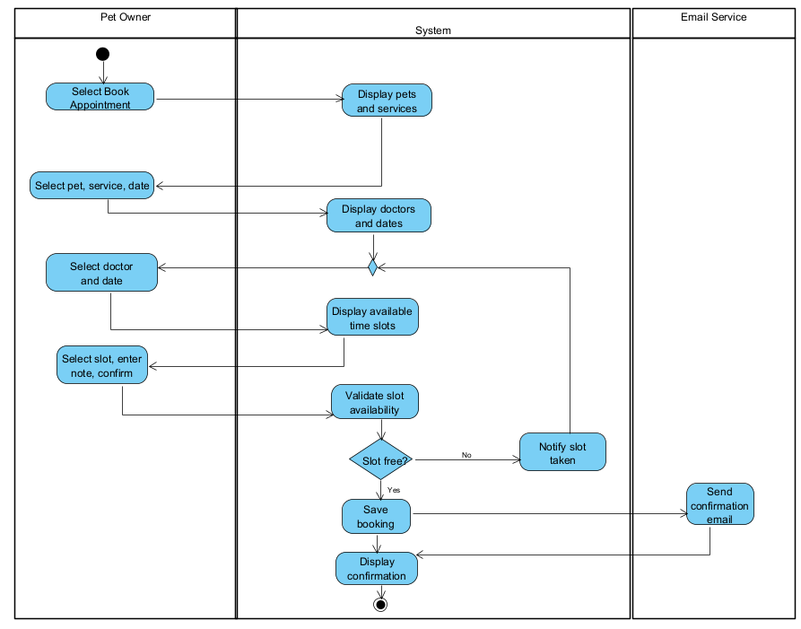
- Activity Workflow 2: Appointment Cancellation (UC-BOOK-03)
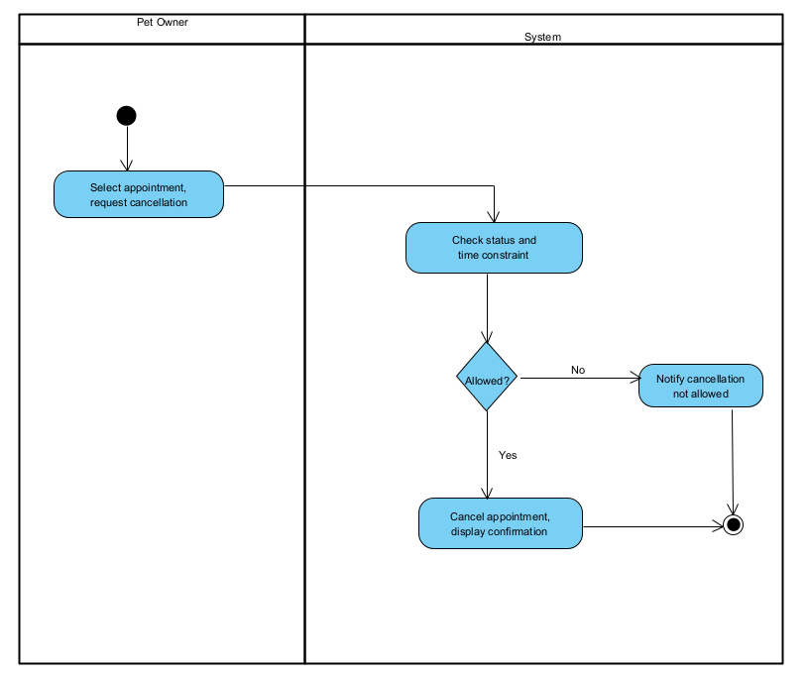

- Activity Workflow 3: Appointment Rescheduling (UC-BOOK-04)
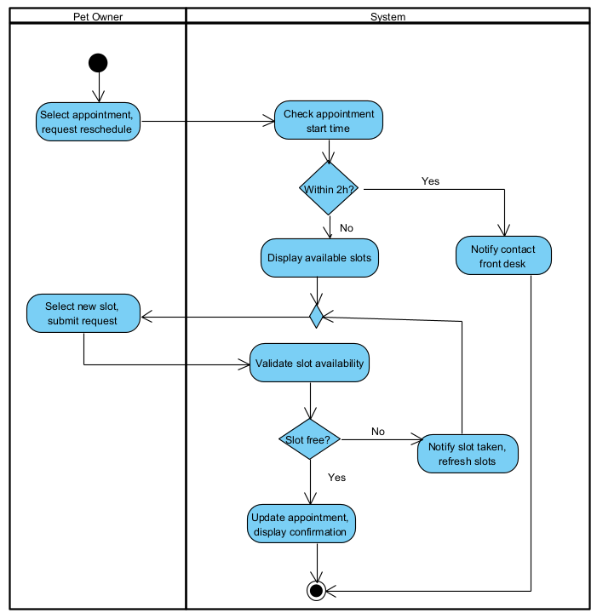
- Activity Workflow 4: Pet Profile Registration (UC-PET-01)
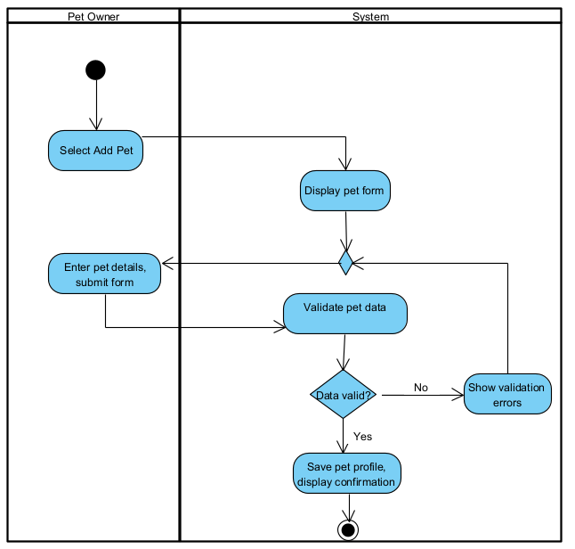

- Activity Workflow 5: Walk-In Emergency Reception & Priority Triage (UC-EMG-01)
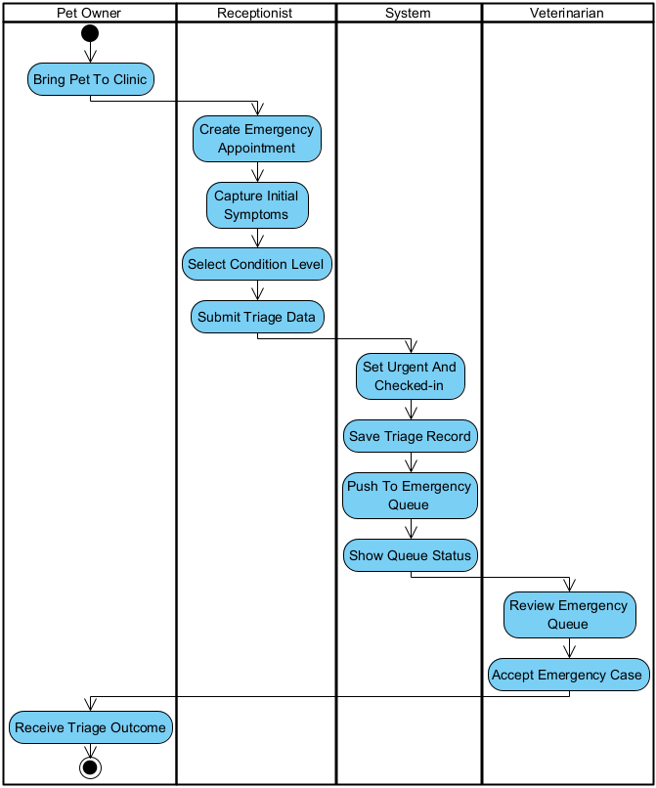

STEP | Actor | Activity/action | Note
1 | Pet Owner | Bring Pet To Clinic | Precondition: Pet arrives at the clinic in an unscheduled critical or urgent condition.
2 | Receptionist | Create Emergency Appointment | Selects "Emergency Walk-in" on the reception portal; searches existing pet profile or creates an anonymous temporary profile (Alt Flow 2.1).
3 | Receptionist | Capture Initial Symptoms | Records observed acute symptoms (e.g., severe hemorrhage, respiratory distress, trauma).
4 | Receptionist | Select Condition Level | Assigns triage severity: Level 1 (Critical), Level 2 (Urgent), or Level 3 (Standard).
5 | Receptionist | Submit Triage Data | Confirms and submits the emergency intake form.
6 | System | Set Urgent And Checked-in | Creates an Appointment (type = EMERGENCY, status = EMERGENCY_WAITING).
7 | System | Save Triage Record | Persists the TriageRecord entity (conditionLevel, initialSymptoms, triageTime) linked to the appointment.
8 | System | Push To Emergency Queue | Applies BR-04: Inserts Level 1 cases directly at position #1 of the on-duty Veterinarian's active queue.
9 | System | Show Queue Status | Triggers an audio alert and pop-up banner on the assigned Veterinarian's dashboard.
10 | Veterinarian | Review Emergency Queue | Views the emergency alert banner, triage severity, and initial symptoms.
11 | Veterinarian | Accept Emergency Case | Acknowledges the case and initiates immediate clinical examination (UC-EMR-01).
12 | Pet Owner | Receive Triage Outcome | Postcondition: Pet is admitted immediately into the examination room based on triage priority.

- Activity Workflow 6: Clinical Examination, Lab Testing, Prescription & Billing (UC-EMR-01, LAB-01, LAB-02, PRES-01, BILL-01)
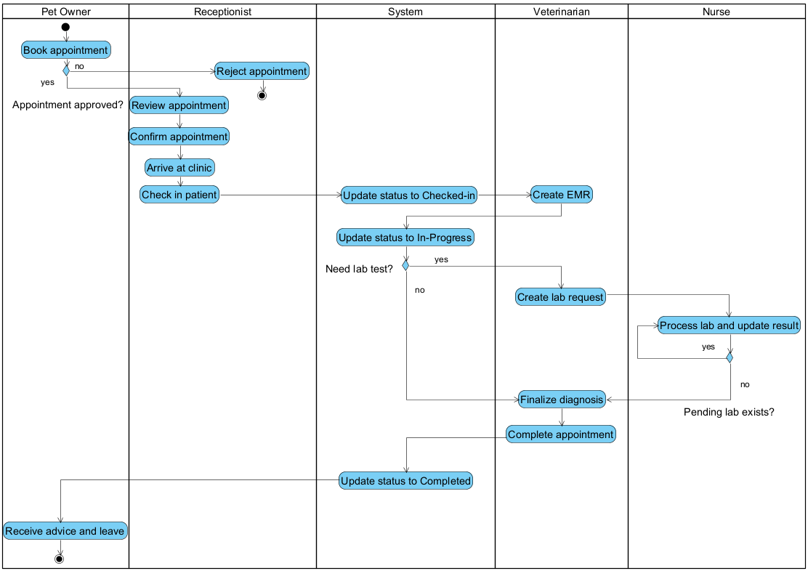
- Activity Workflow 7: Consult Gemini AI Advisor (AI-01)
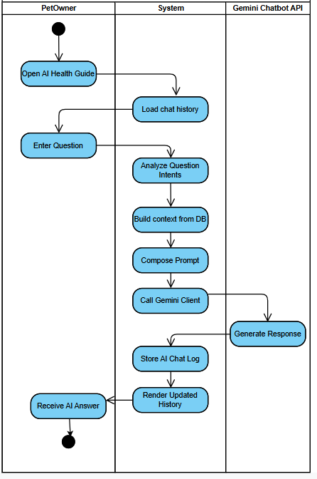

STEP | Actor | Activity/action | Note
1 | PetOwner | Open AI Health Guide | Preconditions: User must be logged in. Navigates to the AI consultation screen.
2 | System | Load chat history | Retrieves and displays previous conversation logs of the user from the database.
3 | PetOwner | Enter Question | Inputs a question regarding pet health, symptoms, or care and submits it.
4 | System | Analyze Question Intents | Parses the user's input to identify keywords, pet context, and specific intents.
5 | System | Build context from DB | Queries the database for relevant data (e.g., pet profile, medical records, vaccination history).
6 | System | Compose Prompt | Combines the user's question, retrieved DB context, and system instructions into a structured prompt.
7 | System | Call Gemini Client | Sends an API request containing the composed prompt to the Gemini service.
8 | Gemini Chatbot API | Generate Response | Processes the prompt using the AI model and returns the generated health advice.
9 | System | Store AI Chat Log | Saves both the user's question and the AI's response into the database for future reference.
10 | System | Render Updated History | Updates the chat UI to append the newly generated response.
11 | PetOwner | Receive AI Answer | Postcondition: Views the AI health advice on the screen. Workflow ends.

- Activity Workflow 8: Submit Feedback (REV-01)
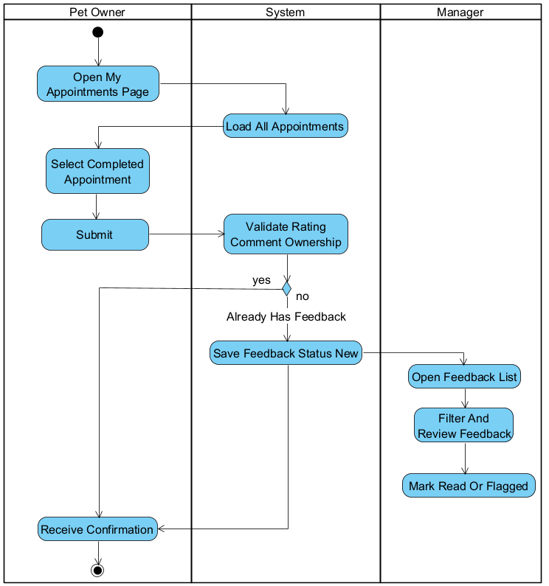

- Activity Workflow 9: Online Payment via VNPay (UC-BILL-01a)
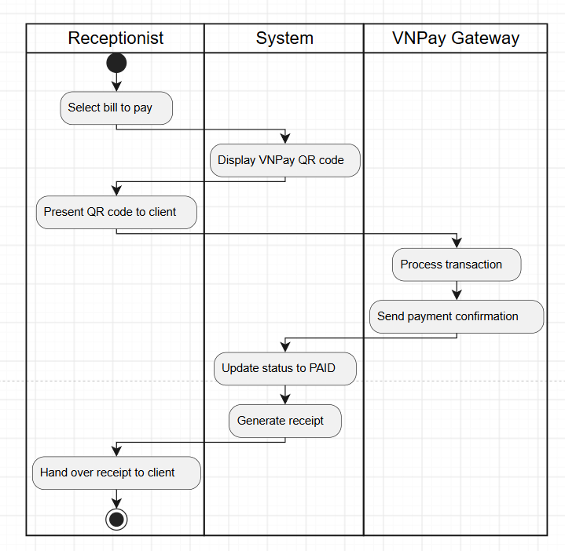

- Activity Workflow 10: Collect Cash Payment (UC-BILL-01b)
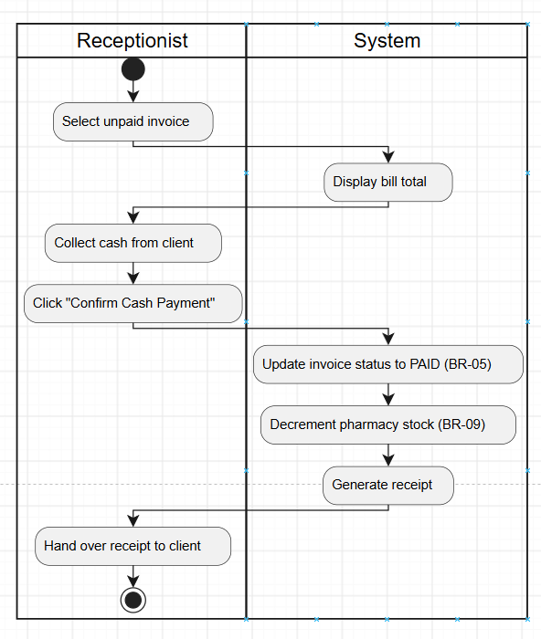

- Activity Workflow 11: View Invoice Detail (UC-BILL-02)
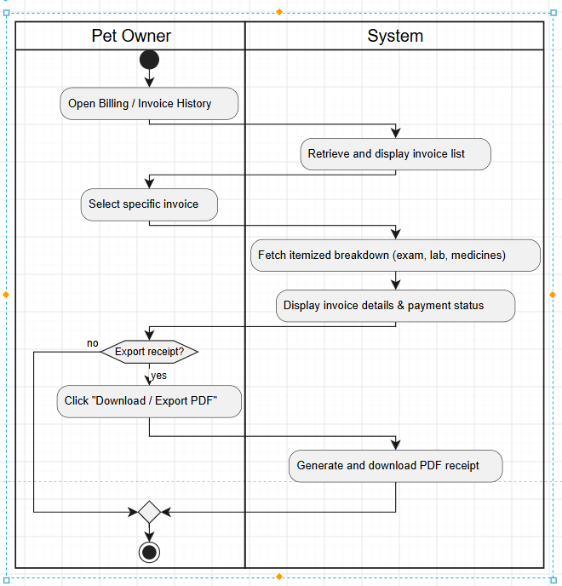

- Activity Workflow 12: Manage Weekly Shift Rosters (UC-HR-01)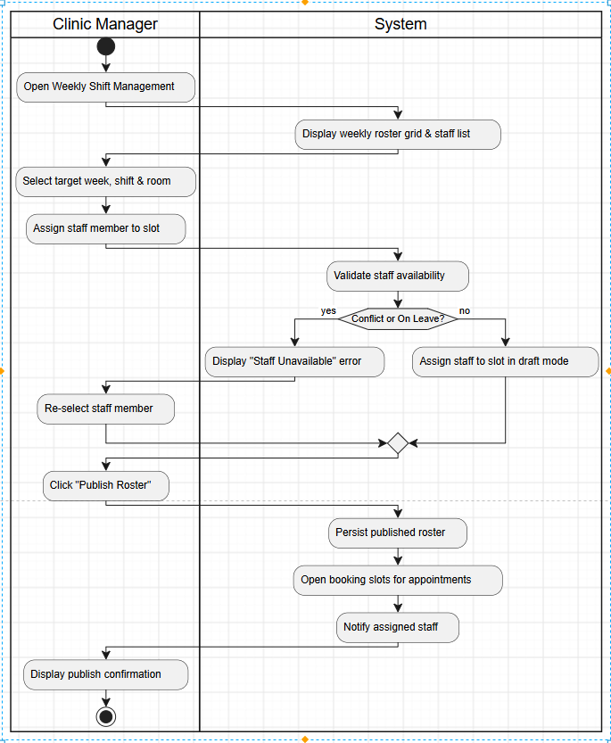

- Activity Workflow 13: Submit, Approve / Reject Staff Leave Request (HR-02, HR-03)
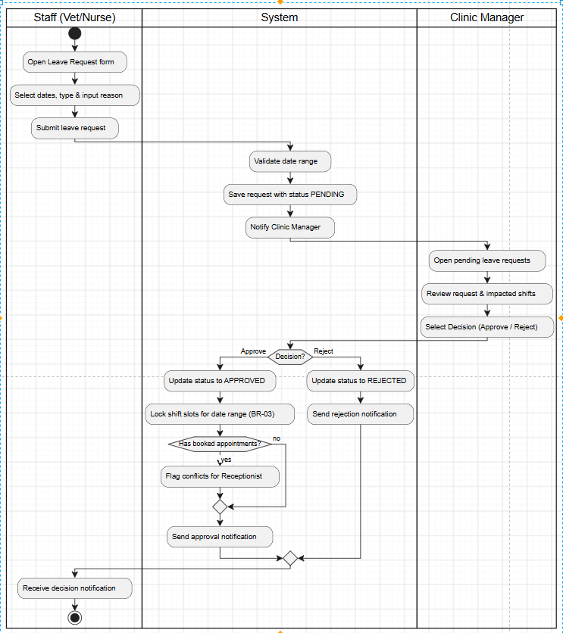

- Activity Workflow 14: Conduct Examination & EMR(EMR-01)
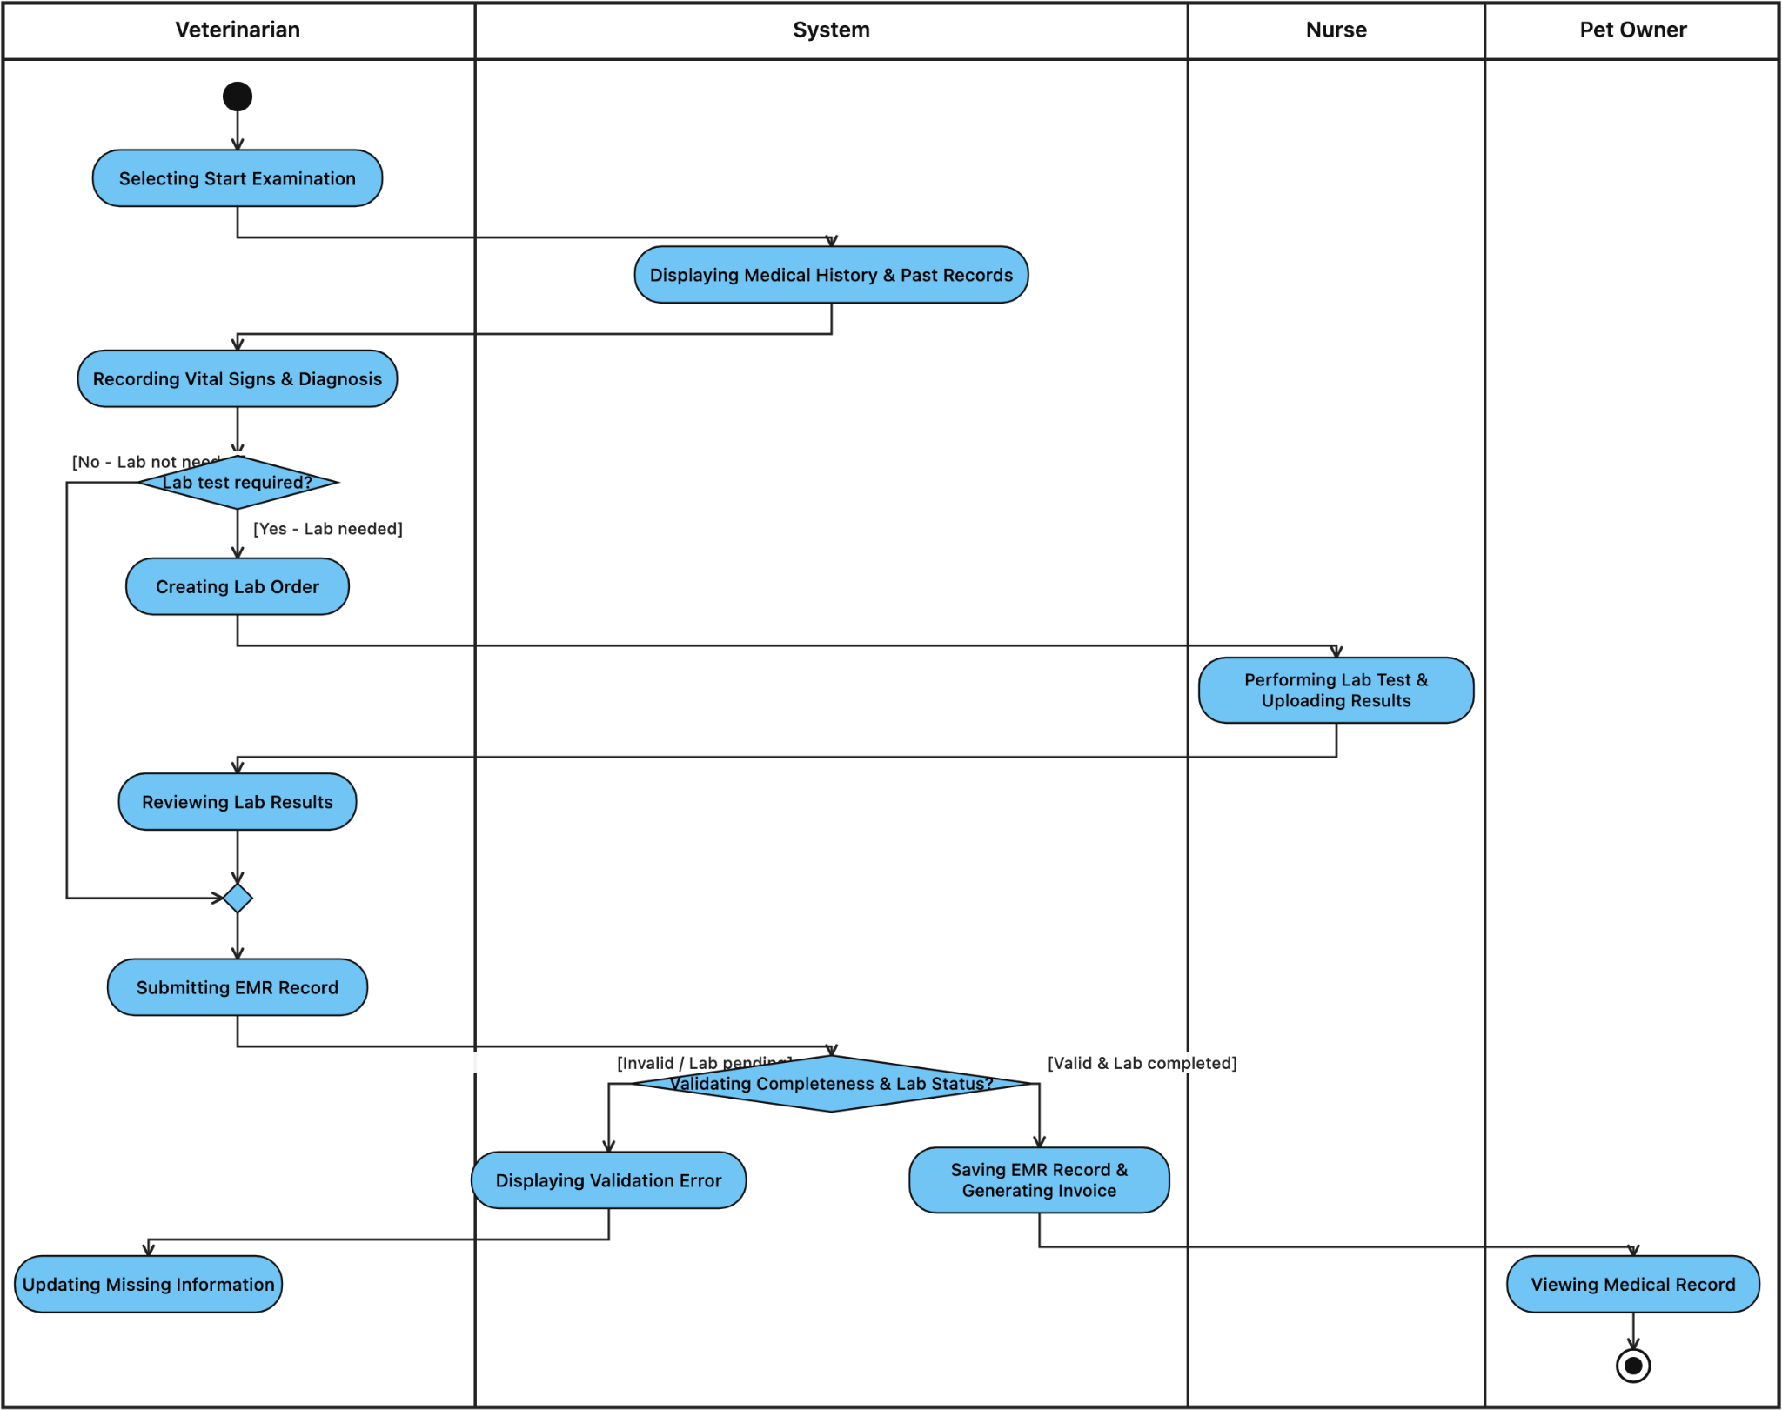

- Activity Workflow 15: View Medical Record List(EMR-02)
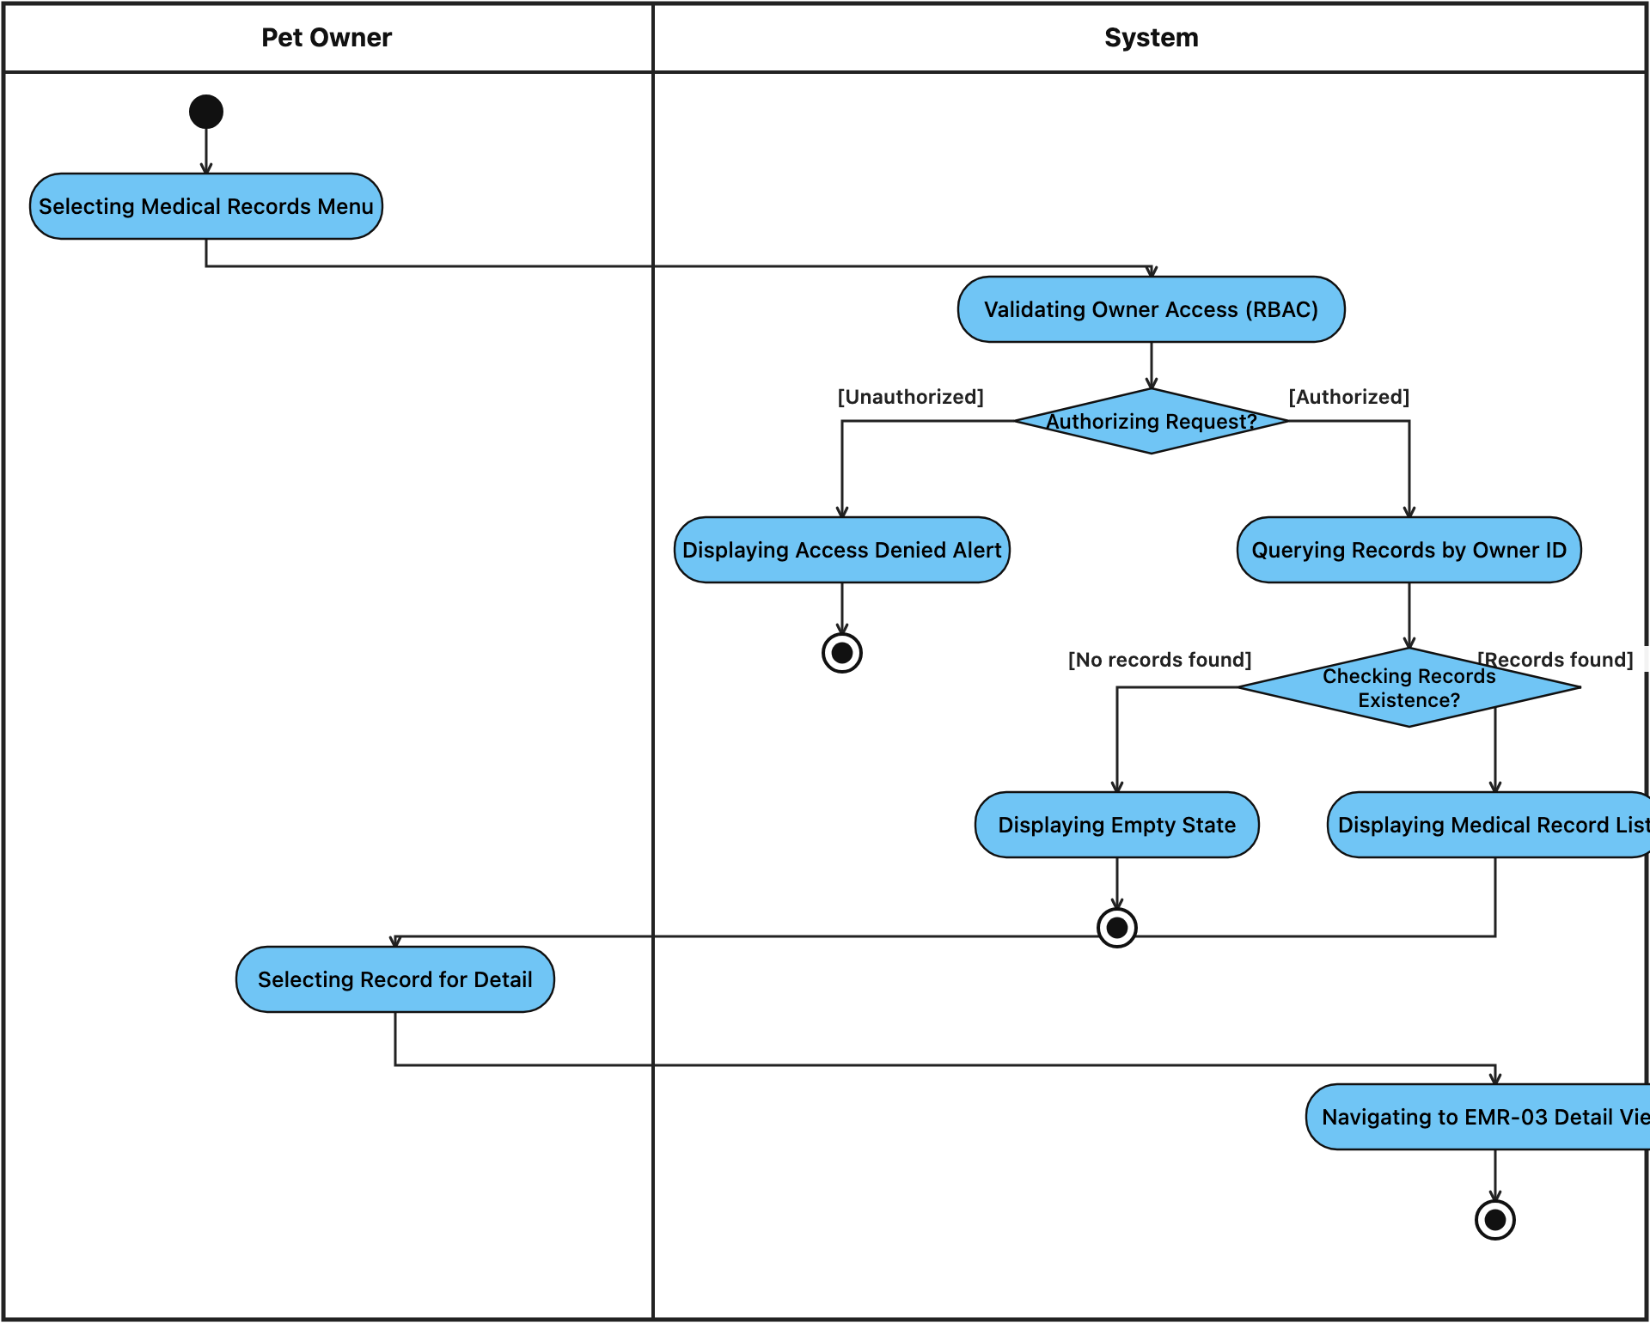
- Activity Workflow 16: View Medical Record Detail(EMR-03)
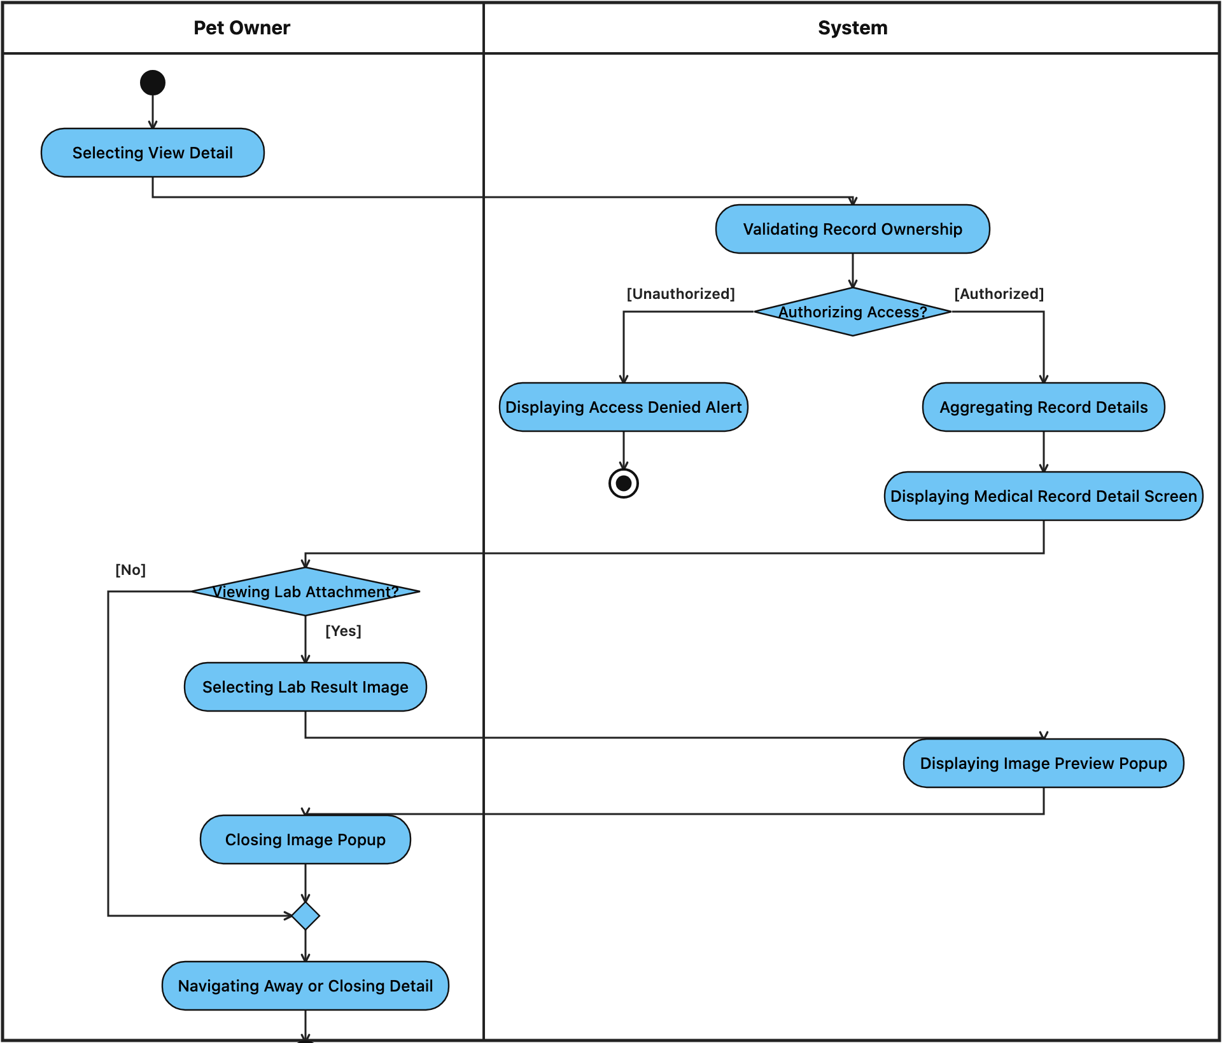

- Activity Workflow 17: Issue Paraclinical Lab Order(LAB-01)
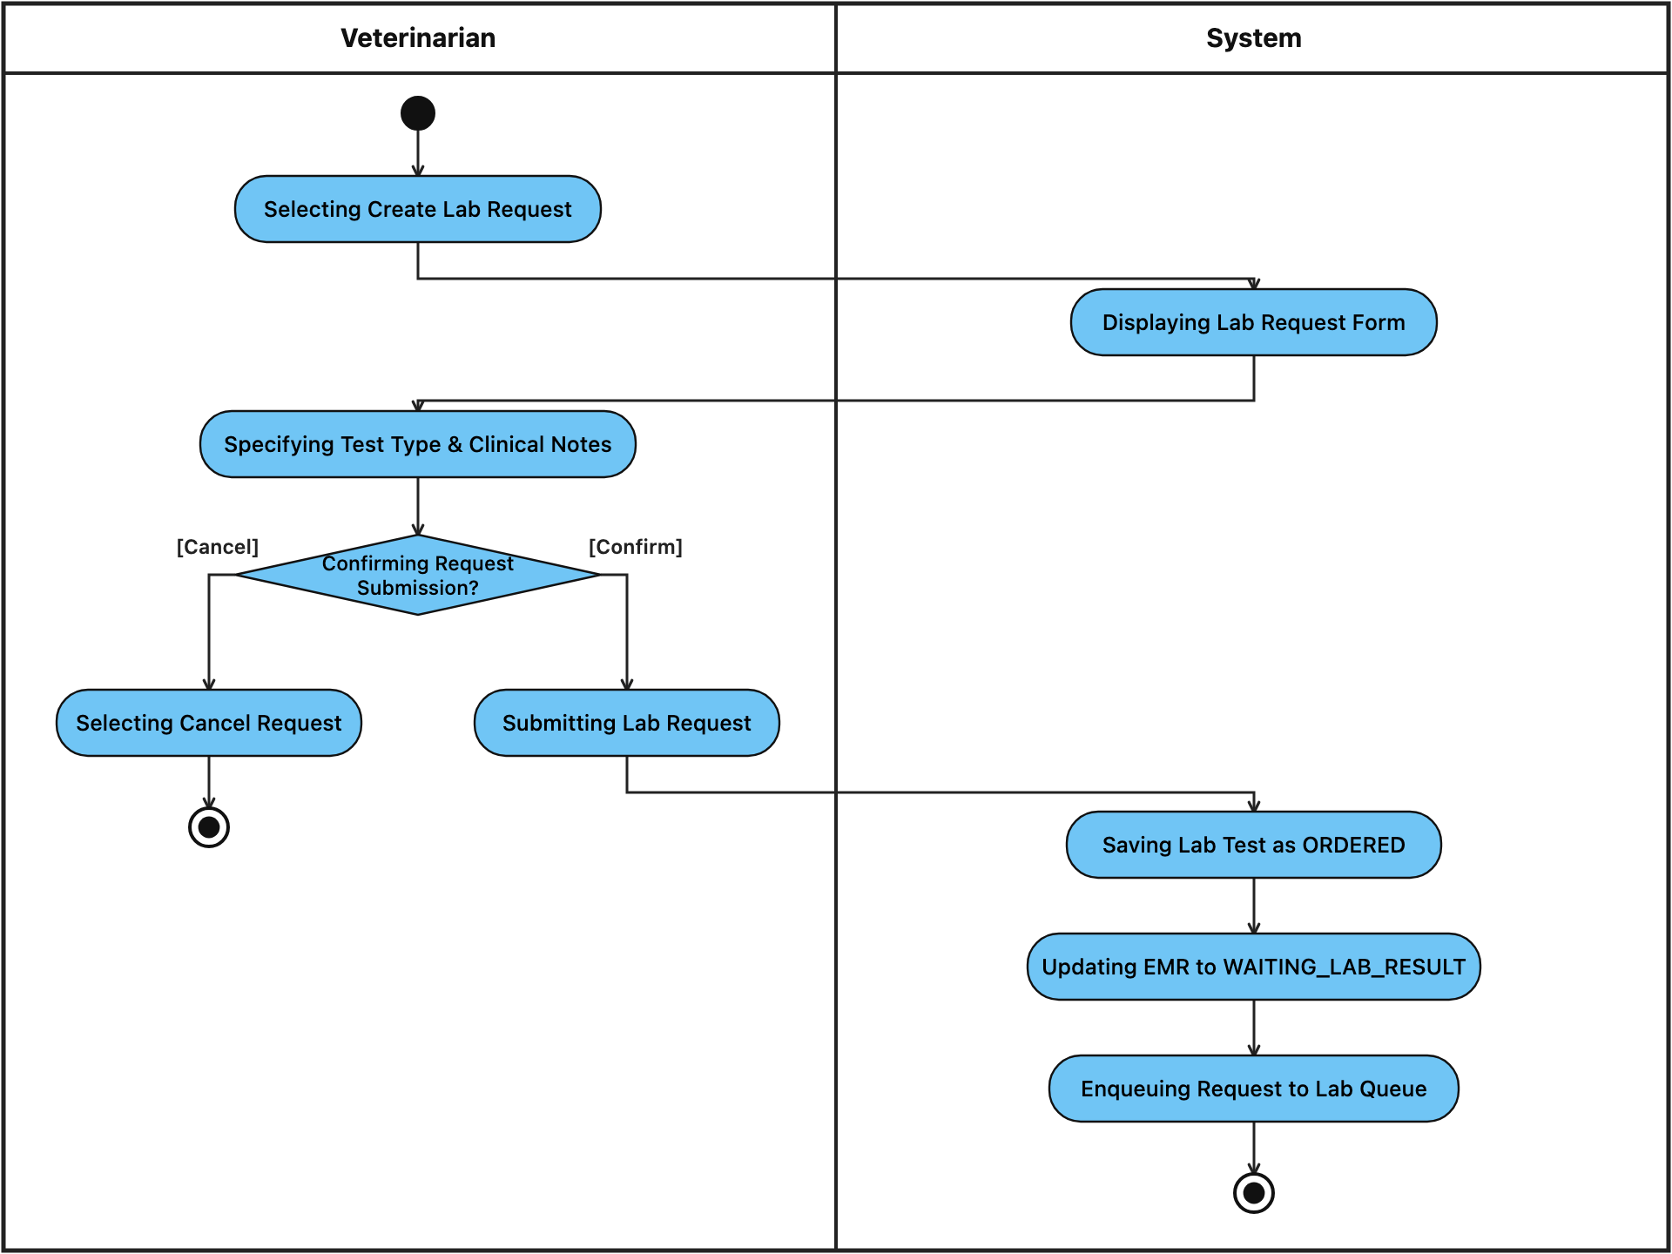

- Activity Workflow 18: Process Lab Order & Results(LAB-02)
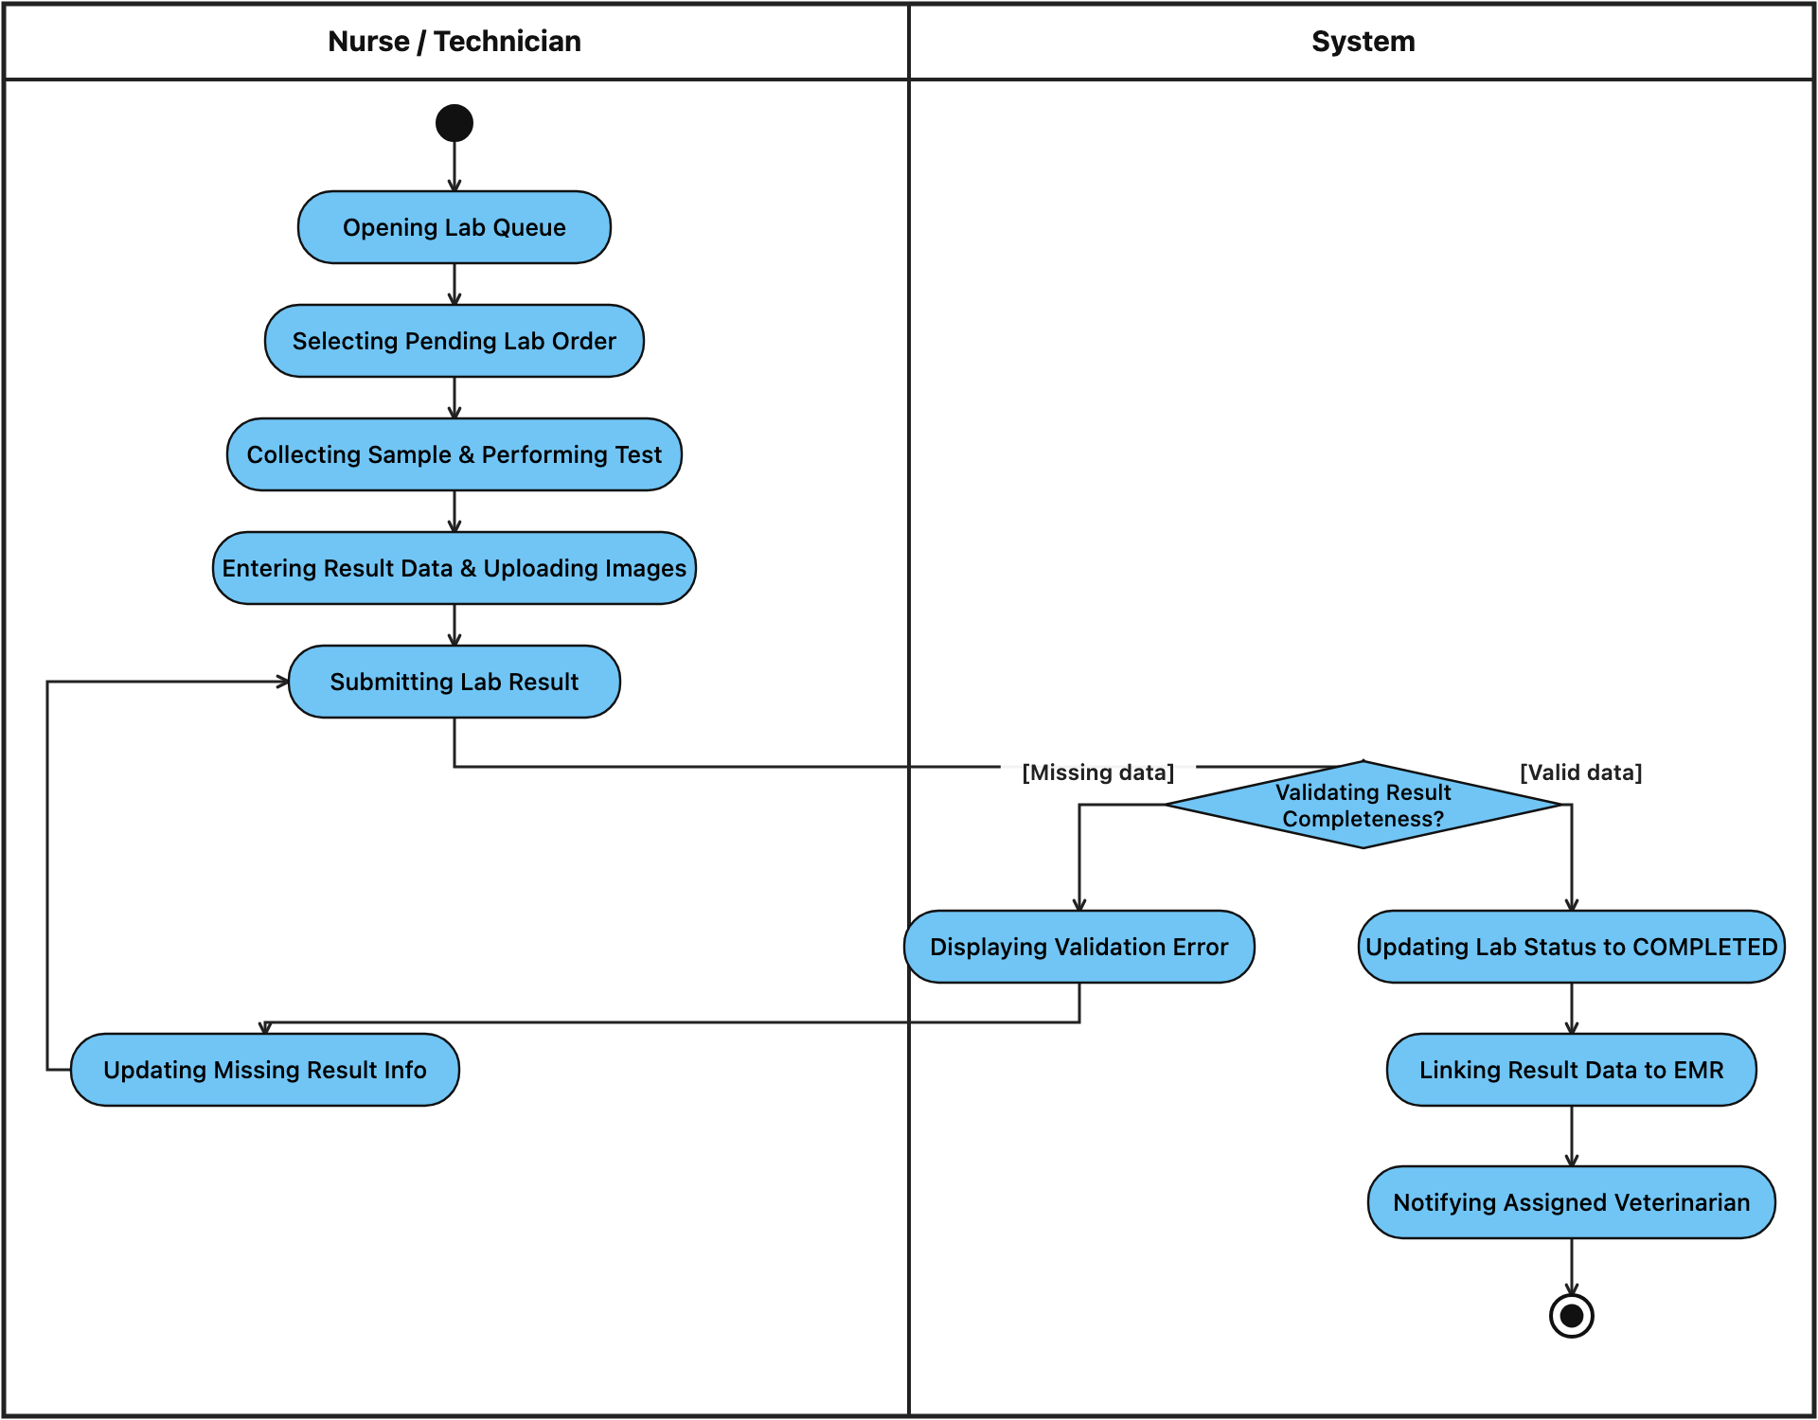

- Activity Workflow 19: Register Account (UC-AUTH-01)
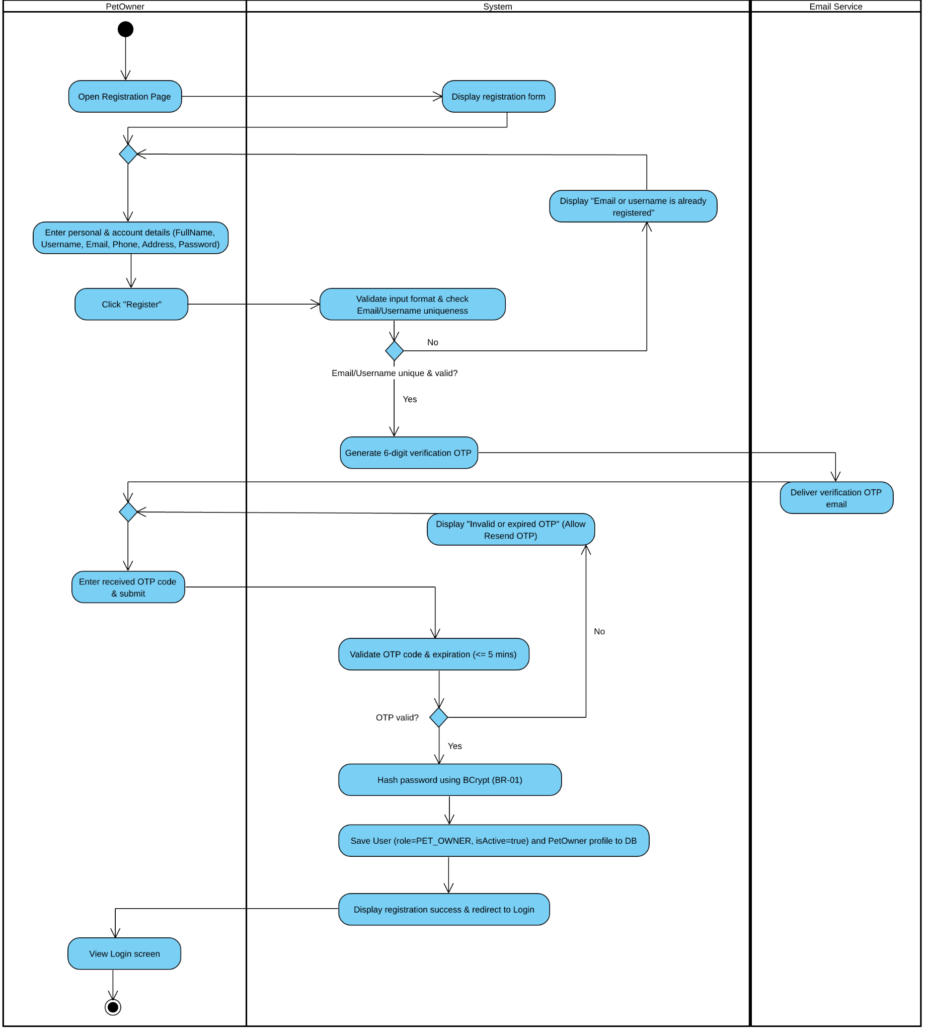

STEP | Actor | Activity/action | Note
1 | Pet Owner | Open Registration Page | Precondition: User is not logged into an active session.
2 | System | Display registration form | Renders fields for Full Name, Username, Email, Phone, Address, Password, and Confirm Password.
3 | Pet Owner | Enter personal & account details | Fills in mandatory registration fields and clicks "Register".
4 | System | Validate input & check uniqueness | Checks format validity and queries DB to ensure Email and Username are not already registered.
5 | System | Generate 6-digit verification OTP | Creates a time-limited 6-digit OTP code and triggers outbound email request.
6 | Email Service | Deliver verification OTP email | Sends the verification OTP to the Pet Owner's registered email address.
7 | Pet Owner | Enter received OTP code & submit | Inputs the 6-digit OTP on the verification screen (or clicks "Resend OTP" if delayed).
8 | System | Validate OTP code & expiration (≤5 mins) | Verifies whether the submitted 6-digit OTP matches the generated token and has not expired. If invalid, displays error and allows resending OTP.
9 | System | Hash password using BCrypt (BR-01) | Encrypts the plaintext password using BCrypt hashing algorithm (cost factor ≥10).
10 | System | Save User & PetOwner profile to DB | Persists a new User record (role = PET_OWNER, isActive = true) and a linked PetOwner profile into the database.
11 | Pet Owner | View Login screen | Postcondition: System displays registration success notification and redirects the Pet Owner to the Login page.

- Activity Workflow 20: Login / Logout (RBAC) (UC-AUTH-02)

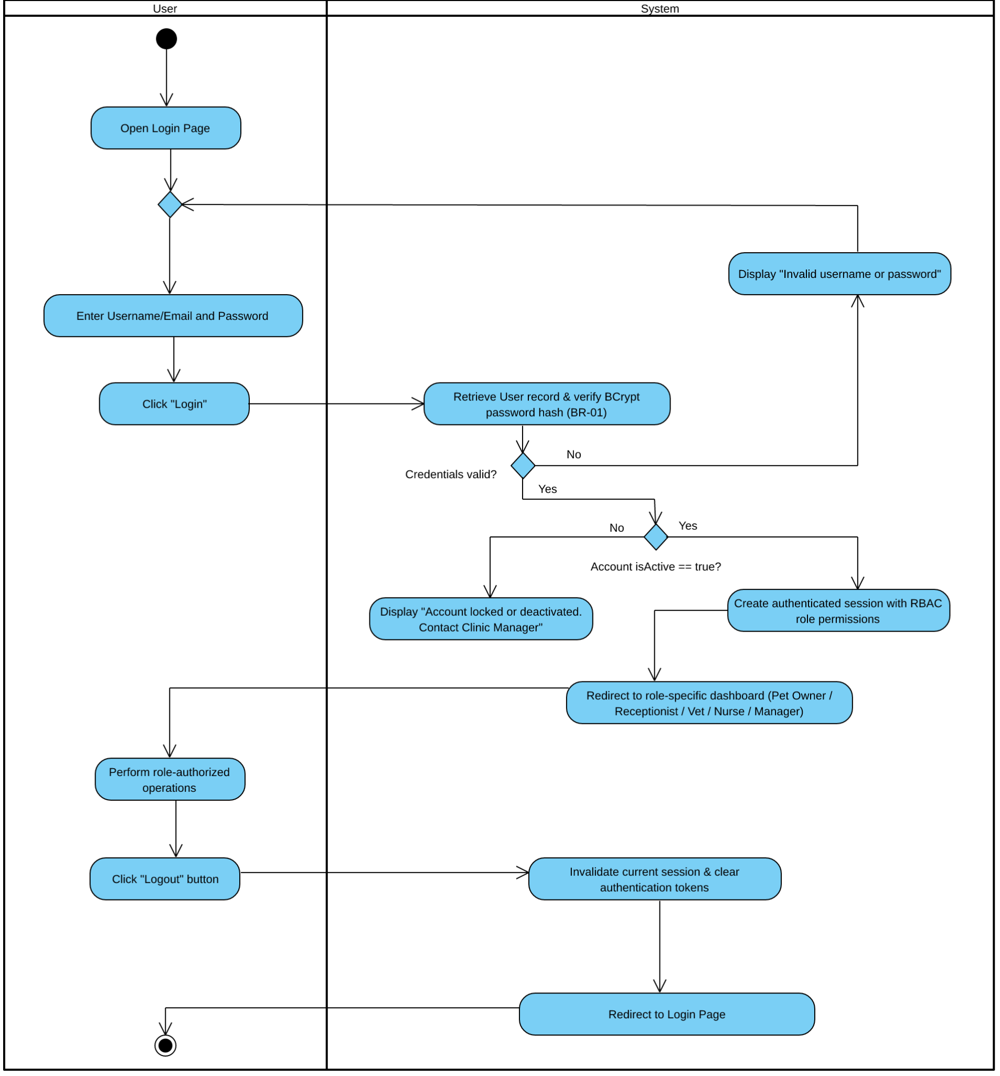

STEP | Actor | Activity/action | Note
1 | User | Open Login Page | Precondition: User has a registered account in PHMS.
2 | User | Enter Username/Email and Password | Submits login credentials (or selects "Forgot Password" to trigger UC-AUTH-03).
3 | System | Retrieve User & verify BCrypt hash | Queries User table and compares input password against stored BCrypt hash (BR-01).
4 | System | Verify account active status (isActive) | Checks if isActive == true. If false, blocks access and displays locked account alert.
5 | System | Create RBAC session & Redirect | Establishes session token and routes User to their role-specific workspace.
6 | User | Click "Logout" button | Initiates session termination when finished working.
7 | System | Invalidate session & clear tokens | Postcondition: Destroys active session and redirects User back to the Login screen.

- Activity Workflow 21: Reset Password via OTP (UC-AUTH-03)
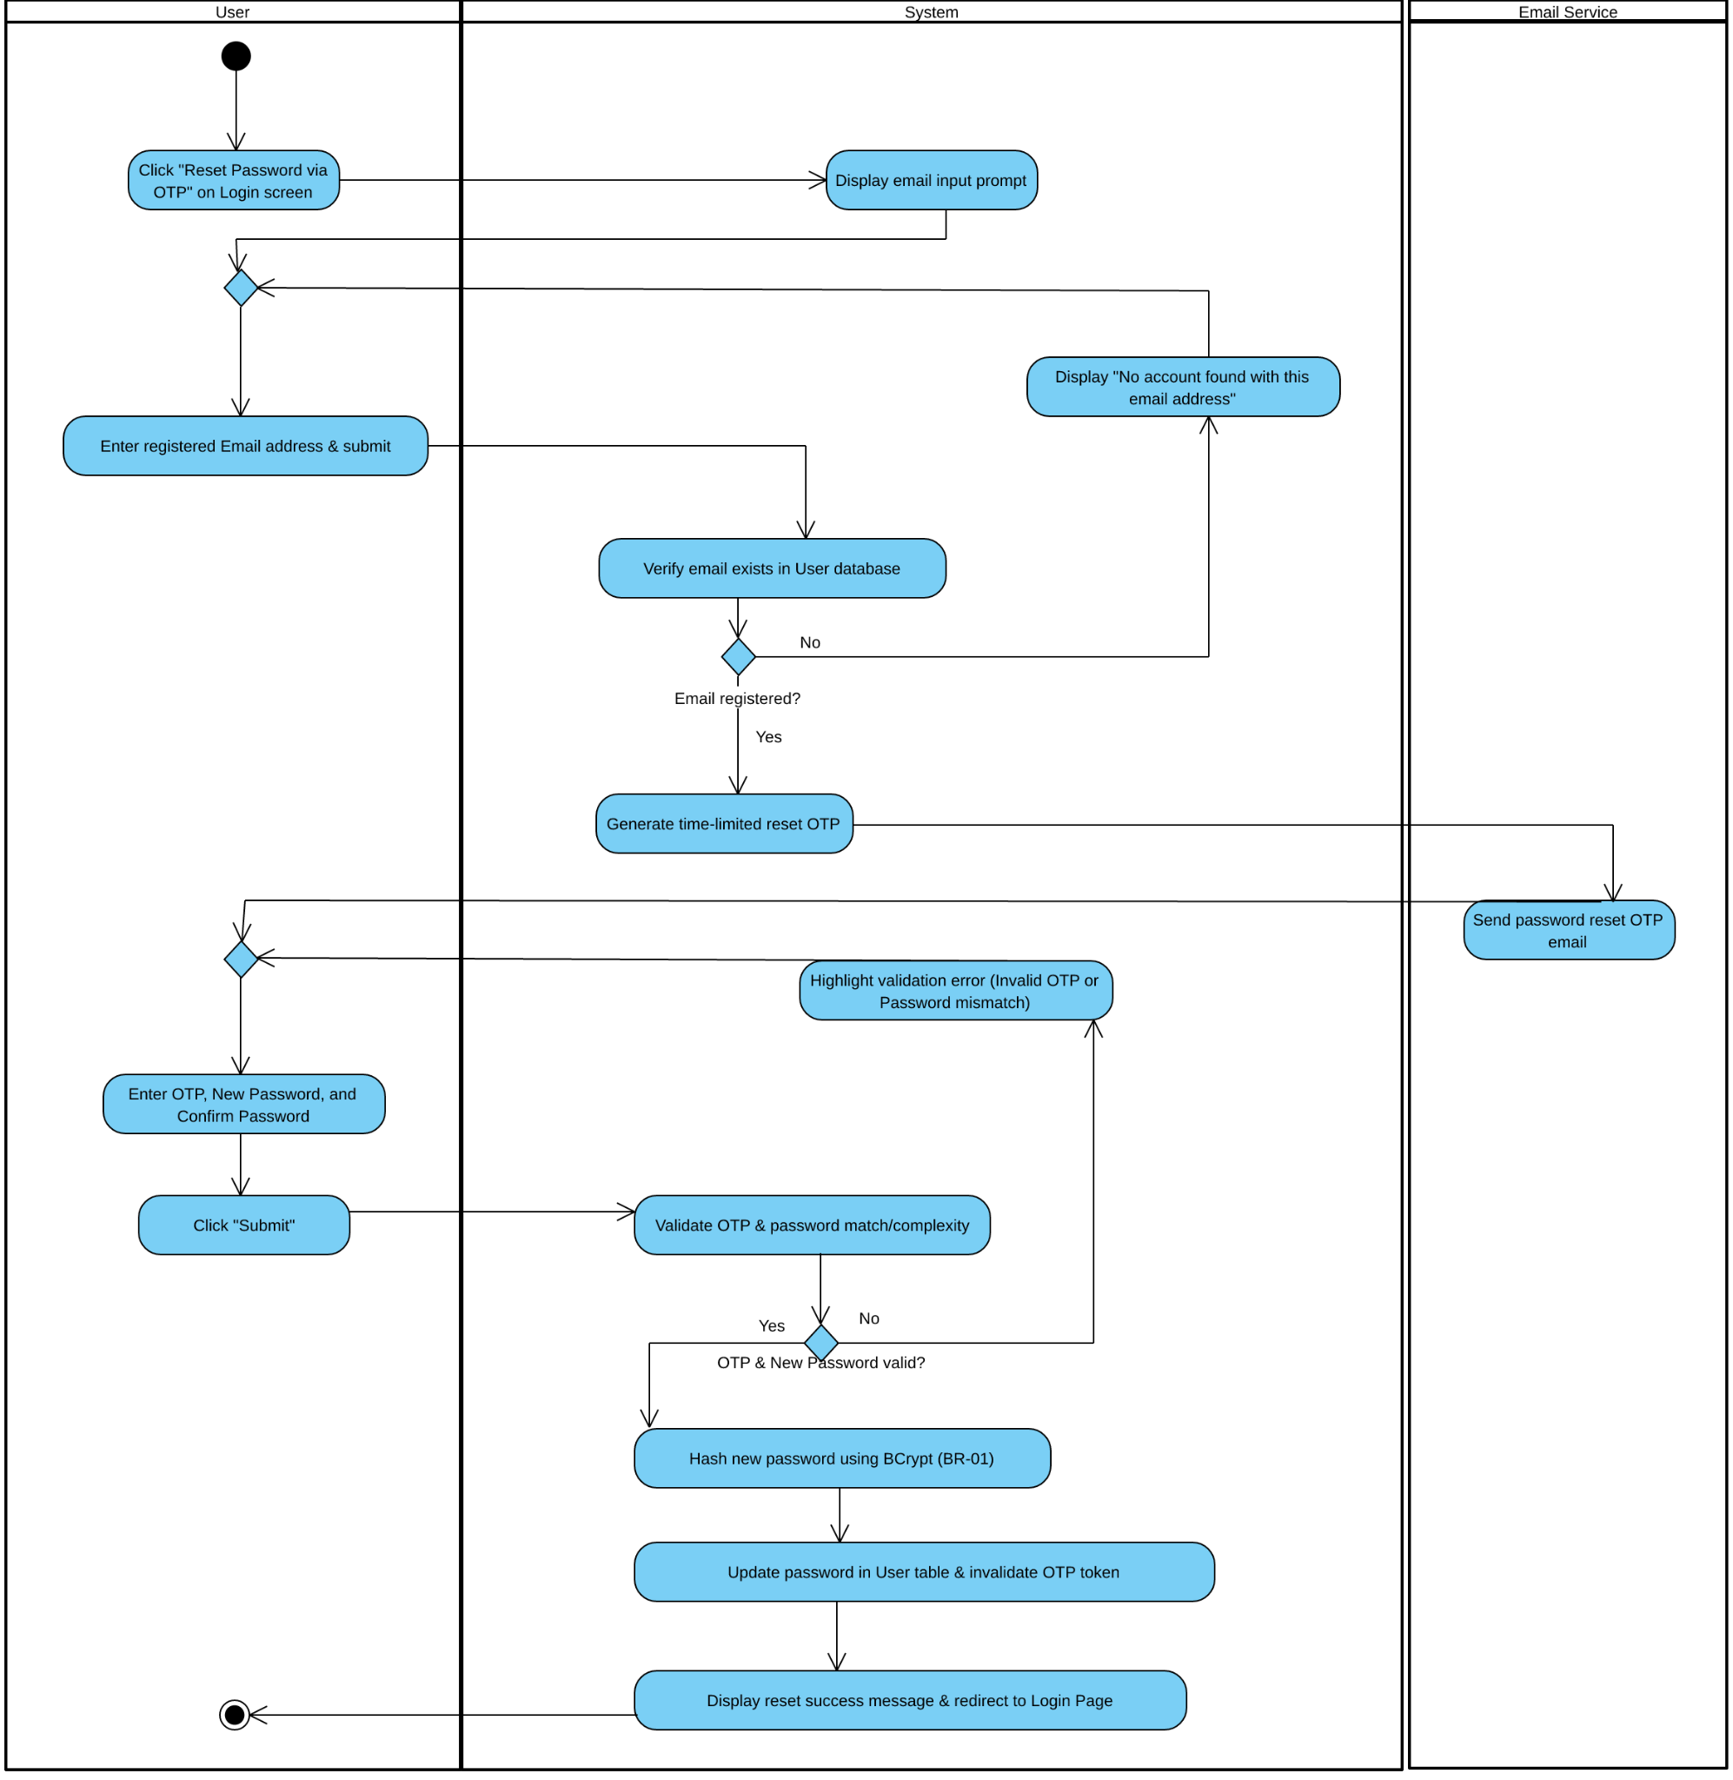

STEP | Actor | Activity/action | Note
1 | User | Click "Reset Password via OTP" | Triggered from the extension point on the Login screen.
2 | System | Display email input prompt | Prompts the user to enter their registered email address.
3 | User | Enter registered Email & submit | Submits the email associated with their account.
4 | System | Verify email & generate reset OTP | Confirms account existence, creates a time-limited OTP, and calls Email Service.
5 | Email Service | Send password reset OTP email | Delivers the OTP code to the user's email inbox.
6 | User | Enter OTP and New Password | Inputs the received OTP, New Password, and Confirm Password, then clicks "Submit".
7 | System | Validate OTP & password rules | Verifies OTP validity and ensures New Password matches Confirm Password.
8 | System | Hash new password & update DB | Postcondition: Hashes new credential via BCrypt (BR-01), updates User record, invalidates OTP, and redirects to Login.

- Activity Workflow 22: View Profile (UC-AUTH-04)
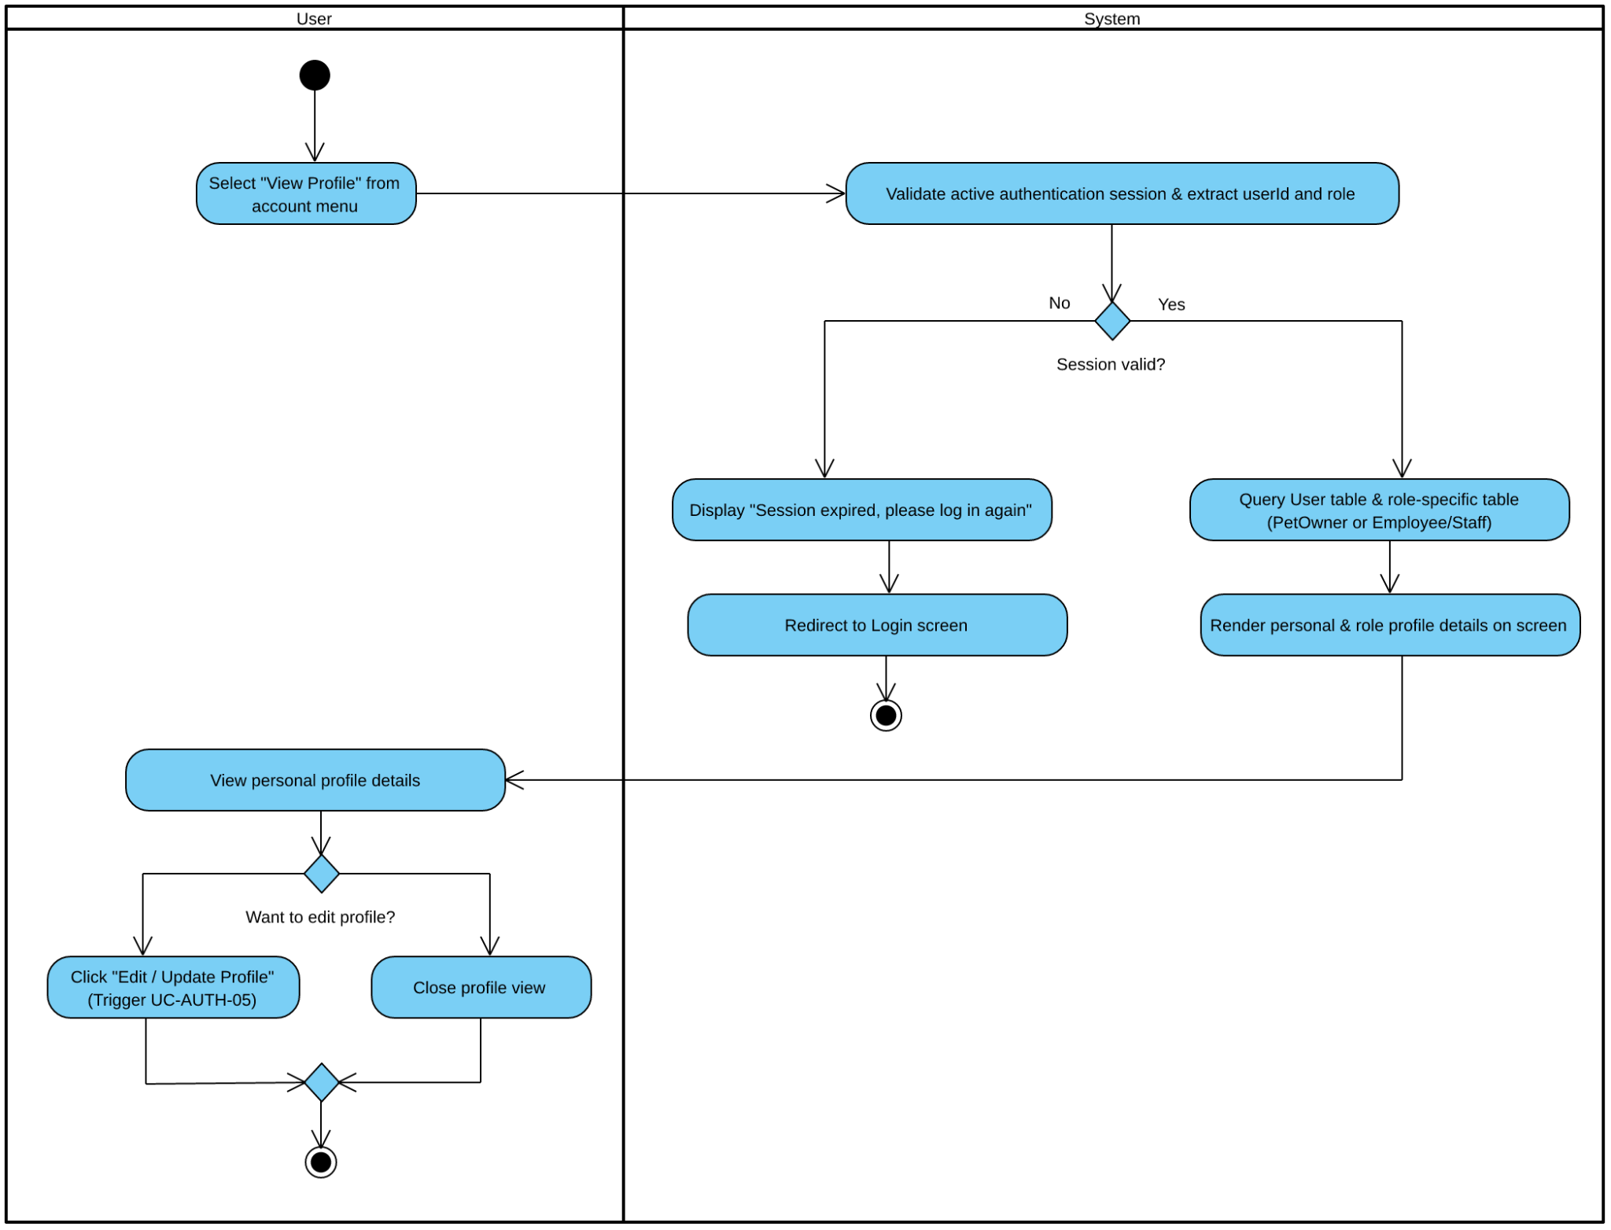

STEP | Actor | Activity/action | Note
1 | User | Select "View Profile" | Precondition: User is logged into an active authenticated session.
2 | System | Validate session & extract userId, role | Verifies session token validity. If expired, redirects to Login screen.
3 | System | Query User & role-specific tables | Fetches data from User and PetOwner (for clients) or Employee/Veterinarian/Nurse/Receptionist/ClinicManager (for staff).
4 | System | Render profile details on screen | Displays Full Name, Username, Role, Phone, Email/Address, or Employee Code/Department.
5 | User | View personal profile details | Postcondition: Reviews profile information (optionally clicks "Edit / Update Profile" to trigger UC-AUTH-05).

- Activity Workflow 23: Update Profile (UC-AUTH-05)

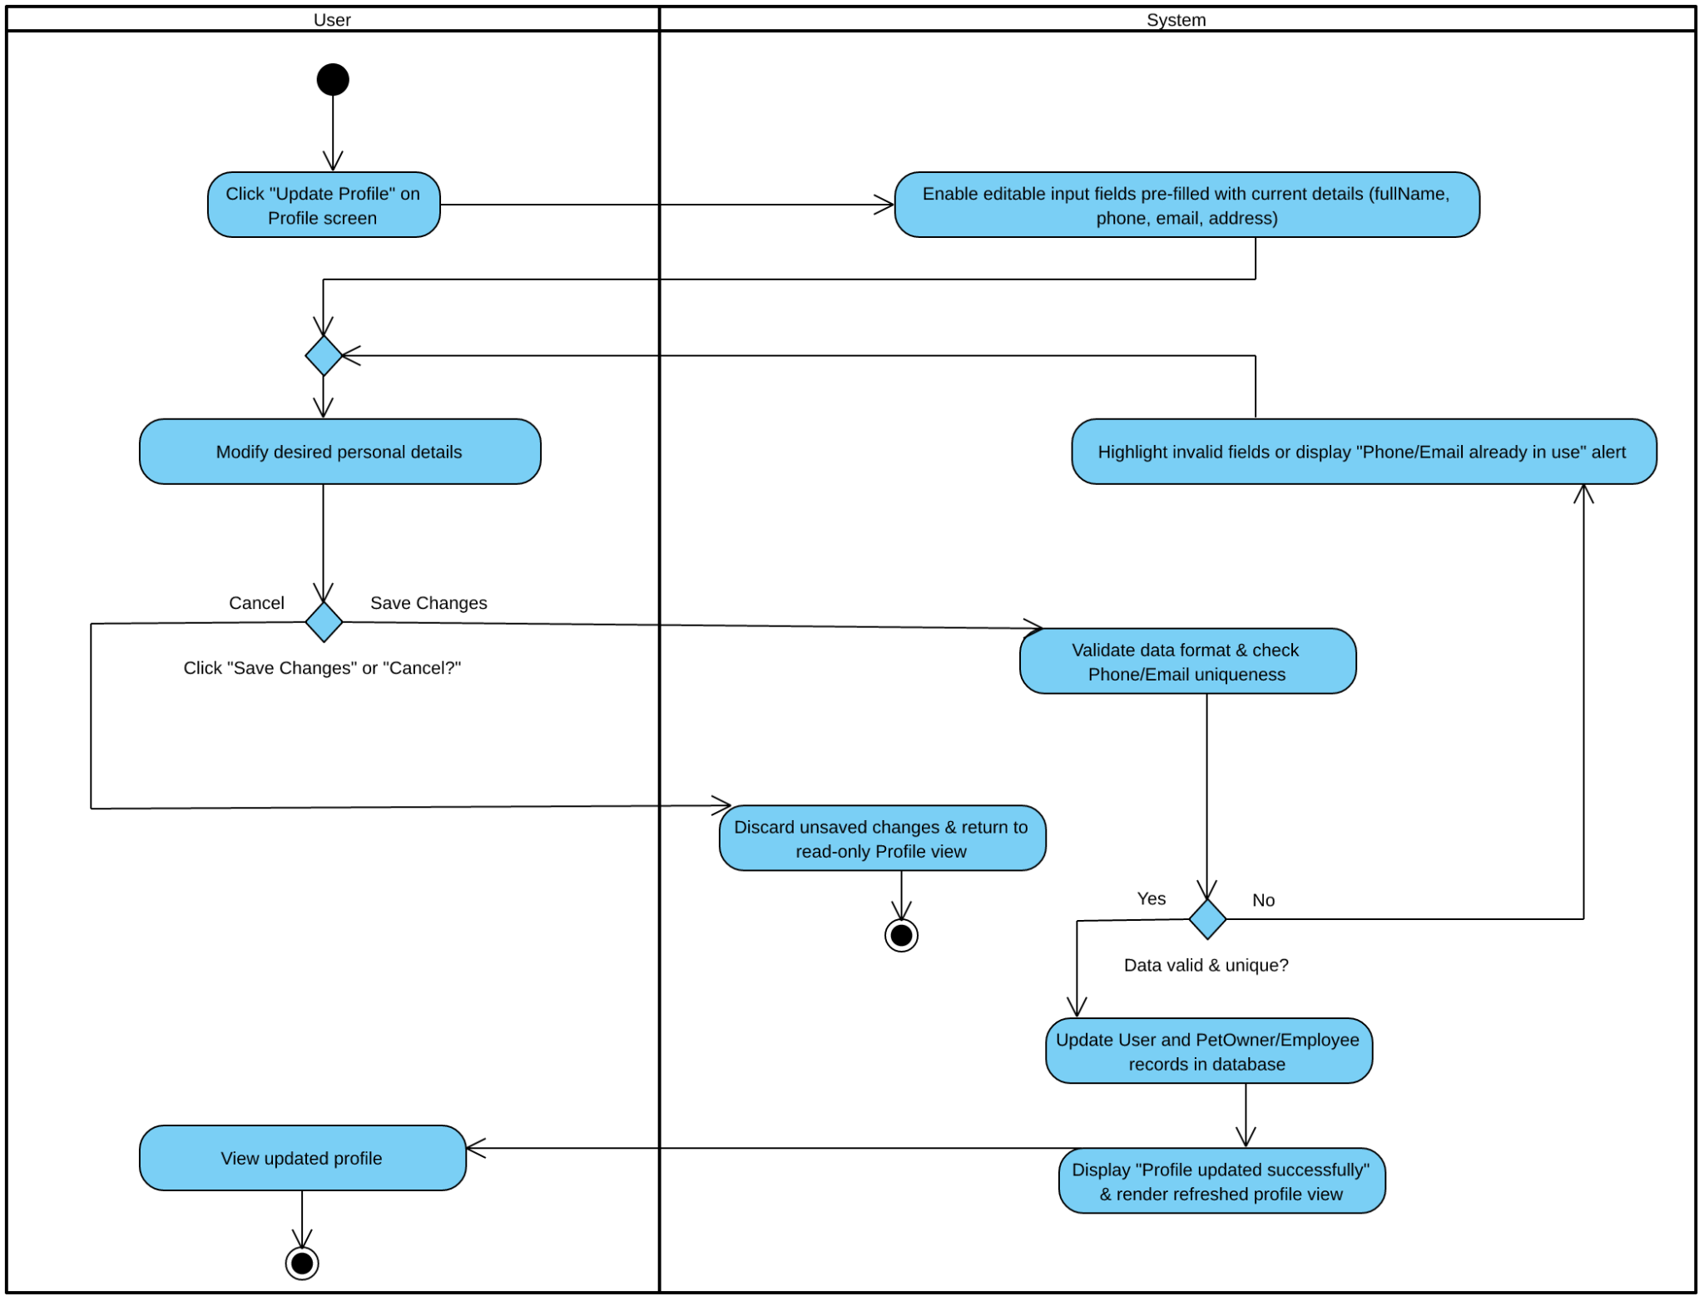

STEP | Actor | Activity/action | Note
1 | User | Click "Update Profile" | Precondition: User is authenticated and viewing their profile (UC-AUTH-04).
2 | System | Enable editable input fields | Pre-fills form with current fullName, phone, email, and address (RBAC role and empCode remain read-only).
3 | User | Modify details & click "Save Changes" | Edits personal contact details and submits (or clicks "Cancel" to discard changes).
4 | System | Validate format & Phone/Email uniqueness | Checks mandatory fields, Vietnamese phone format, and ensures updated Phone/Email does not conflict with another account.
5 | System | Update database records | Persists changes into User and PetOwner/Employee tables.
6 | System | Display confirmation & refresh view | Shows "Profile updated successfully" message and renders updated profile.
7 | User | View updated profile | Postcondition: Updated personal details are saved and displayed.

III. Analysis models.

III.1. High-level class diagram (structural models)

Entity class diagram mức đặc tả - 1 sơ đồ
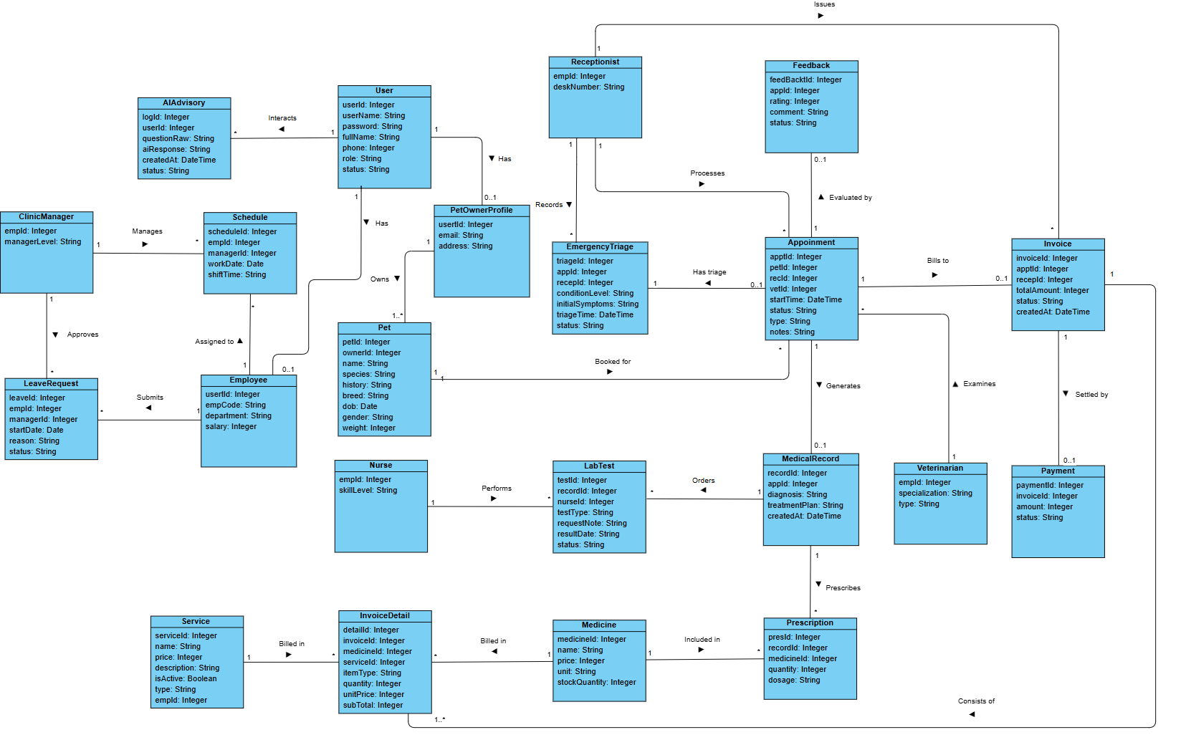

ID | Entity | Attributes | Association | Description
01 | User | userId: Integer, userName: String, password: String, fullName: String, phone: Integer, role: String, isActive: boolean | • 1 to * with AIChatLog (Interacts)  • 1 to 0..1 with PetOwner (Has)  • 1 to 0..1 with Employee (Has) | Stores core authentication credentials, personal profile details, account status, and role-based access control (RBAC) permissions for all system users.
02 | AIChatLog | logId: Integer (PK), userId: Integer (FK, Ref: User), petId: Integer (FK, Ref: Pet, Allow Null), questionRaw: Text, aiResponse: Text, createdAt: DateTime | • * to 1 with User (Interacts)  • * to 0..1 với Pet (Relates to) | Logs natural-language pet health queries submitted by users and the corresponding automated advisory responses generated by the Gemini AI Chatbot.
03 | PetOwner | userId: Integer, email: String, address: String | • 0..1 to 1 with User (Has)  • 1 to 1..* with Pet (Owns) | Represents external clients (pet owners) registered in the system, storing contact email and residential address details.
04 | Pet | petId: Integer, ownerId: Integer, name: String, species: String, history: String, breed: String, dob: Date, gender: String, weight: Integer | • 1..* to 1 with PetOwner (Owns)  • 1 to * with Appointment (Booked for) | Stores comprehensive profile information, physical characteristics, and medical history of pets belonging to pet owners.
05 | Employee | userId: Integer, empCode: String, department: String, salary: Integer | • 0..1 to 1 with User (Has)  • 1 to * with Schedule (Assigned to)  • 1 to * with LeaveRequest (Submits)  • Base entity for ClinicManager, Receptionist, Veterinarian, Nurse | Represents internal hospital staff members, tracking employee codes, assigned clinical departments, and salary data.
06 | ClinicManager | empId: Integer, managerLevel: String | • 1 to * with Schedule (Manages)  • 1 to * with LeaveRequest (Approves) | Represents administrative clinic managers responsible for overseeing staff duty rosters, approving leave requests, and managing catalogs.
07 | Receptionist | empId: Integer, deskNumber: String | • 1 to * with TriageRecord (Records)  • 1 to * with Appointment (Processes)  • 1 to * with Invoice (Issues) | Represents front-desk personnel who handle appointment queues, customer check-ins, walk-in emergency triage intake, and billing.
08 | Veterinarian | empId: Integer, specialization: String, type: String | • 1 to * with Appointment (Examines) | Represents licensed veterinary doctors who conduct physical examinations, diagnose conditions, order lab tests, and prescribe treatments.
09 | Nurse | empId: Integer, skillLevel: String | • 1 to * with LabTest (Performs) | Represents veterinary nurses and laboratory technicians responsible for executing paraclinical lab procedures and uploading test results.
10 | Schedule | scheduleId: Integer, empId: Integer, managerId: Integer, workDate: Date, shiftTime: String | • * to 1 with ClinicManager (Manages)  • * to 1 with Employee (Assigned to) | Manages weekly duty shift assignments for clinic personnel across designated working dates and shift time slots.
11 | LeaveRequest | leaveId: Integer, empId: Integer, managerId: Integer, startDate: Date, reason: String, status: String | • * to 1 with Employee (Submits)  • * to 1 with ClinicManager (Approves) | Tracks staff absence and leave applications, storing leave start dates, reasons, and approval statuses (Pending, Approved, Rejected).
12 | Appointment | apptId: Integer, petId: Integer, recId: Integer, vetId: Integer, startTime: DateTime, status: String, type: String, notes: String | • * to 1 with Pet (Booked for)  • * to 1 with Receptionist (Processes)  • * to 1 with Veterinarian (Examines)  • 1 to 0..1 with TriageRecord (Has triage)  • 1 to 0..1 with Feedback (Evaluated by)  • 1 to 0..1 with MedicalRecord (Generates)  • 1 to 0..1 with Invoice (Bills to) | Central scheduling entity that coordinates outpatient bookings and walk-in visits between pets, receptionists, and veterinarians.
13 | TriageRecord | triageId: Integer, appId: Integer, recepId: Integer, conditionLevel: String, initialSymptoms: String, triageTime: DateTime | • * to 1 with Receptionist (Records)  • 0..1 to 1 with Appointment (Has triage) | Captures emergency intake assessments for critical walk-in patients, recording severity levels (Level 1–3) and initial symptoms to prioritize queues.
14 | Feedback | feedBackId: Integer, appId: Integer, rating: Integer, comment: String, status: String | • 0..1 to 1 with Appointment (Evaluated by) | Stores post-visit customer satisfaction ratings and qualitative review comments submitted by pet owners for completed appointments.
15 | MedicalRecord | recordId: Integer, appId: Integer, diagnosis: String, treatmentPlan: String, createdAt: DateTime | • 0..1 to 1 with Appointment (Generates)  • 1 to * with LabTest (Orders)  • 1 to * with Prescription (Prescribes) | Represents the Electronic Medical Record (EMR) generated during a clinical consultation, documenting formal diagnoses and treatment plans.
16 | LabTest | testId: Integer, recordId: Integer, nurseId: Integer, testType: String, requestNote: String, resultDate: String, status: String | • * to 1 with MedicalRecord (Orders)  • * to 1 with Nurse (Performs) | Tracks paraclinical laboratory diagnostic requests ordered by veterinarians and processed by nurses, including test types, notes, and completion status.
17 | Prescription | presId: Integer, recordId: Integer, medicineId: Integer, quantity: Integer, dosage: String | • * to 1 with MedicalRecord (Prescribes)  • * to 1 with Medicine (Included in) | Stores medication orders linked to a medical record, specifying the prescribed drug, dispensed quantity, and administration dosage instructions.
18 | Medicine | medicineId: Integer, name: String, price: Integer, unit: String, stockQuantity: Integer | • 1 to * with Prescription (Included in)  • 1 to * with InvoiceDetail (Billed in) | Manages the hospital pharmacy catalog, tracking medication names, dispensing units, unit prices, and real-time inventory stock levels.
19 | ServiceList | serviceId: Integer, name: String, price: Integer, description: String, isActive: boolean, type: String, empId: Integer | • 1 to * with InvoiceDetail (Billed in) | Maintains the catalog of clinical, grooming, and diagnostic services offered by the hospital, including pricing and active availability status.
20 | Invoice | invoiceId: Integer, apptId: Integer, recepId: Integer, totalAmount: Integer, status: String, createdAt: DateTime | • 0..1 to 1 with Appointment (Bills to)  • * to 1 with Receptionist (Issues)  • 1 to 1..* with InvoiceDetail (Consists of)  • 1 to 0..1 with Payment (Settled by) | Represents the master billing statement generated for an appointment, consolidating all service and medication charges with payment status tracking.
21 | InvoiceDetail | detailId: Integer, invoiceId: Integer, medicineId: Integer, serviceId: Integer, itemType: String, quantity: Integer, unitPrice: Integer, subTotal: Integer | • 1..* to 1 with Invoice (Consists of)  • * to 1 with Medicine (Billed in)  • * to 1 with ServiceList (Billed in) | Stores individual line items within an invoice, detailing the specific clinical service or medication billed, quantity, unit price, and subtotal.
22 | Payment | paymentId: Integer, invoiceId: Integer, amount: Integer | • 0..1 to 1 with Invoice (Settled by) | Records financial settlement transactions (via counter cash or VNPay/VietQR online gateway) against an issued invoice.

III.1.1. Describe the object lifecycle

1.1.1 Entity: User (Core entity for UC-AUTH-01, UC-AUTH-02, UC-AUTH-03, UC-AUTH-04, UC-AUTH-05)

Field | Value
Purpose | Represents an authenticated system identity across all role types (Pet Owner, Receptionist, Veterinarian, Nurse, Clinic Manager), providing cryptographic authentication, role-based access control (RBAC), and security policy enforcement.
Key business attributes | userId, userName, password (BCrypt hash), fullName, phone, role (PET_OWNER, RECEPTIONIST, VETERINARIAN, NURSE, CLINIC_MANAGER), isActive (boolean account flag), linked email and address (from PetOwner), linked empCode and department (from Employee).
Business identity | userName and email must each be globally unique across all system accounts (enforced by unique database constraints and BR-01). phone is unique per user profile.
Status / lifecycle | Unverified (initial registration via OTP; 5-minute TTL) → Active (OTP verified, permitted to authenticate, view/update profile; cycles between LoggedOut, AuthenticatedSession, and PasswordResetPending) ↔ Suspended / Locked (administrative suspension by Clinic Manager or security block; isActive = false, authentication blocked with HTTP 403 Forbidden) → Terminated (terminal - account closure, soft-delete, and PII anonymization).

1.1.2 Entity: TriageRecord (Core entity for UC-EMG-01: Emergency Triage)

Field | Value
Purpose | Captures clinical triage assessments for unscheduled walk-in emergency patients, recording condition severity levels and initial acute symptoms to enforce priority queue overriding (BR-04)..
Key business attributes | triageId (PK), appId (FK referencing Appointment), recepId (FK referencing Receptionist), conditionLevel (LEVEL_1_CRITICAL, LEVEL_2_URGENT, LEVEL_3_STANDARD), initialSymptoms (textual description), triageTime (timestamp).
Business identity | triageId is the synthetic primary key; appId is unique per TriageRecord (1-to-0..1 relationship with Appointment), ensuring each emergency encounter has exactly one authoritative triage record.
Status / lifecycle | TriageInitiated (Receptionist opens walk-in emergency intake and records symptoms) → QueuedByPriority (triage persisted; Level 1 routed to position #1, Level 2 queued after active patient with 15-min SLA, Level 3 placed in FIFO with 30-min vital re-check reminder) → Escalated (optional transition if a Level 2/3 patient deteriorates during waiting and is upgraded to Level 1) → HandedOffToVet (terminal for triage phase — on-duty Veterinarian accepts case and transitions appointment to IN_EXAMINATION).

1.1.3 Entity: Appointment (Emergency & Clinical Visits)

Field | Value
Purpose | Represents a scheduled or emergency clinical consultation encounter between a Pet Owner's registered Pet, a duty Veterinarian, and a Receptionist, coordinating clinic queue allocation, medical examination, and invoicing.
Key business attributes | appId, petId, recId, vetId, startTime, status, type (EMERGENCY or ROUTINE), notes (clinical observations / chief complaint).
Business identity | appId is the synthetic PK. A single Pet can have at most one active non-terminal Appointment in the same time window.
Status / lifecycle | Draft / Intake (intake details entered) → EMERGENCY_WAITING (inserted at top of Vet priority queue for emergency triage) → IN_EXAMINATION (vet initiates clinical encounter and vital monitoring) → COMPLETED (terminal - examination finished, medical record written, invoice generated) or CANCELLED (terminal - owner cancellation or administrative void) or NO_SHOW (terminal - patient failed to arrive within scheduled threshold).

1.1.4 Entity: AIChatLog (Core entity for UC-AI-01: Consult Gemini AI Advisor)

Field | Value
Purpose | Preserves a persistent audit log of automated 24/7 natural-language pet health symptom consultations between Pet Owners and the Google Gemini Chatbot API, maintaining clinical context and tracking SLA response times.
Key business attributes | logId, userId (FK to User), questionRaw (user input symptom query), aiResponse (Gemini-generated guidance or system fallback message), createdAt (timestamp).
Business identity | logId is the synthetic PK. Multiple logs per userId are ordered sequentially by createdAt.
Status / lifecycle | QueryDrafted (user inputs symptom query on UI; client-side length and non-blank validation) → ContextEnriching (system retrieves owner's pet profiles and past medical history from DB) → AwaitingGeminiResponse (structured prompt dispatched to Google Gemini API over HTTPS; 8-second watchdog timer active per NF-01) → ResponsePersisted (terminal - AI guidance received within 8s, persisted to database, and displayed) or FallbackHandled (terminal - API timeout > 8s or 5xx error; fallback message with emergency clinic hotline logged and displayed).

1.1.5 Entity: Invoice (Core entity for UC-BILL-01a, UC-BILL-01b, UC-BILL-02)

Field | Value
Purpose | Represents the master billing statement generated for a clinical encounter, consolidating consultation fees, diagnostic test costs, and prescribed medications to track payment execution and inventory deduction.
Key business attributes | invoiceId (PK), apptId (FK), recepId (FK), totalAmount, status (UNPAID, PAID, REFUNDED), createdAt.
Business identity | invoiceId is the synthetic PK. apptId is unique per Invoice (1-to-0..1 relationship with Appointment), ensuring each medical encounter generates exactly one authoritative billing invoice.
Status / lifecycle | Draft / Unpaid (generated automatically when veterinarian completes EMR/examination) $→$ Paid (updated when counter cash is collected or VNPay IPN webhook verifies online payment; triggers BR-05 invoice immutability and BR-09 pharmacy stock decrement) $→$ Refunded (terminal state - optional administrative reversal for authorized post-payment adjustments).

1.1.6 Entity: LeaveRequest (Core entity for UC-HR-02, UC-HR-03)
Field | Value
Purpose | Tracks absence applications submitted by clinic personnel (Veterinarians, Nurses, Receptionists) for Clinic Manager review and automated schedule enforcement.
Key business attributes | leaveId (PK), empId (FK), managerId (FK), startDate, endDate, reason, status (PENDING, APPROVED, REJECTED).
Business identity | leaveId is the synthetic PK. Composite constraint on (empId, startDate, endDate) prevents submitting overlapping leave requests for the same employee.
Status / lifecycle | Pending (created when staff submits leave request; queued on Clinic Manager approval dashboard) $→$ Approved (manager approves; system automatically updates status, locks corresponding shift slots per BR-03, and flags pre-booked appointment conflicts) OR Rejected (manager rejects with reason; shift roster remains unchanged). Both Approved and Rejected are terminal states.

1.1.7 Entity: Schedule (Core entity for UC-HR-01)
Field | Value
Purpose | Manages weekly duty shift assignments for hospital staff across work dates, time slots, and examination rooms.
Key business attributes | scheduleId (PK), empId (FK), managerId (FK), workDate, shiftTime (Morning/Afternoon/Evening), status (DRAFT, PUBLISHED, LOCKED).
Business identity | scheduleId is the synthetic PK. Unique constraint on (empId, workDate, shiftTime) guarantees an employee cannot be double-booked across multiple stations in the same time slot.
Status / lifecycle | Draft (manager configures weekly shifts and assigns personnel) $→$ Published (manager publishes roster; activates online booking slots for Pet Owners and dispatches shift notifications to staff) $→$ Locked (system automatically locks shift slots when a staff leave request is approved per BR-03, blocking further appointment bookings).

III.2. Interaction diagrams

III.2.1. Sequence Diagrams

2.1.1. Sequence Diagram for UC-BILL-01a: Online Payment via VNPay

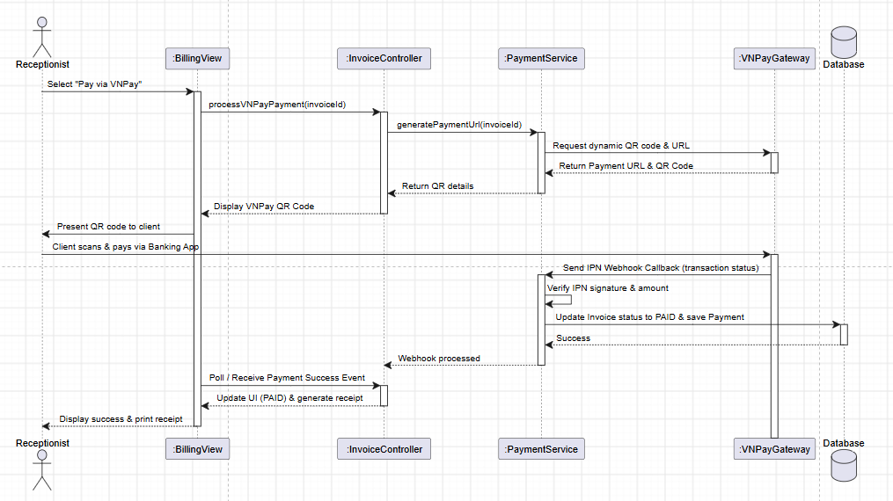

2.1.2. Sequence Diagram for UC-BILL-01b: Collect Cash Payment

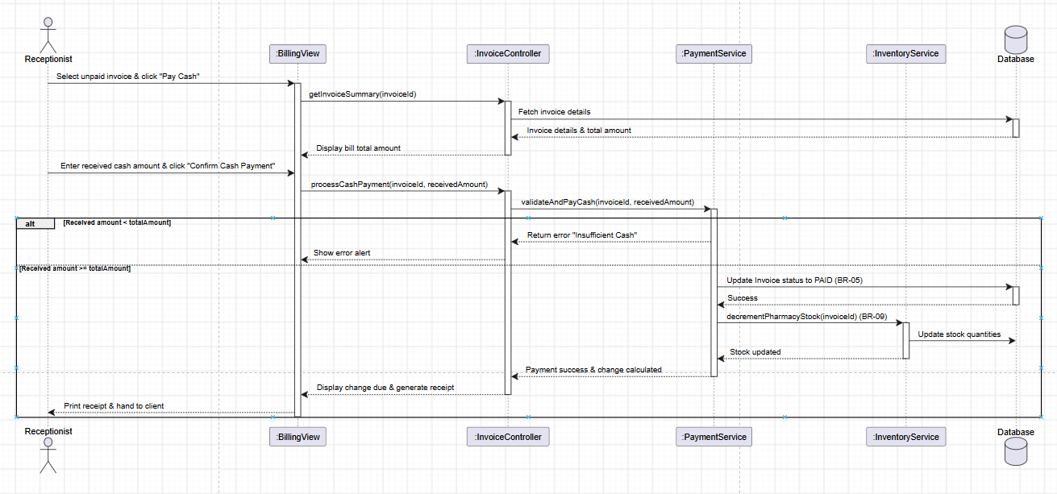

2.1.3. Sequence Diagram for UC-BILL-02: View Invoice Detail
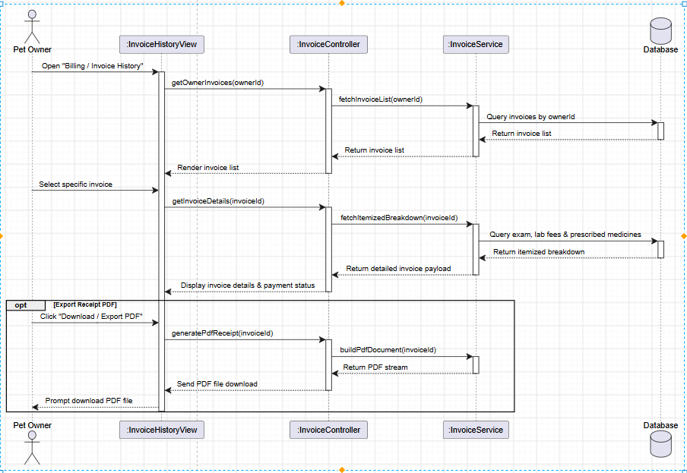

2.1.4. Sequence Diagram for UC-HR-01: Manage Weekly Shift Rosters
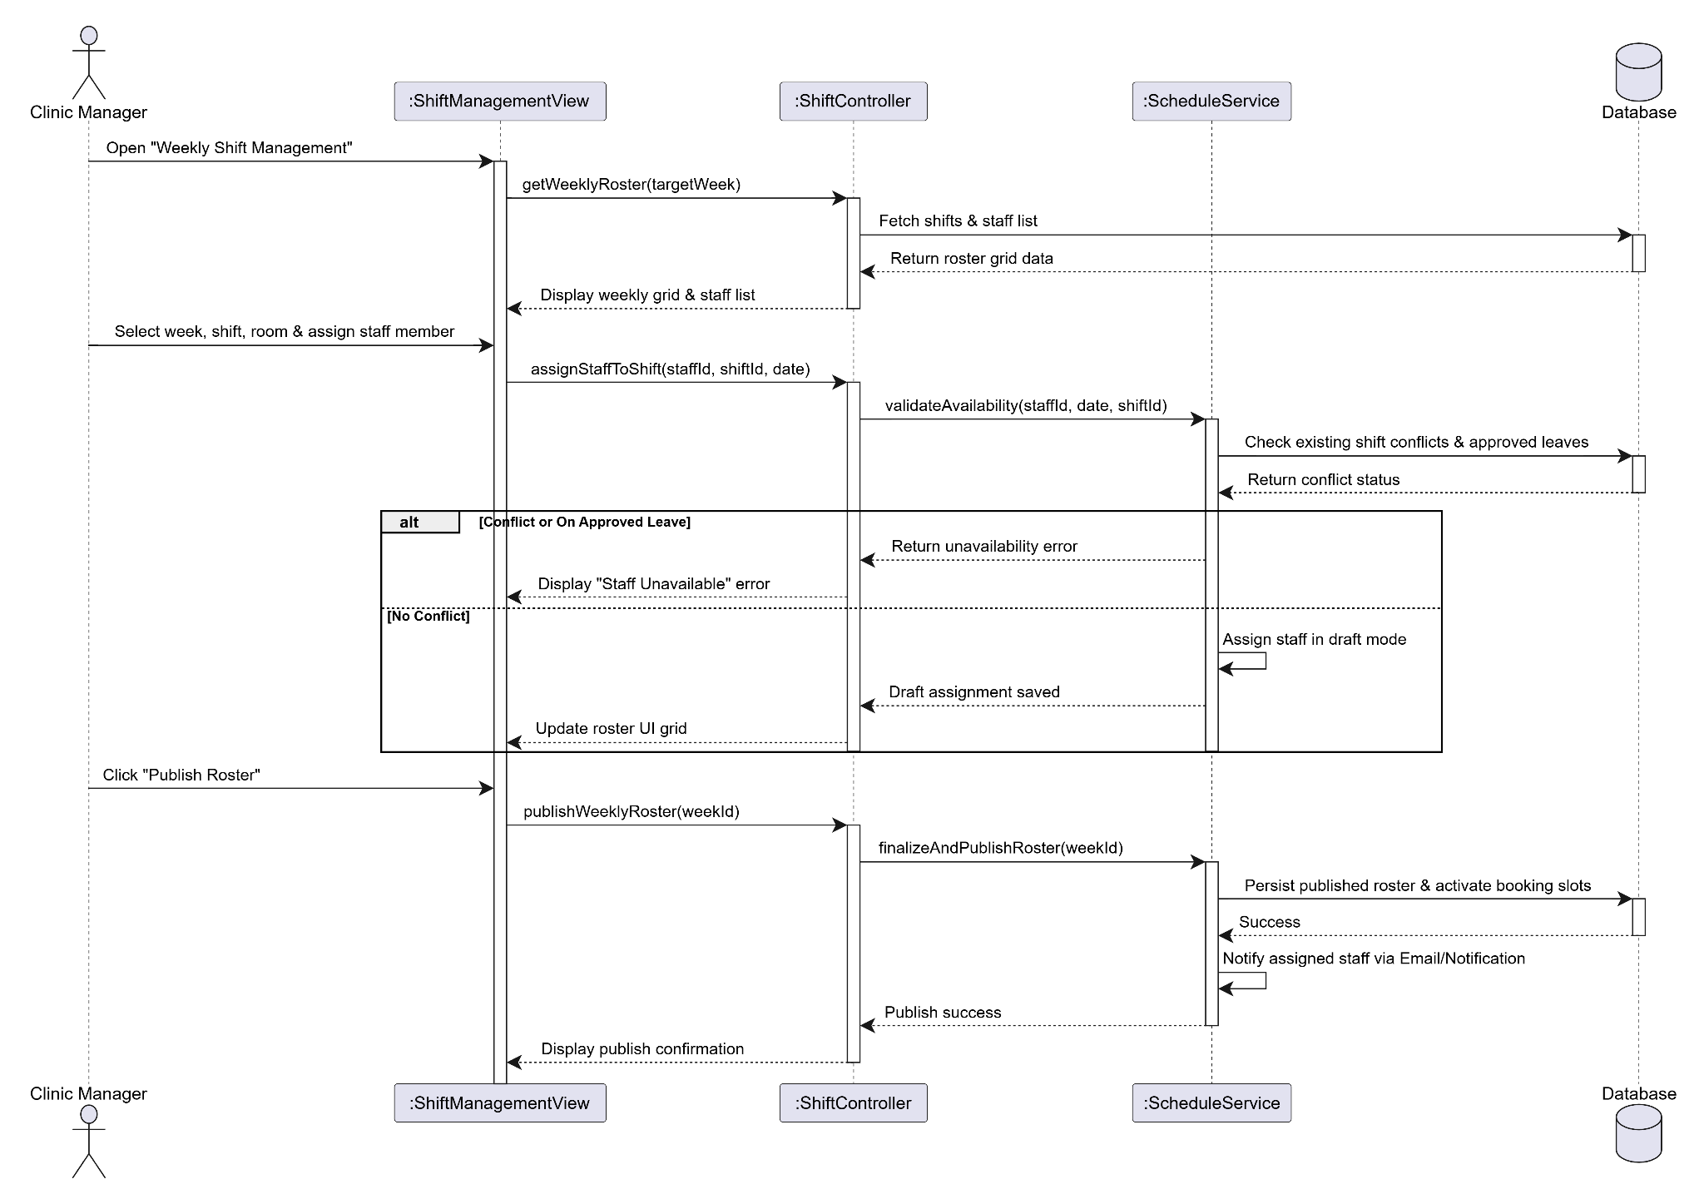

2.1.5. Sequence Diagram for UC-HR-02 & UC-HR-03: Submit & Approve/Reject Staff Leave Request
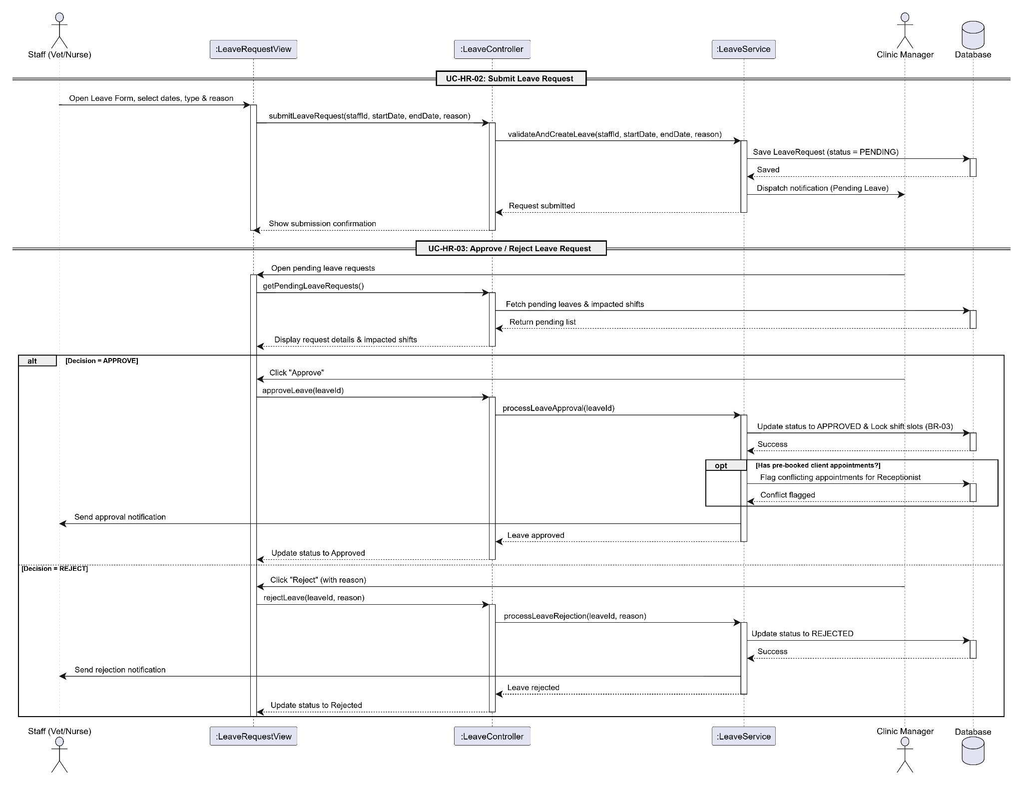
2.1.6. Sequence Diagram for UC-BOOK-03: Appointment cancellation Link Imag

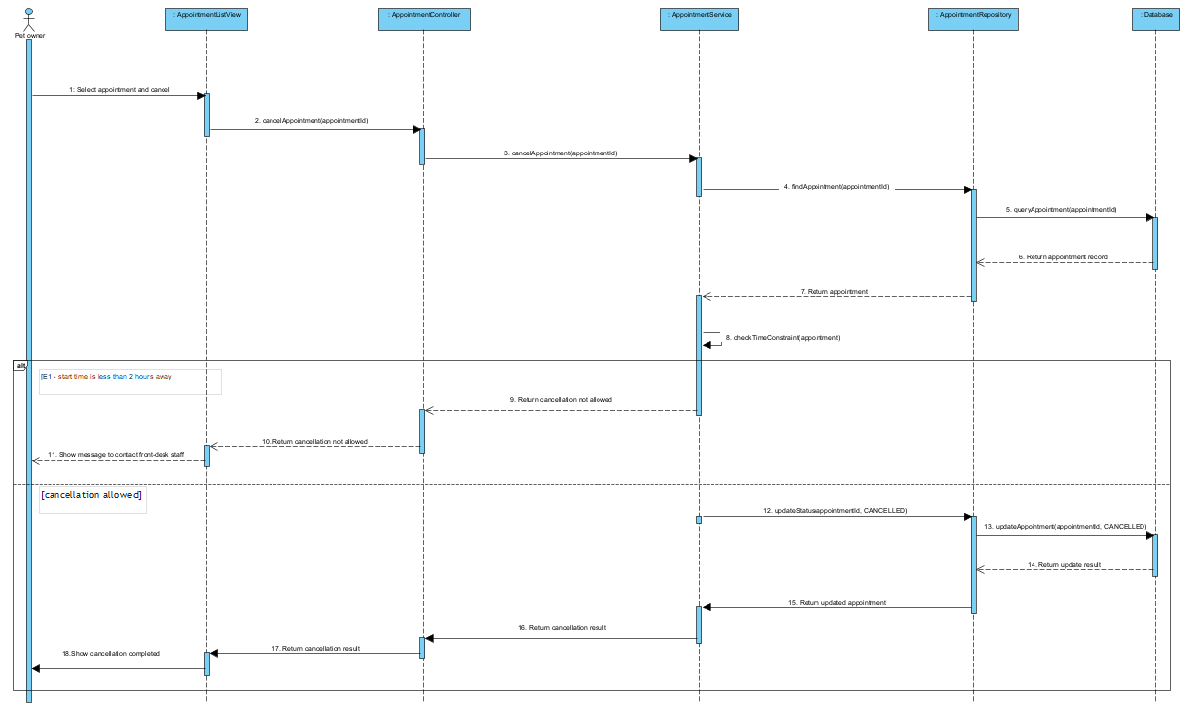
2.1.7. Sequence Diagram for UC-PET-01: Pet Profile Registration (Link Image)

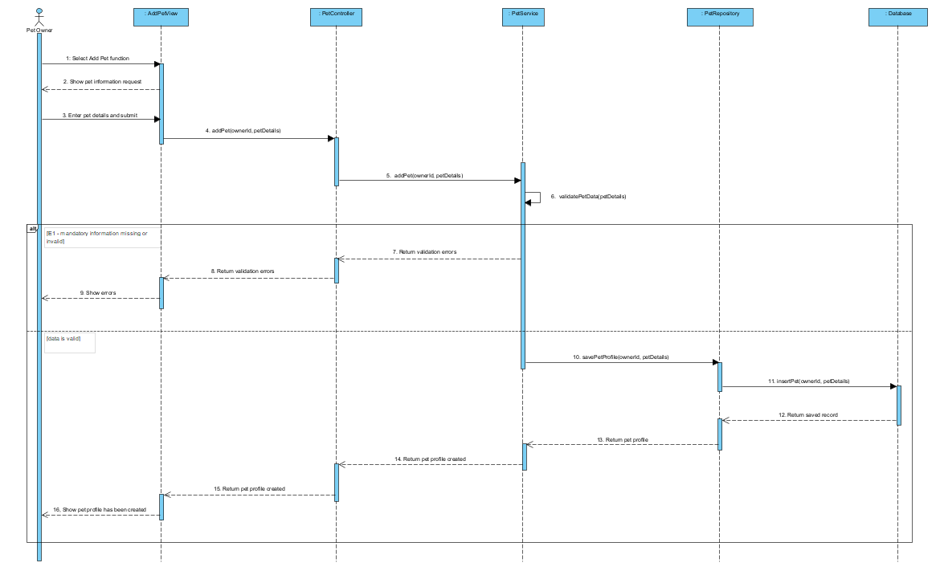

2.1.8 :Online Appointment Booking (UC-BOOK-01) Link Imag

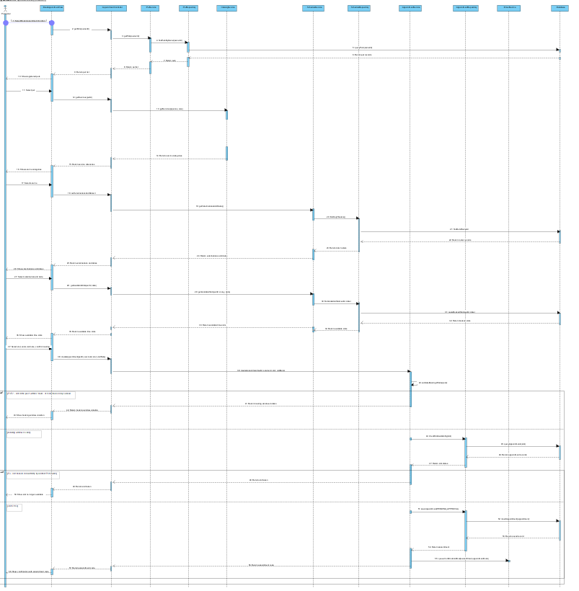

2.1.9 :Appointment Rescheduling (UC-BOOK-04) Link Imag
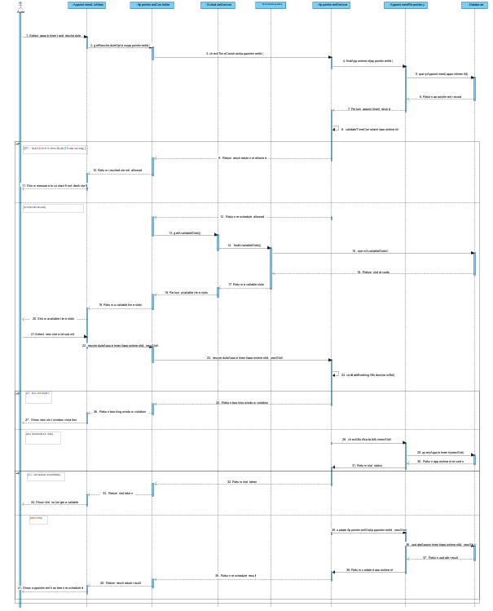

2.1.10. Sequence Diagram for UC-AUTH-01: Register Account (Link Image)
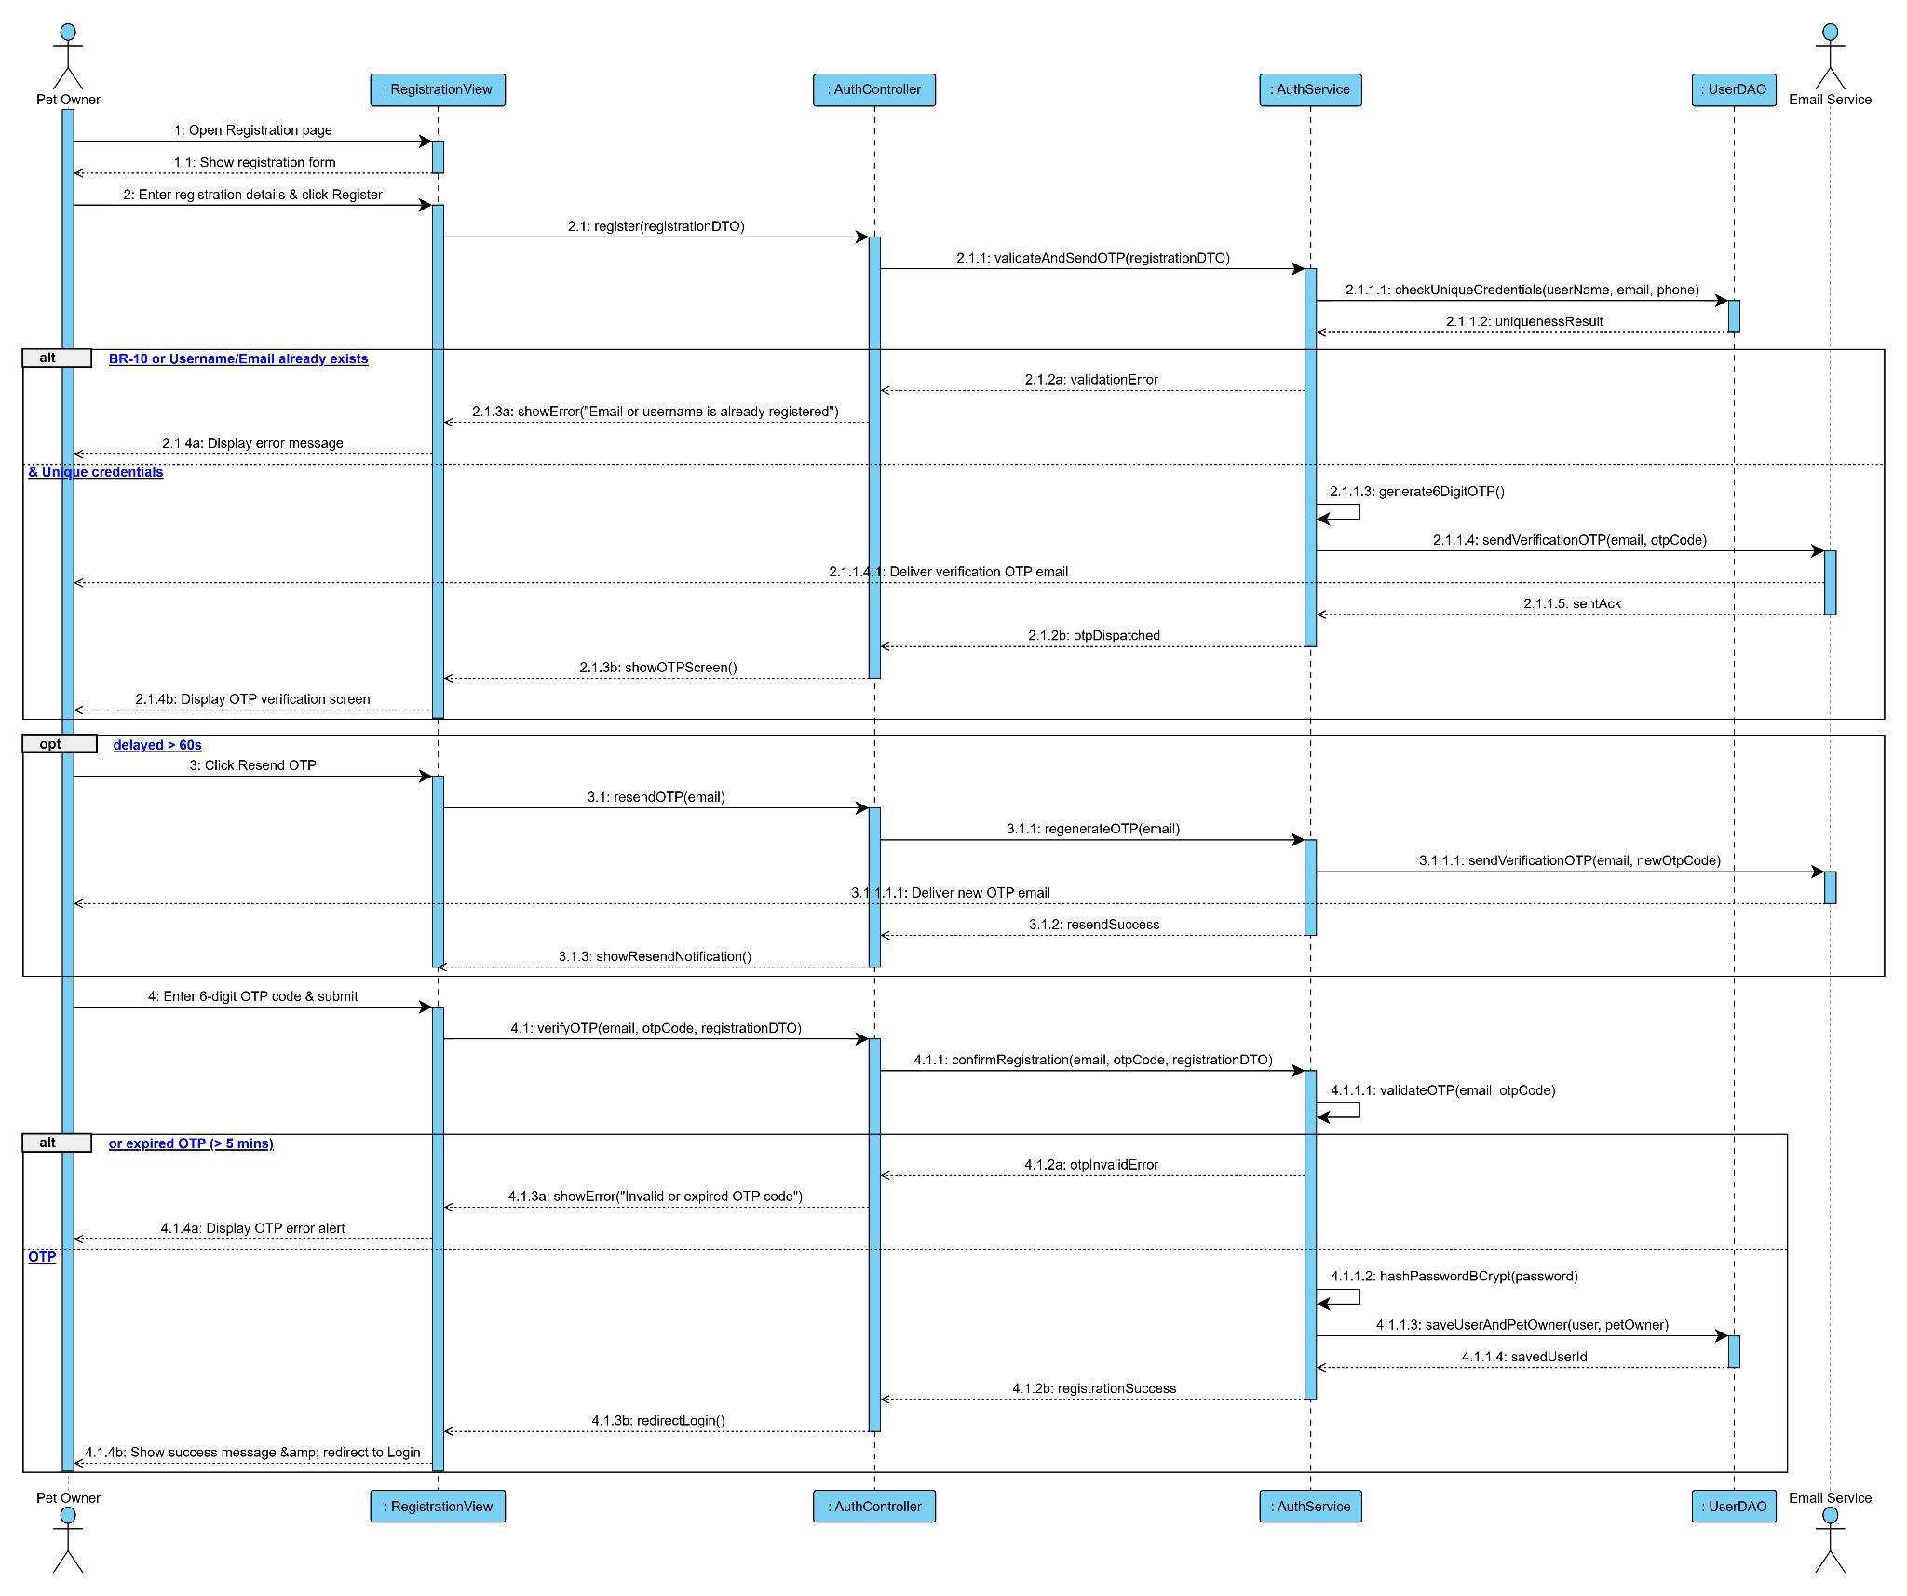
2.1.11. Sequence Diagram for UC-AUTH-02: Login / Logout (RBAC) (Link Image)
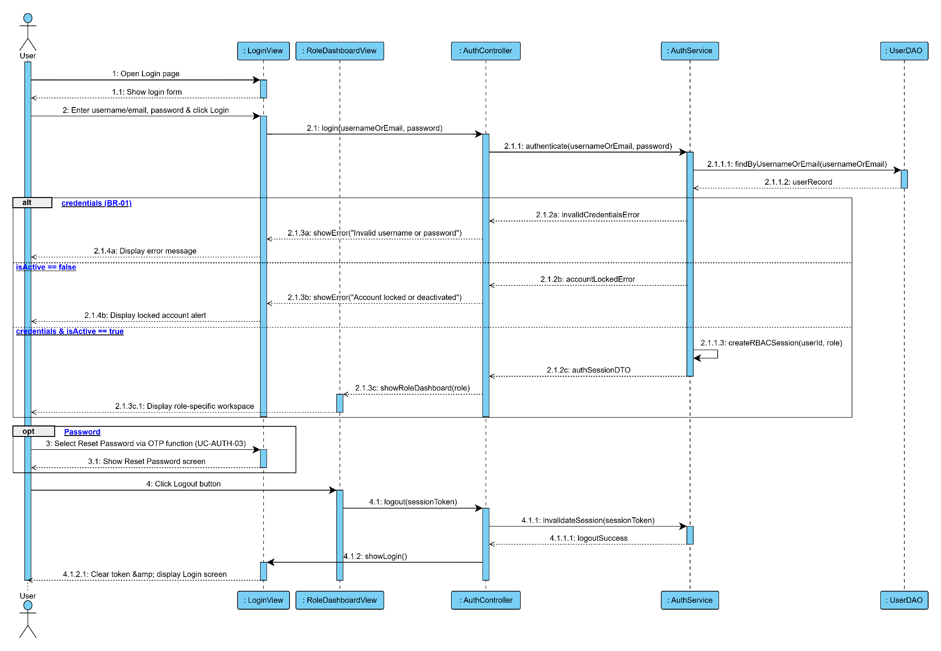
2.1.12. Sequence Diagram for UC-AUTH-03: Reset Password via OTP (Link Image)
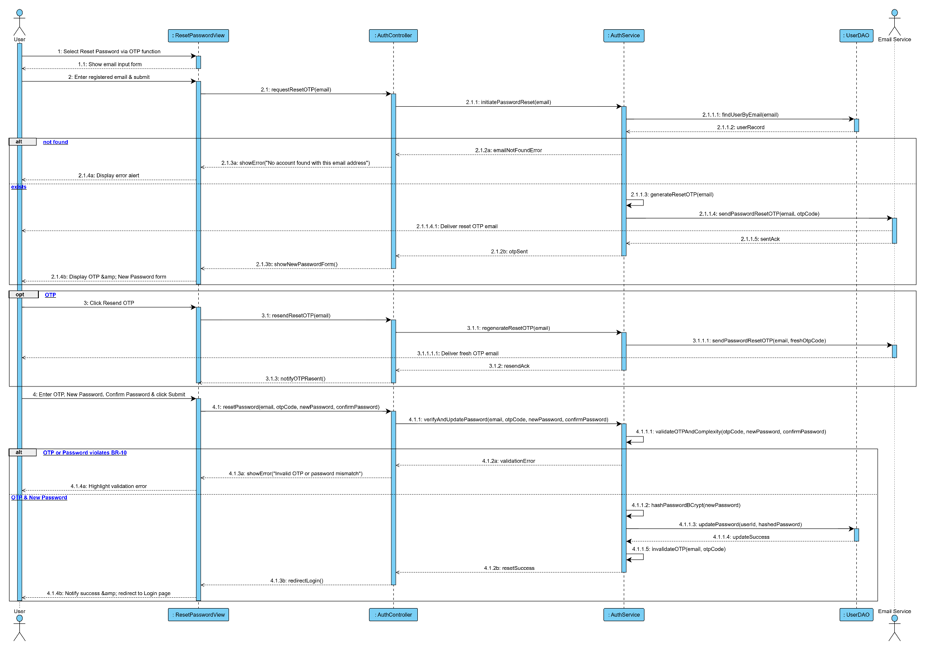
2.1.13. Sequence Diagram for UC-AUTH-04: View Profile & UC-AUTH-05: Update Profile (Link Image)
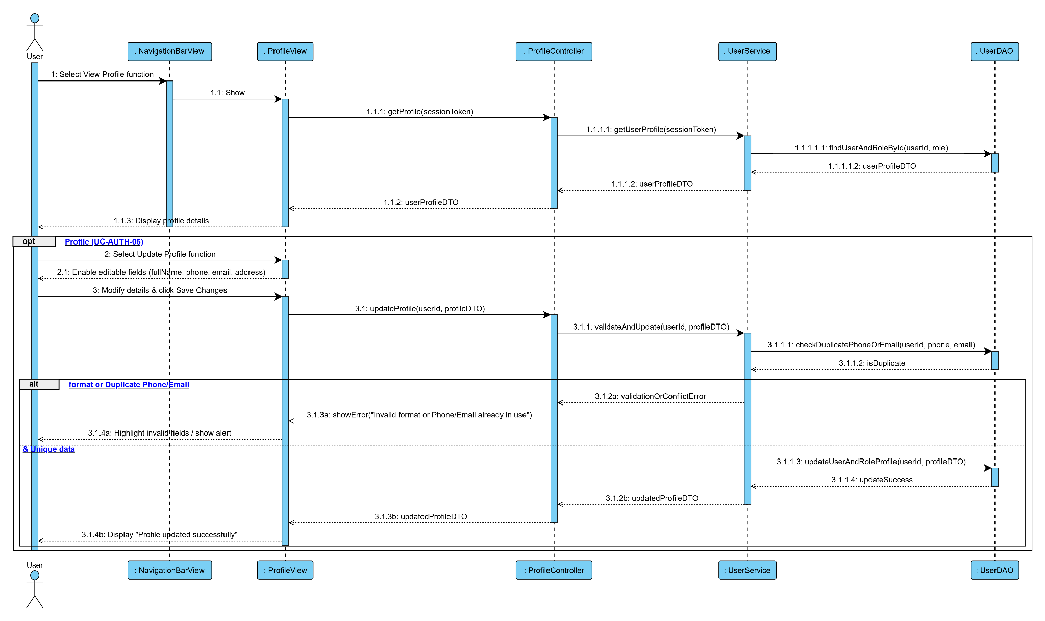

2.1.14. Sequence Diagram for UC-AI-01: Consult Gemini AI Advisor (Link Image)
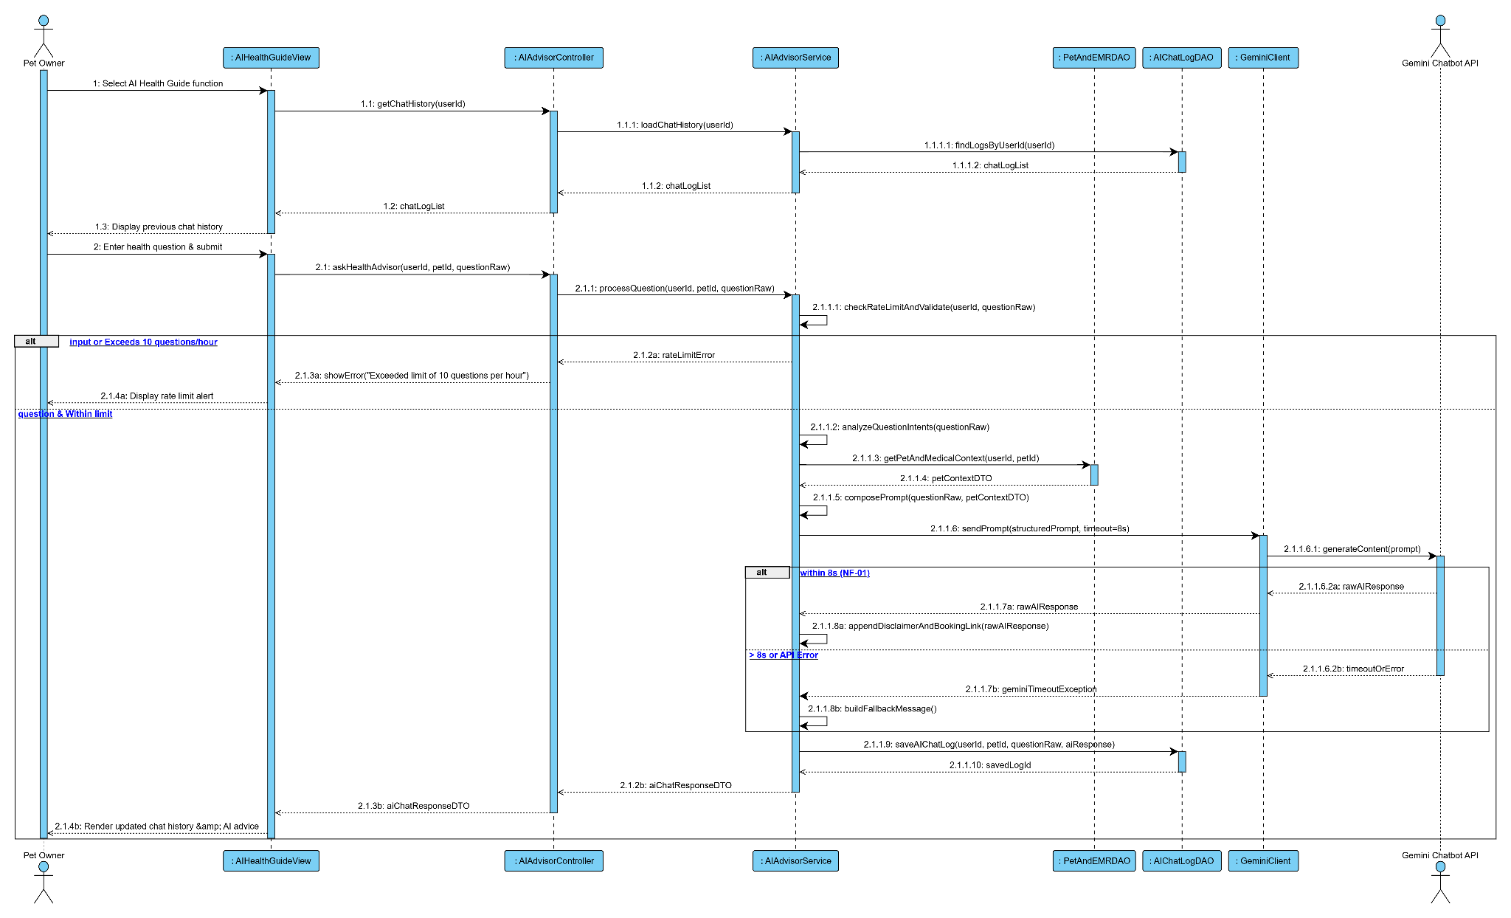

2.1.15. Sequence Diagram for UC-EMG-01: Emergency Triage Intake (Link Image)
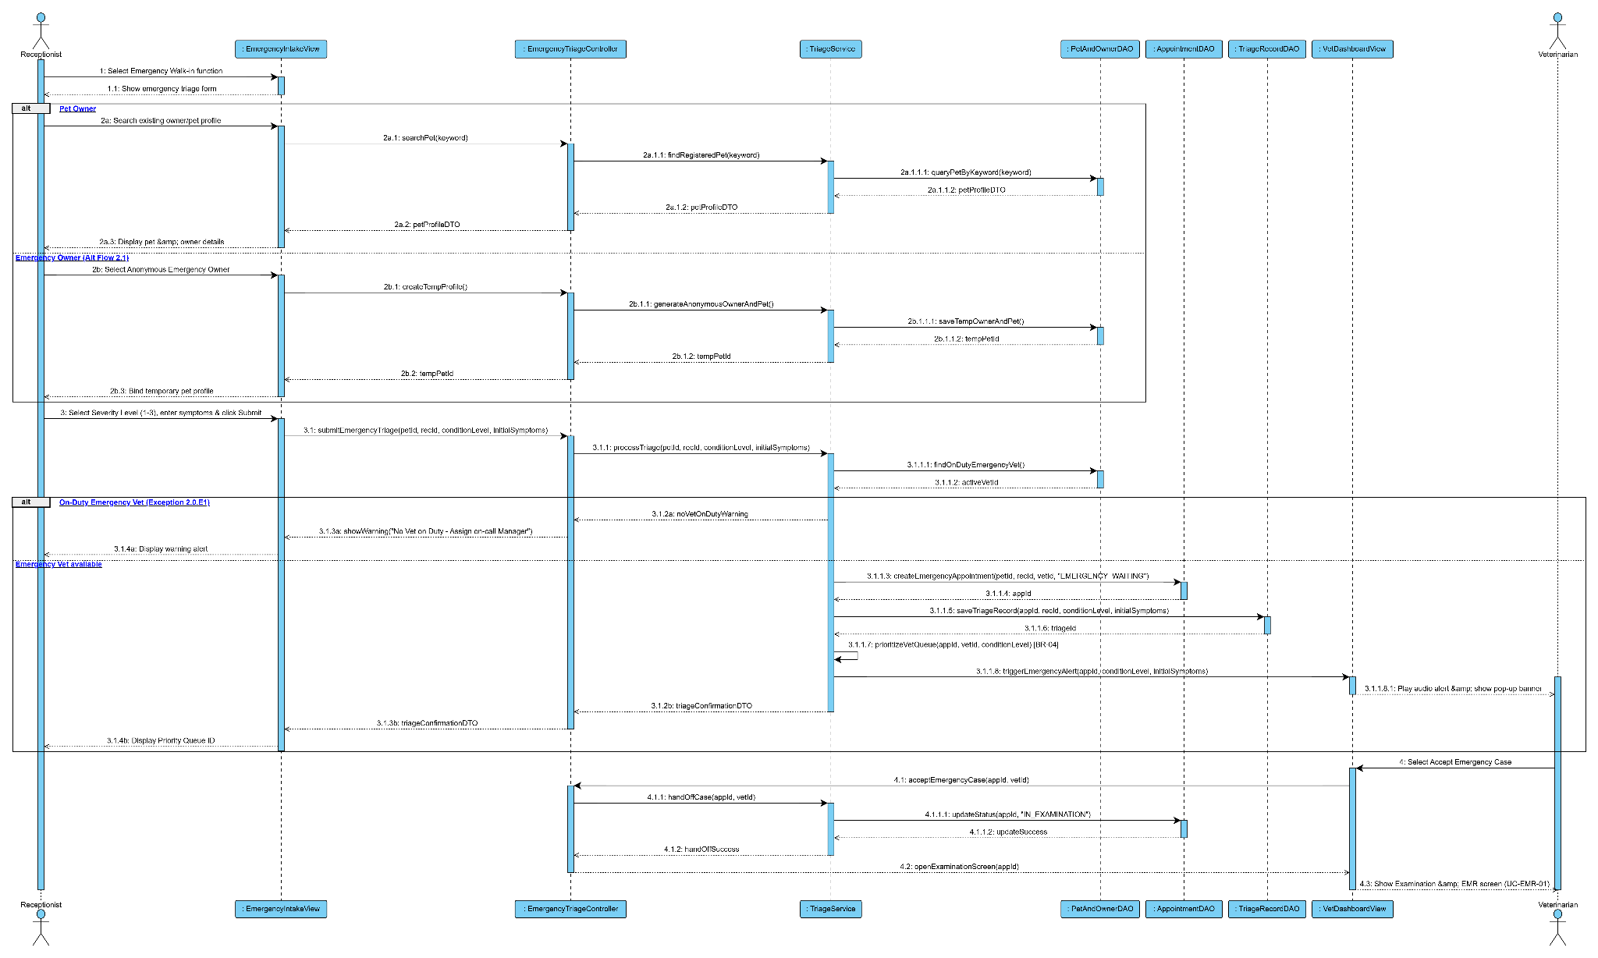
2.1.16. Sequence Diagram for EMR-01:Conduct Examination & EMR
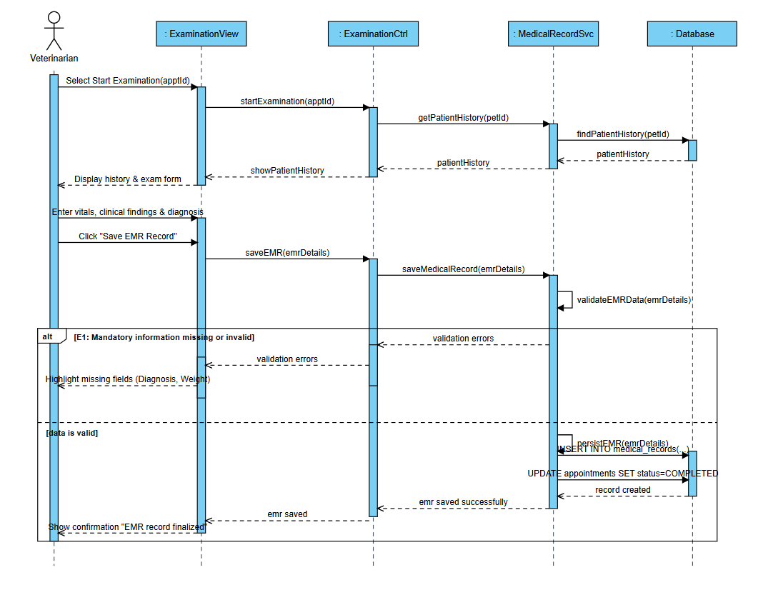
2.1.17. Sequence Diagram for EMR-02:View Medical Record List
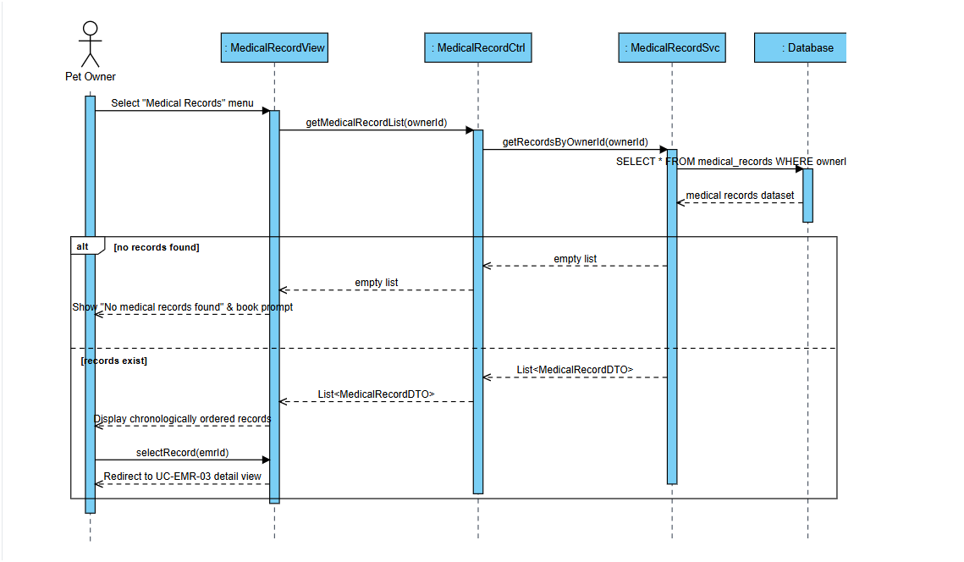
2.1.18. Sequence Diagram for EMR-03:View Medical Record Detail
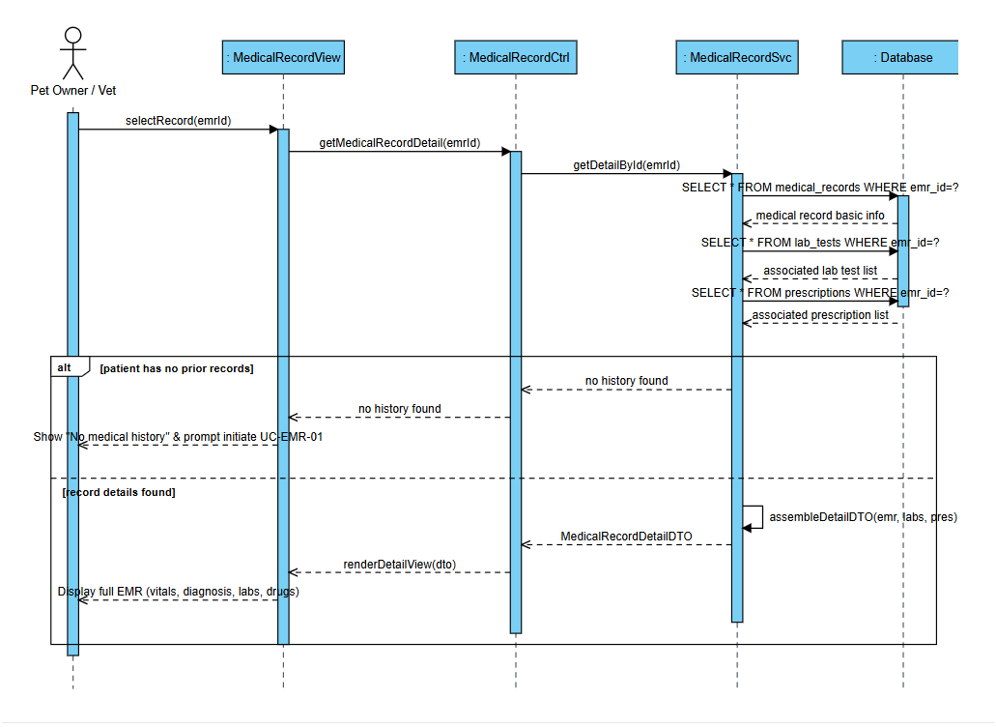
2.1.19. Sequence Diagram for LAB-01:Issue Paraclinical Lab Order
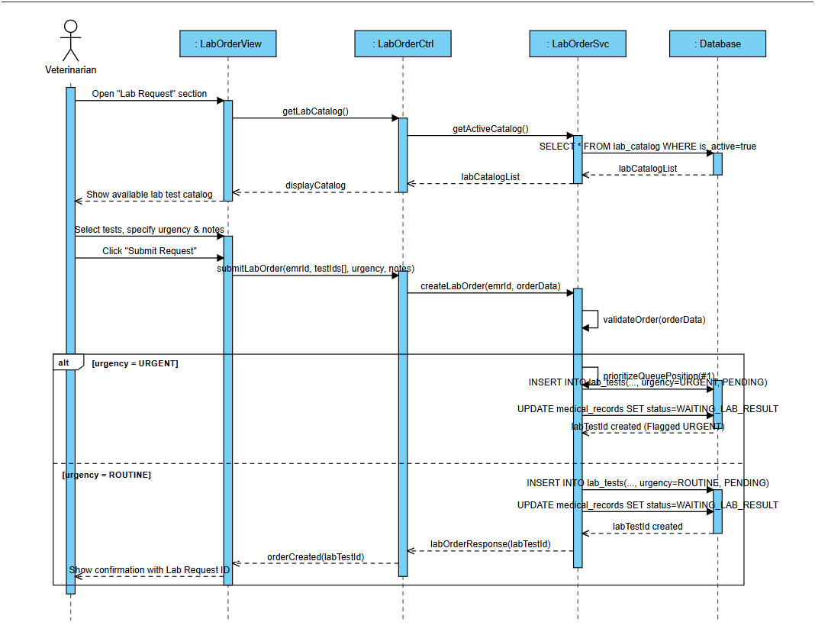
2.1.20. Sequence Diagram for LAB-02:Process Lab Order & Results
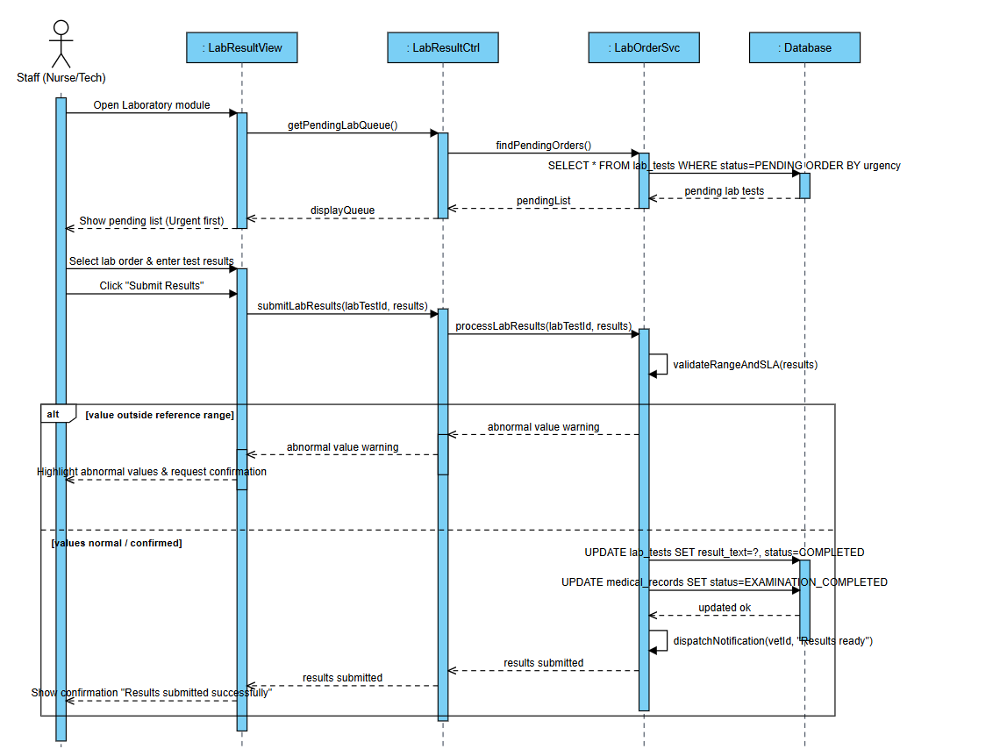

2.1.21. Sequence Diagram – Update Pet Profile
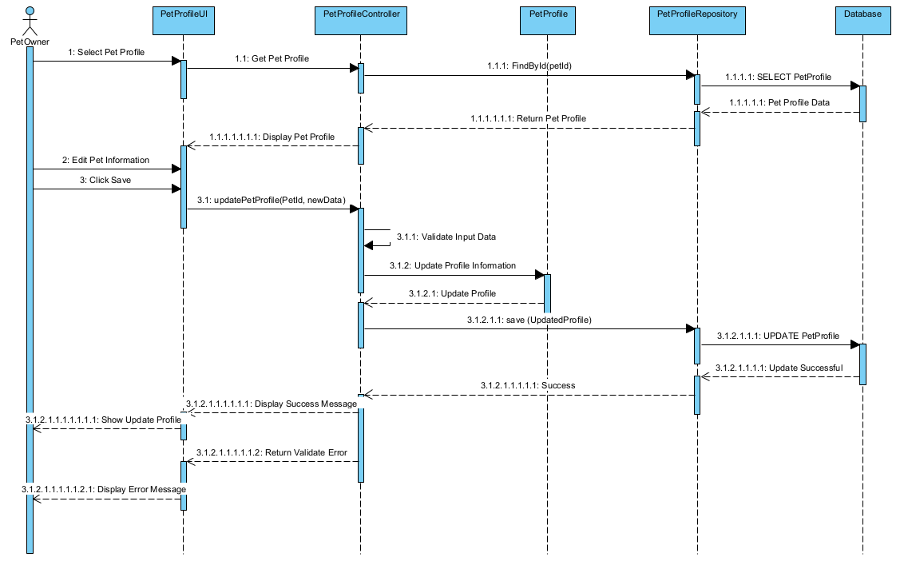
2.1.22. Sequence Diagram – Soft-Delete Pet Profile
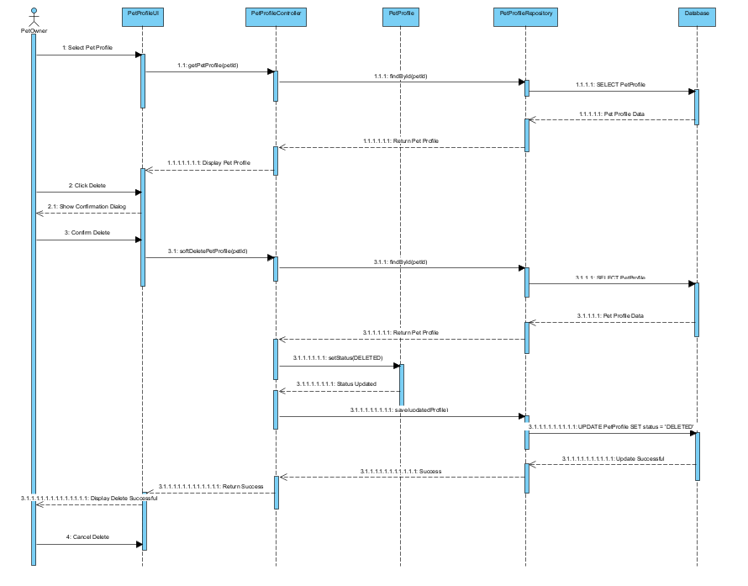
2.1.. Sequence Diagram – Add Pet Profile
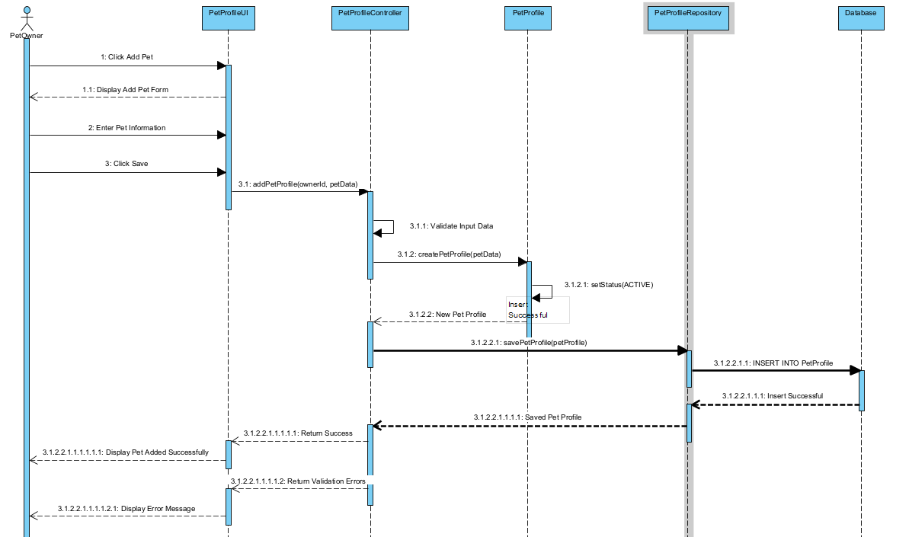

III.2.2. Communication Diagrams

2.2.1. Communication for UC-PET-01: Pet Profile Registration

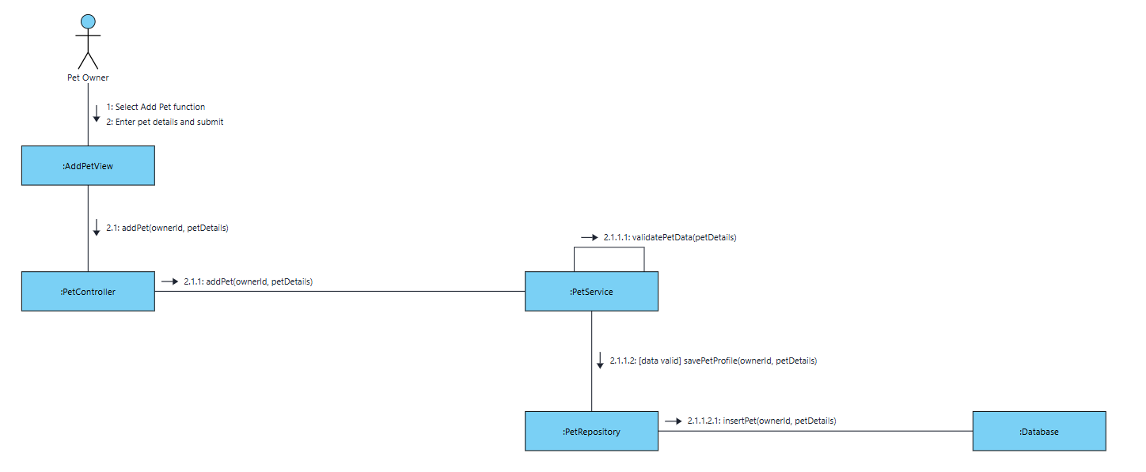

2.2.2. Communication for UC-BOOK-04: Appointment Rescheduling

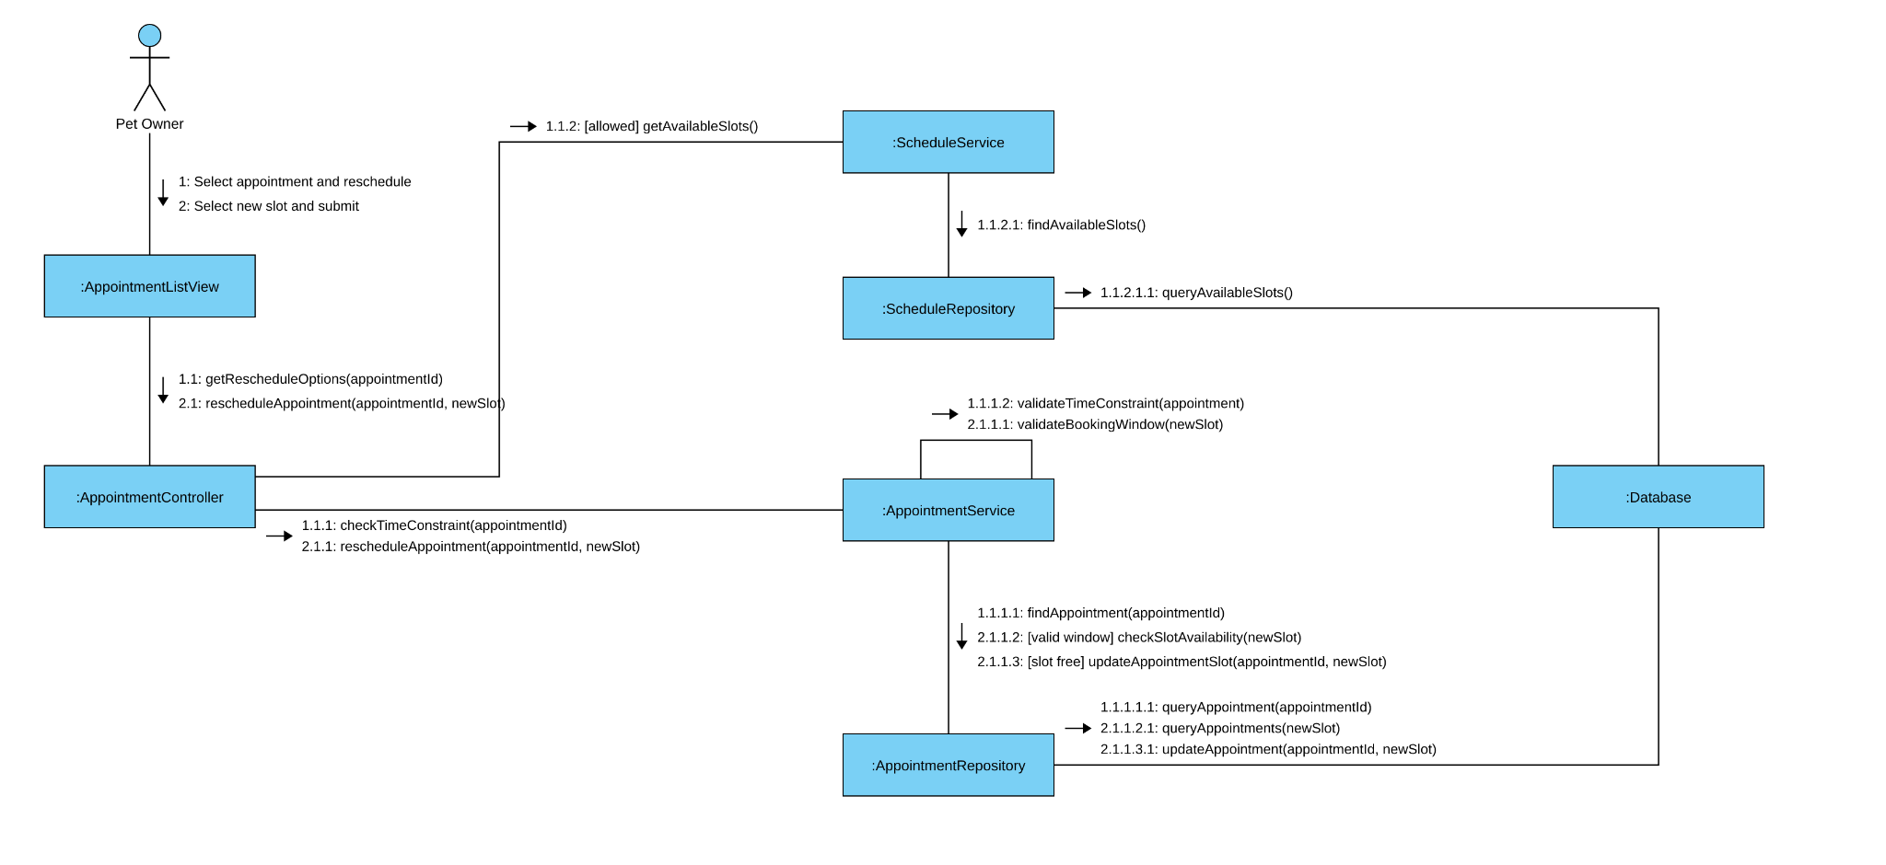

2.2.3. Communication for UC-BOOK-03: Appointment Cancellation
`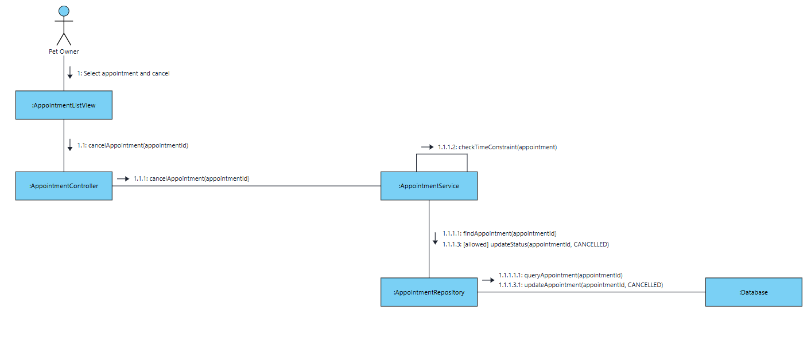
2.2.4. Communication for UC-BOOK-01: Online Appointment Booking

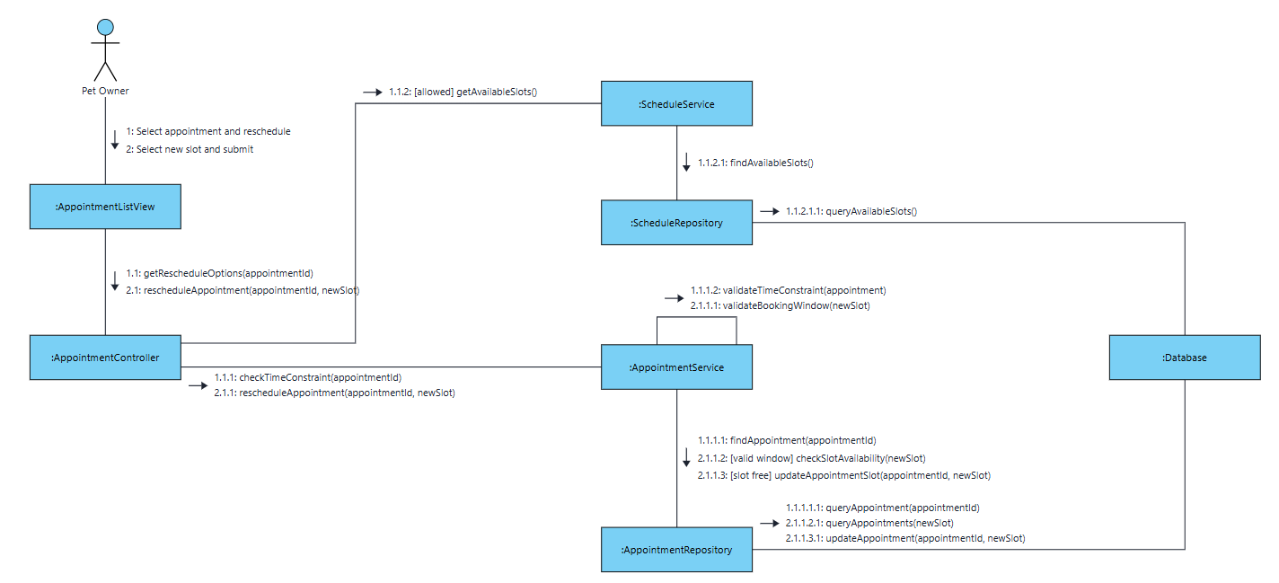

2.2.5. Communication Diagram cho UC-BILL-01a: Process Online Payment via VNPay

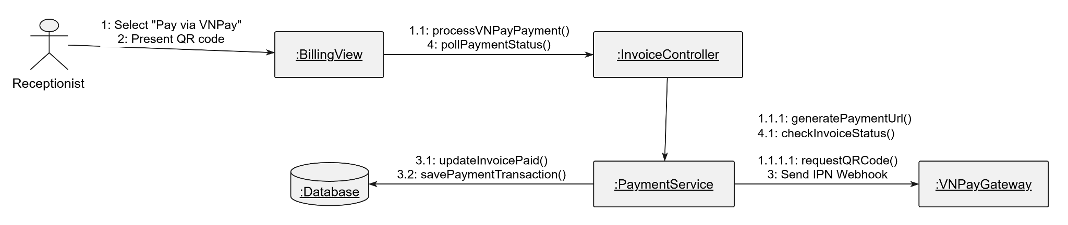

2.2.6. Communication Diagram cho UC-BILL-01b: Collect Cash Payment
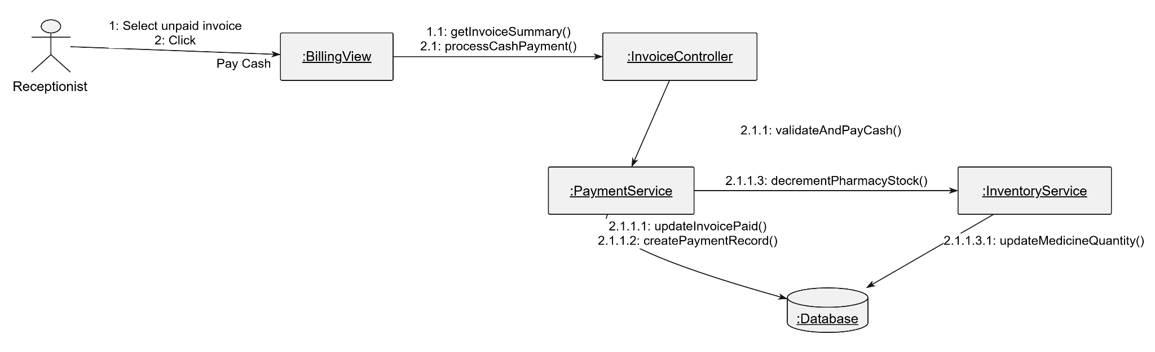

2.2.7. Communication Diagram cho UC-BILL-02: View Invoice Detail

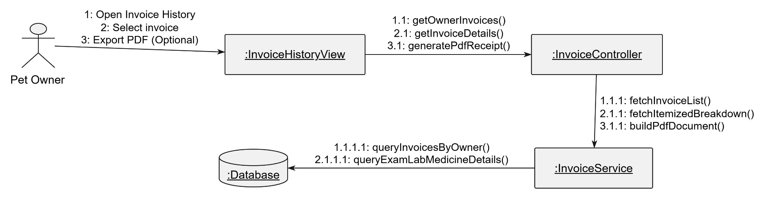

2.2.8. Communication Diagram cho UC-HR-01: Manage Weekly Shift Rosters

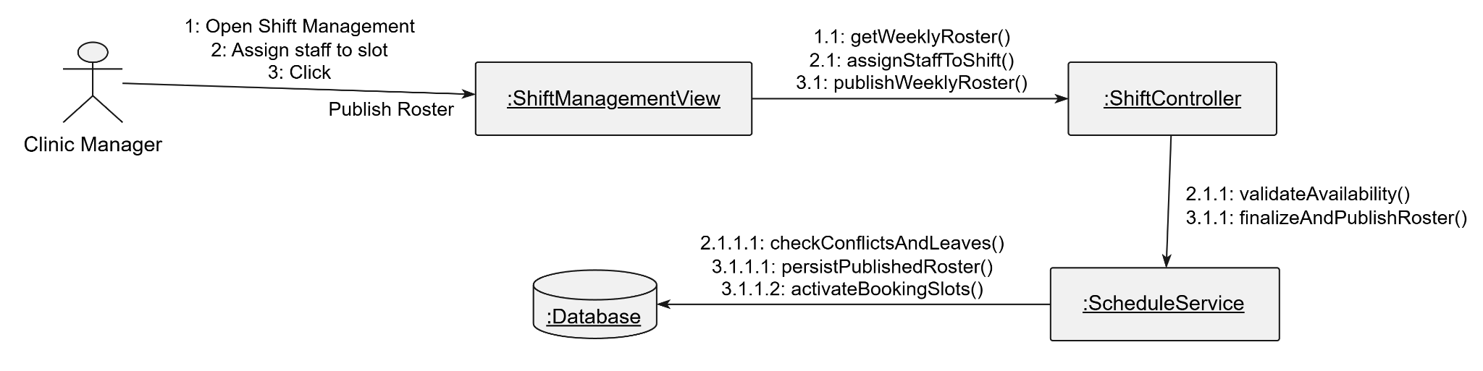

2.2.9. Communication Diagram cho UC-HR-02 & UC-HR-03: Submit & Approve/Reject Staff Leave Request

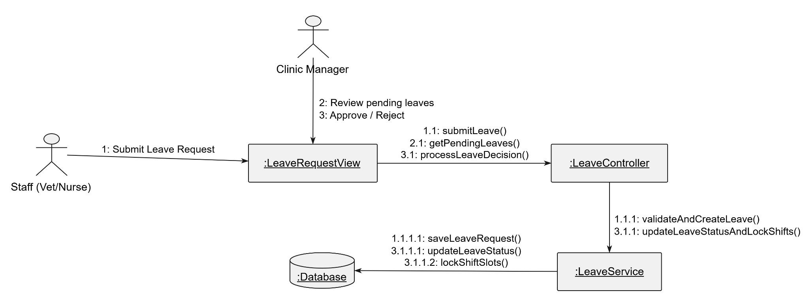
2.2.10. Communication Diagram for UC-AUTH-01: Register Account
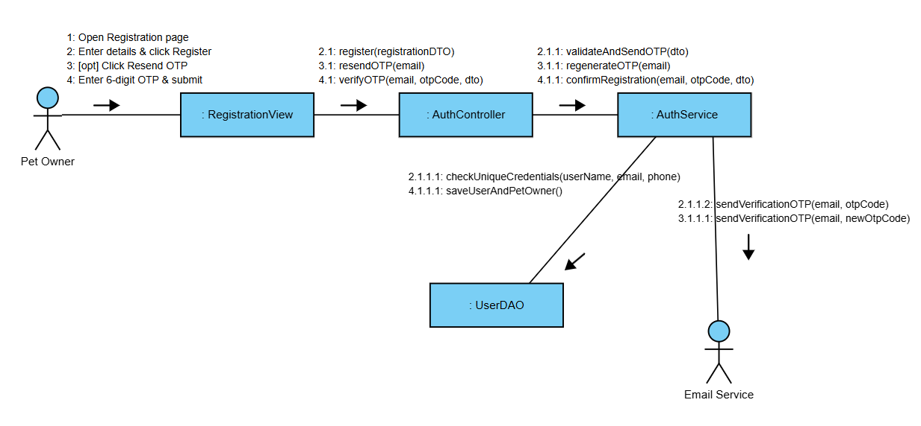
2.2.11. Communication Diagram for UC-AUTH-02: Login / Logout (RBAC)

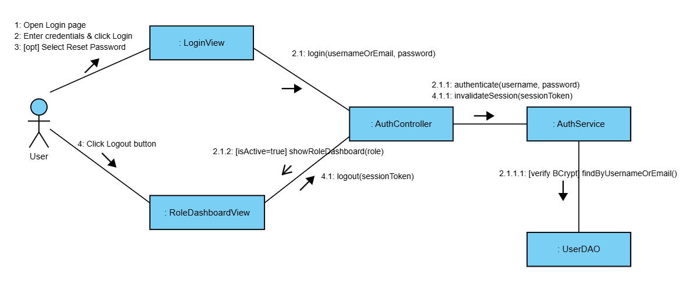
2.2.12. Communication Diagram for UC-AUTH-03: Reset Password via OTP

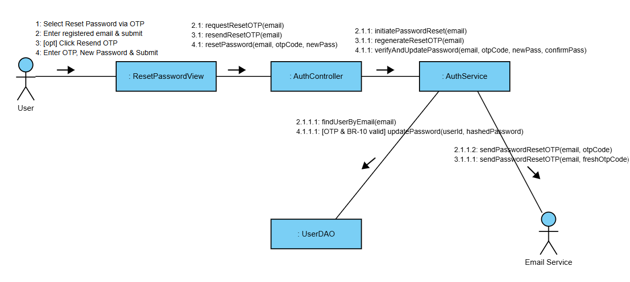
2.2.13. Communication Diagram for UC-AUTH-04: View Profile & UC-AUTH-05: Update Profile

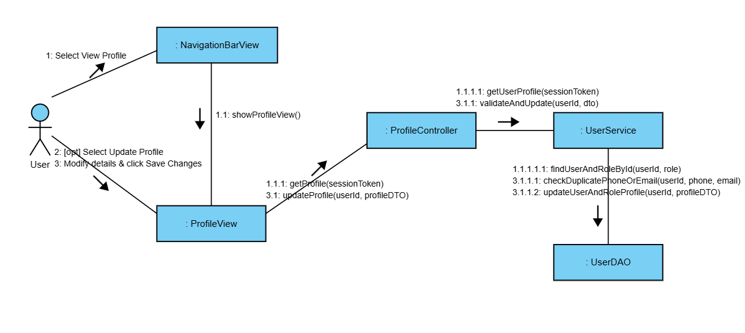
2.2.14. Communication Diagram for UC-AI-01: Consult Gemini AI Advisor

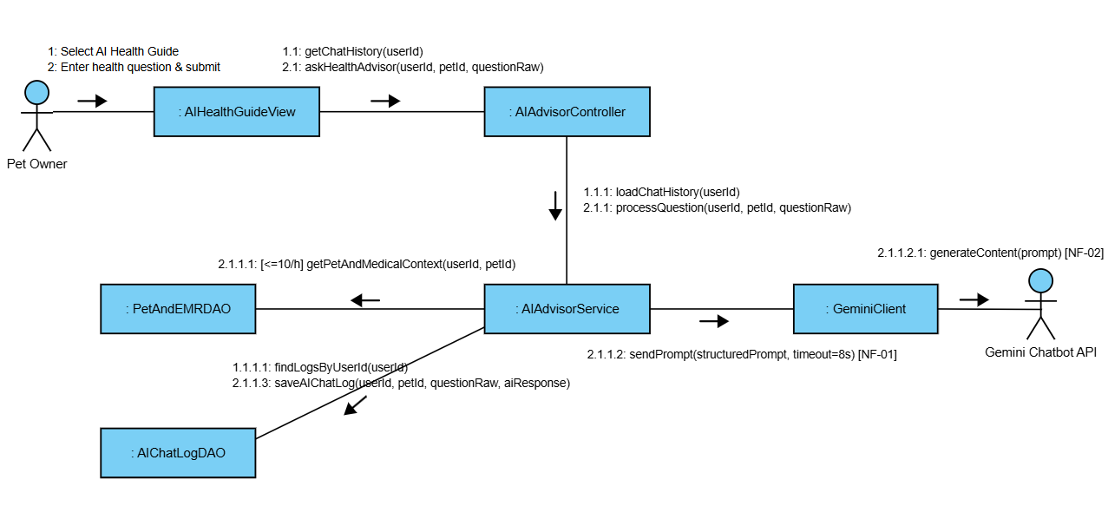
2.2.15. Communication Diagram for UC-EMG-01: Emergency Triage Intake
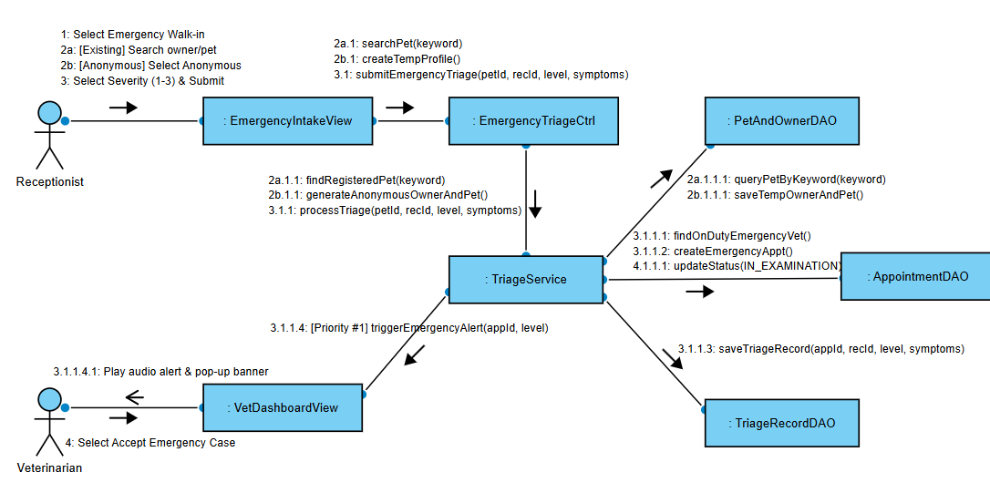

2.2.16. Communication Diagram for EMR-01:Conduct Examination & EMR
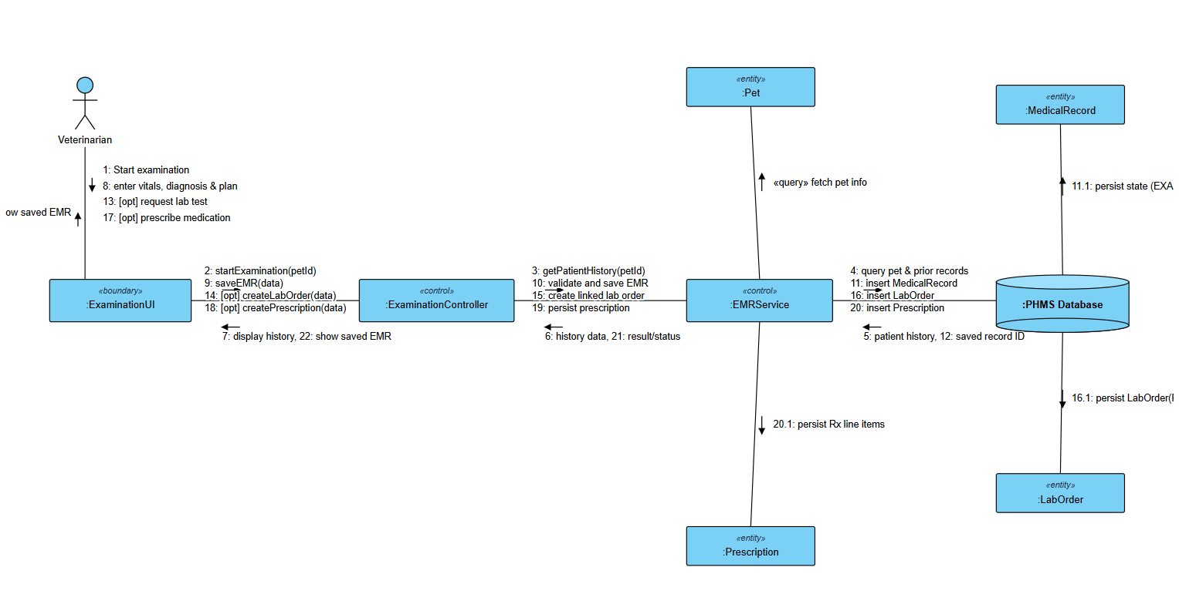
2.2.17. Communication Diagram for EMR-02:View Medical Record List
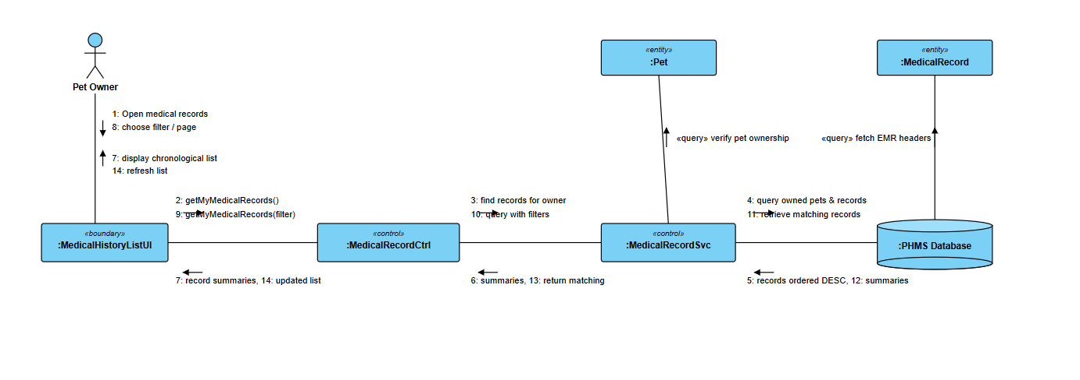
2.2.18. Communication Diagram for EMR-03:View Medical Record Detail
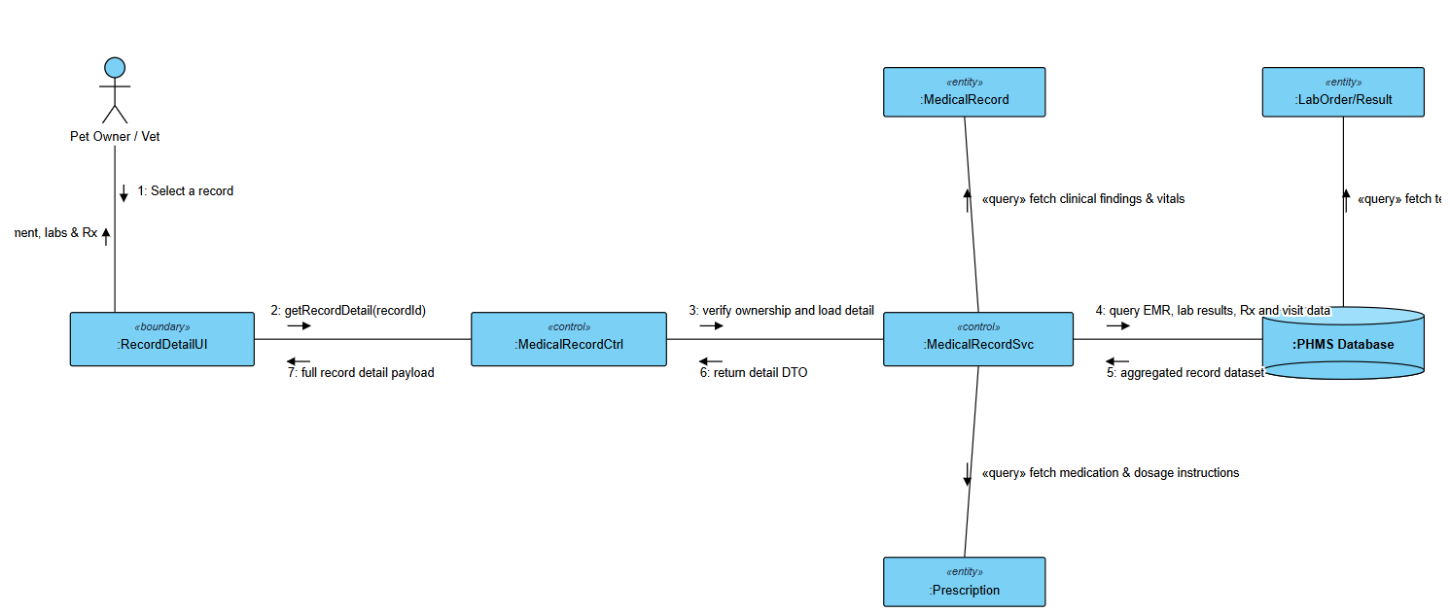
2.2.19. Communication Diagram for LAB-01:Issue Paraclinical Lab Order
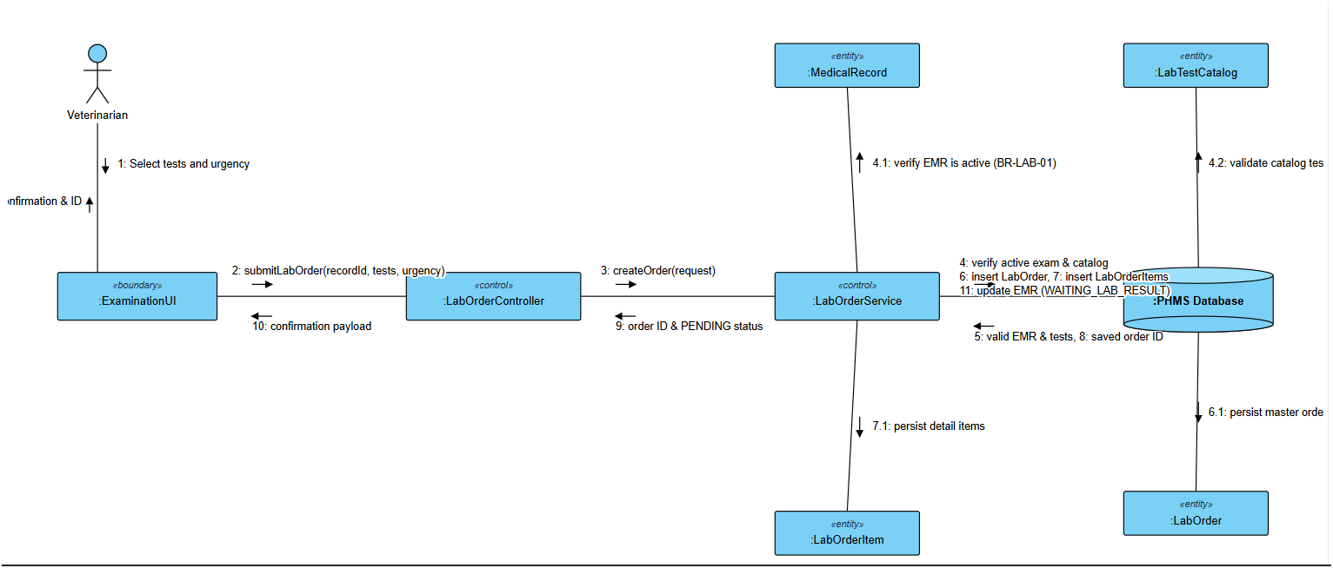
2.2.20. Communication Diagram for LAB-02:Process Lab Order & Results
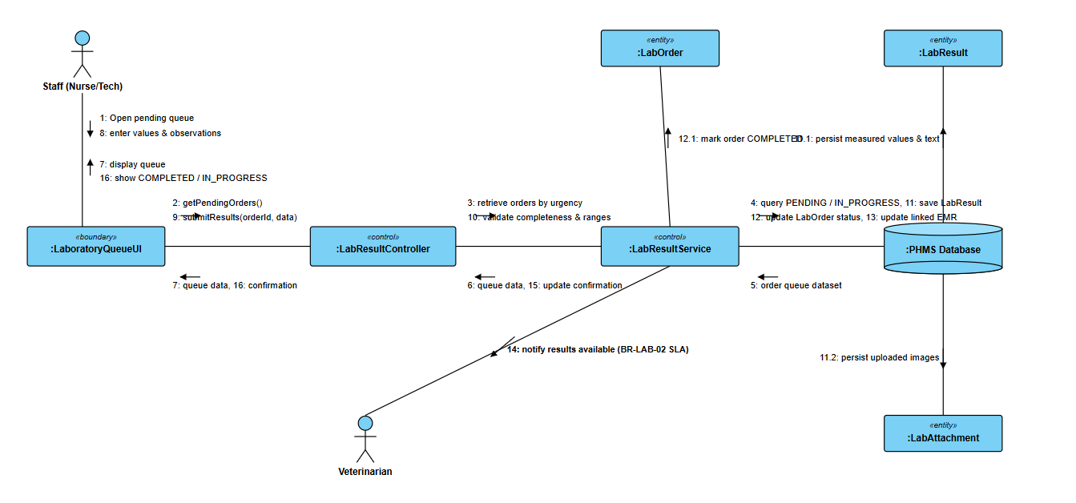

III.3 State diagrams (Behavioral models)

3.3.1. State diagram for User State Machine (AUTH-01, AUTH-02, AUTH-03, AUTH-04, AUTH-05)

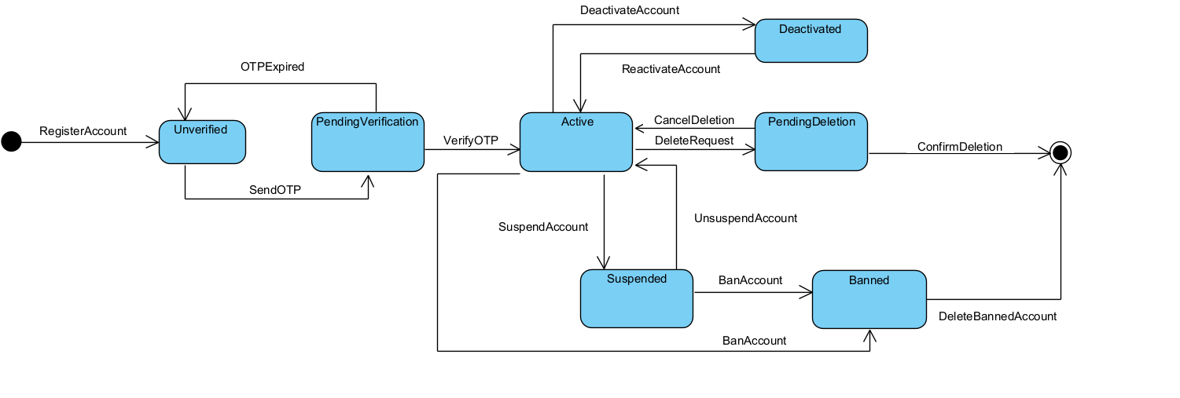
3.3.2. State diagram for Emergency Triage State Machine (EMG-01)

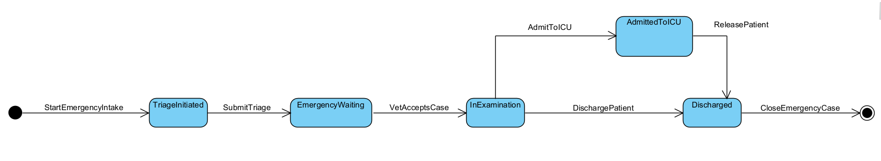

3.3.3. State diagram for AI Advisory State Machine (AI-01)

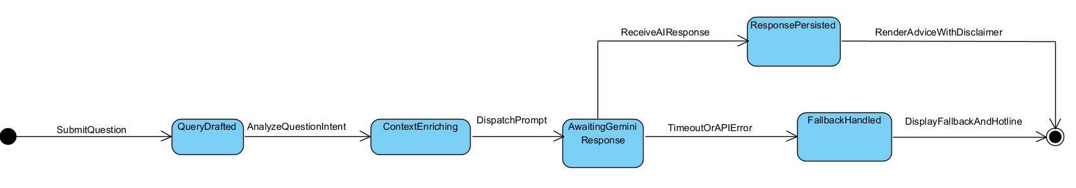
3.3.4. State diagram for Appointment State Machine (BOOK-01, BOOK-02, BOOK-03, BOOK-04)

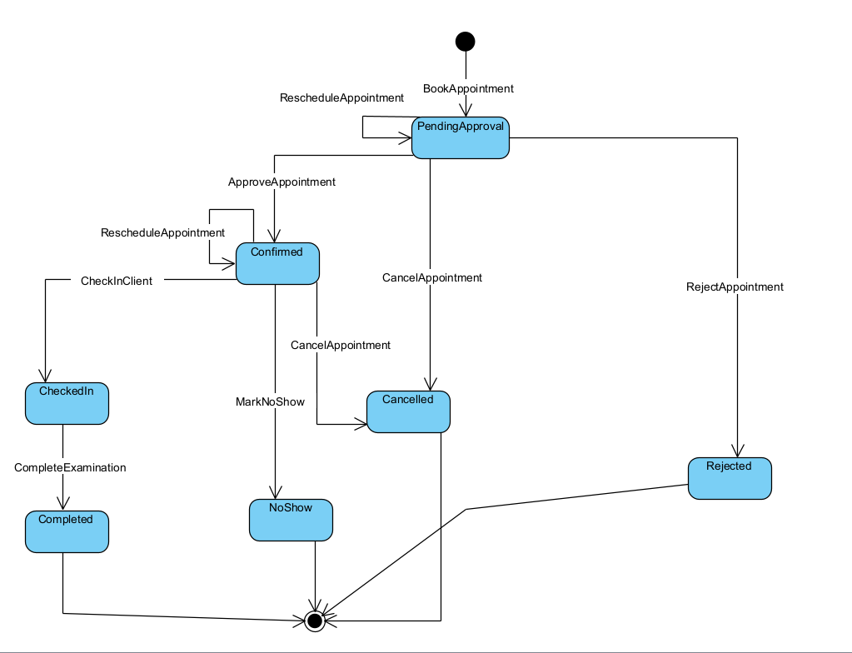

3.3.5. State diagram for medical record state machine(EMR-01,EMR-02,EMR-03)

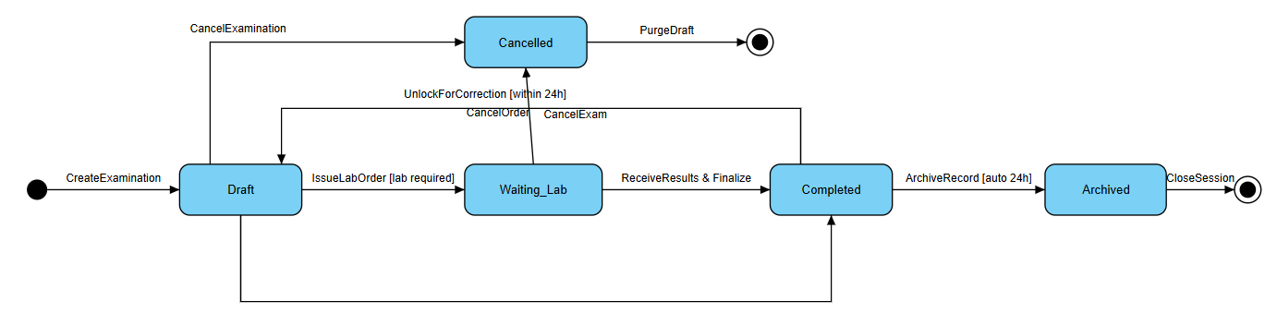

3.3.6. State diagram for paraclinical lab order state machine(LAB-01,LAB-02)

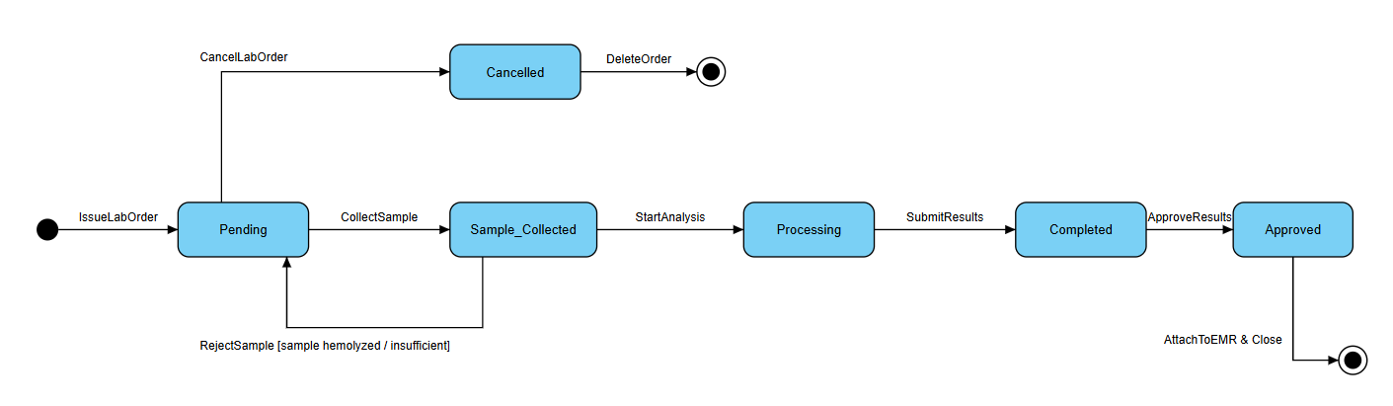

3.3.7. State diagram for integrated EMR & LAB collaboration state machine

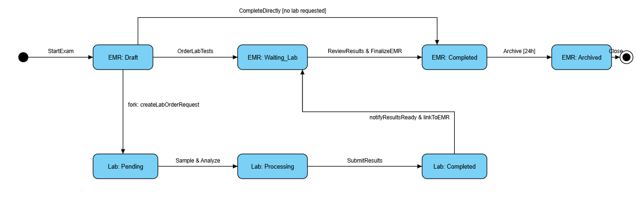

IV. Design specification

IV.1 Integrated Communication Diagrams

4.1.1 Integrated Communication Diagram of EMR Module (EMR-01, 02, 03)
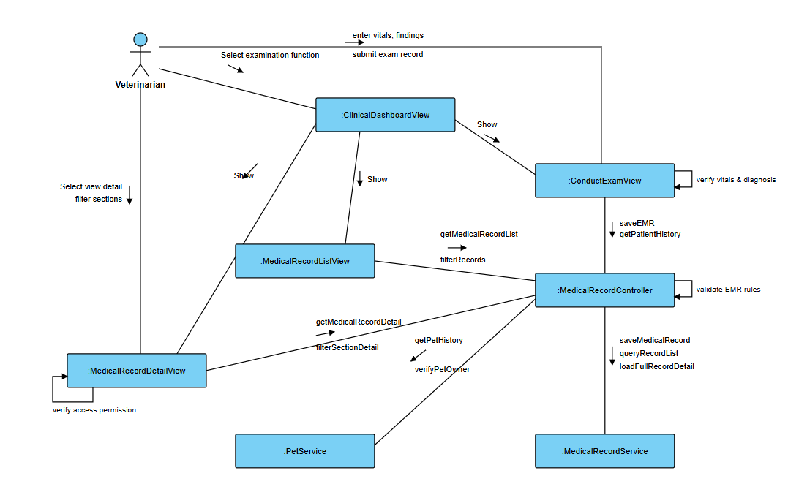
4.1.2 Integrated Communication Diagram of Lab Module (LAB-01, LAB-02)
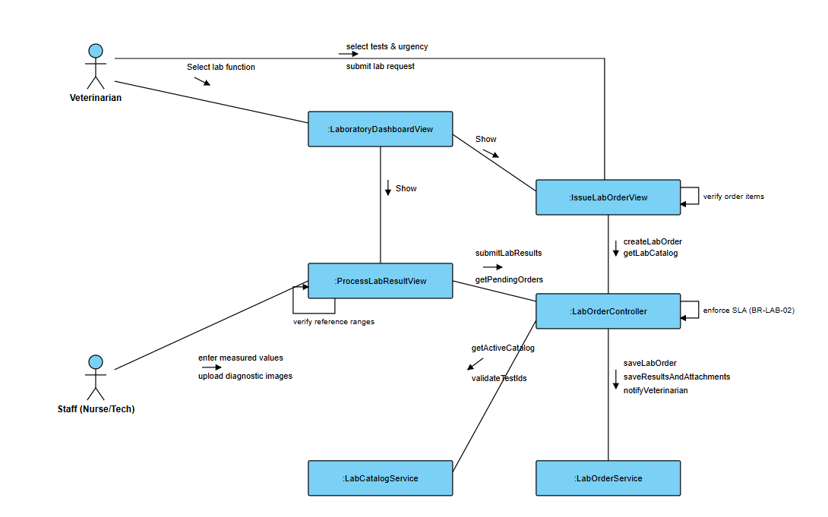
4.1.3 Comprehensive Integrated Diagram (EMR & Paraclinical Lab)
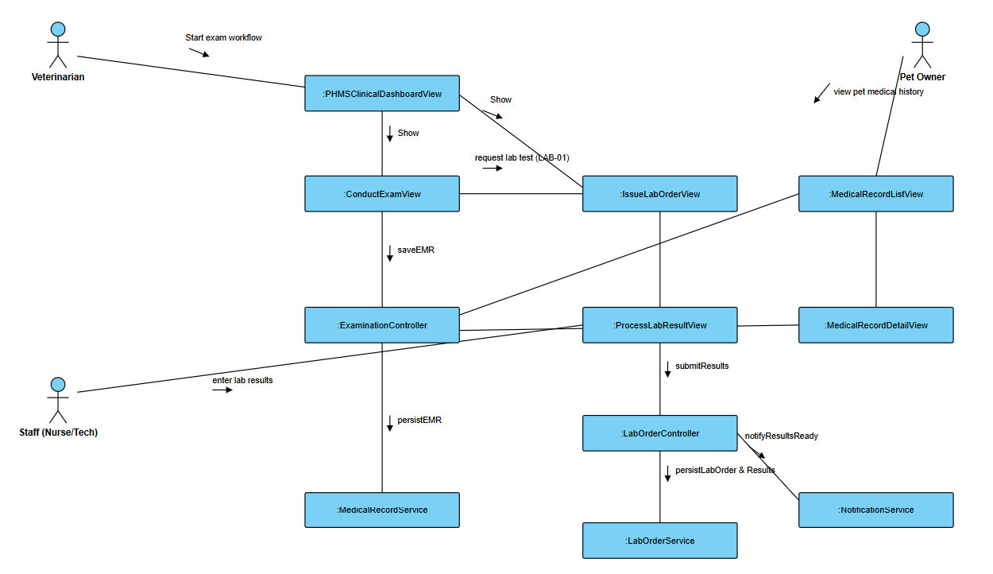
4.1.4. Integrated Communication Diagram of Authentication (UC-AUTH-01 to UC-AUTH-05)
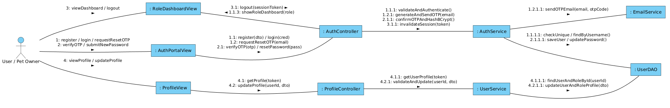
4.1.5. Integrated Communication Diagram of Emergency Triage & AI Health Advisory Module (UC-EMG-01, UC-AI-01)
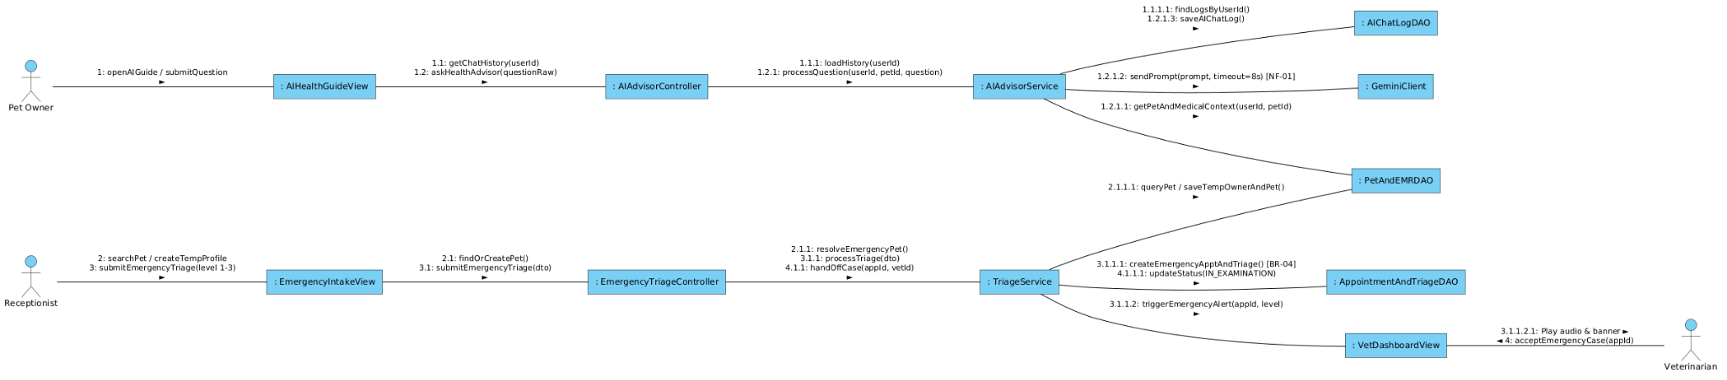

IV.2 System High-Level Design
Sample
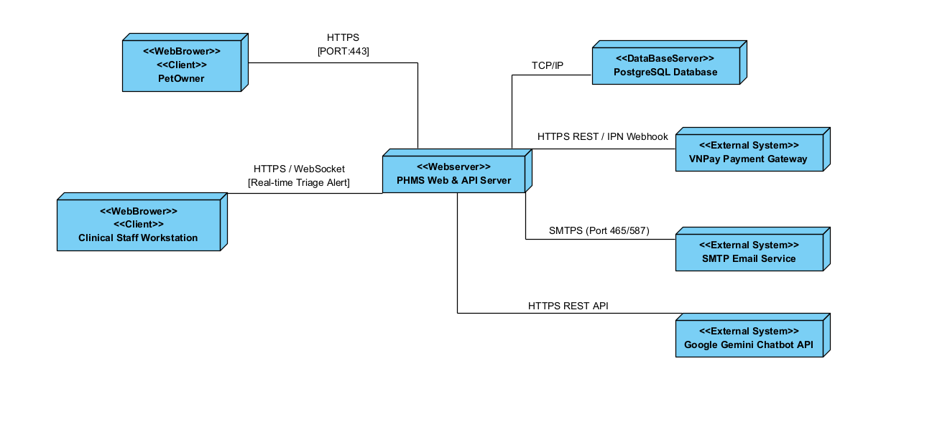

IV.3 Component and Package Diagram

IV.3.1 Component Diagram
Sample
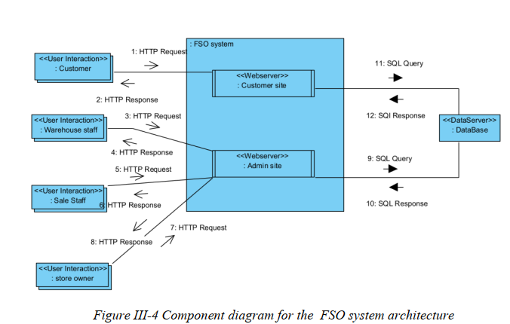

IV.3.2 Package Diagram
[Provide the package diagram for each sub-system. The content of this section including the overall package diagram, the explanation, package and class naming conventions in each package. Please see the sample & description table format below (please note: package names don’t follow Java package naming convention yet)]
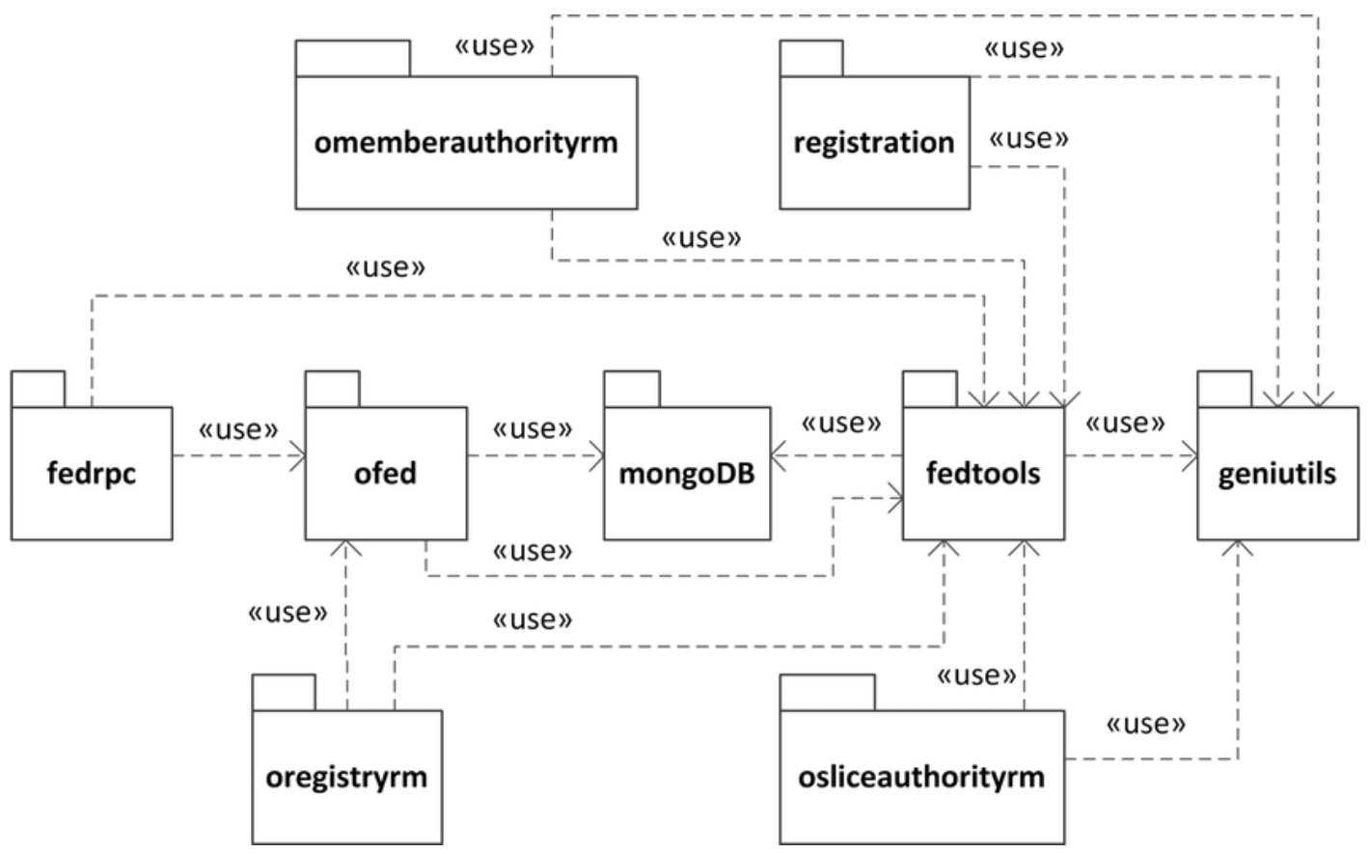
Package descriptions
No | Package | Description
01 | omemberauthorityrm | <Description of the package>
02 | registration | <Description of the package>
03 | fedrpc | <Description of the package>
04 | ofed | <Description of the package>
05 | mongoDB | <Description of the package>
06 | fedtools | <Description of the package>
07 | …

IV.4 Implementation Class diagram
[This part presents the class diagram for the relevant feature]
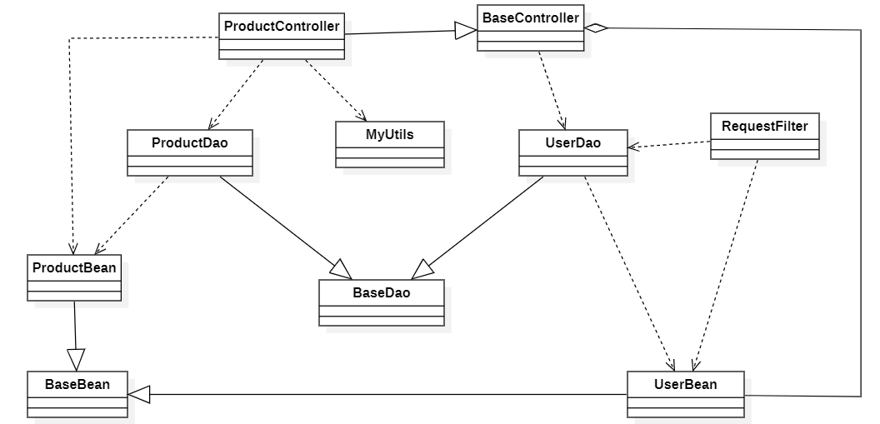
Figure x.y. Implementation class diagram for the the Product Management component

Kẻ bảng mô tả danh sách các class, attributes và methods của class
Cần vẽ nhiều implementation class diagrams cho các feature khác nhau của hệ thống. Mỗi implementation class diagram mô tả quan hệ giữa các class trong code cài đặt 1 tính năng độc lập của hệ thống. Một tính năng có thể 1 detail use case/ 1 abstract use cases/ detail feature/ major feature 🡪 group member phụ trách tính năng nào thì vẽ implementation class diagram cho tính năng đó.
- Product management
- Order management
- Customer management
- Promotion management
- Post management
- Warehouse management
- system configuration management
….

IV.5 Database Design
[Provide the tables relationship like example below – following MySQL database naming convention]

Cách 1: vẽ 1 sơ đồ Physical ERD, sử dụng hệ thống data type của một DBMS
Sau đó viết mô tả từ bảng dữ liệu theo cấu trúc sau:

Table name
Column name | Data type | Size | Key  (PK/FK) | Allow null | Default value | Auto incremental | Description/ Constraint / Example

Cách 2: Tạo DB trên MySQL/MS SQL Server/ PostgreSQL,…sau đó view từng nhóm table ra thành các sơ đồ con của database diagram (nộp cả file .Sql)

Sau đó viết mô tả từ bảng dữ liệu theo cấu trúc sau:
DDL Template — [table_name]
-- [TABLE NAME] — [one-line description]
-- SRS Reference: [Entity from SRS 4.1], [DC-xx constraints]
CREATE TYPE [enum_type] AS ENUM ('val1', 'val2', 'val3'); -- if PostgreSQL

CREATE TABLE [table_name] (
[pk_column] [TYPE] PRIMARY KEY,
[column_name] [TYPE] NOT NULL,
[column_name] [TYPE] NOT NULL DEFAULT [value],
[fk_column] [TYPE] NOT NULL
REFERENCES [ref_table]([ref_col]) ON DELETE RESTRICT,
[amount_col] DECIMAL(12,2) NOT NULL CHECK ([col] >= 0), -- DC-xx
[enum_col] [ENUM_TYPE] NOT NULL DEFAULT 'value',
created_at TIMESTAMPTZ NOT NULL DEFAULT NOW(),
updated_at TIMESTAMPTZ NOT NULL DEFAULT NOW(),
UNIQUE ([col1], [col2]) -- BR-xx: [reason]
);

-- Indexes — justify each one with the query pattern it supports
CREATE INDEX idx_[table]_[col] ON [table_name]([col]); -- [query pattern]

-- [Repeat for each table]

V. Implementation

V.1 Map architecture to the structure of the project
[Provide:
- Overview of the Chosen Architecture
Briefly describe the architectural style (e.g., Layered, MVC, Service-Oriented Architecture)
Explain why it was selected for this project (e.g., to meet non-functional requirements like maintainability, scalability, reusability)
- Mapping to Project Structure
Present the actual project folder/package structure
Map each layer/component in the architecture to concrete project modules]

V.2 Map Class Diagram and Interaction Diagram to Code
[Demo the implementation of several features using design patterns]
Mỗi thành viên code 5 use cases chi tiết (cho phép dùng GenAI để code)

VI. Applying Alternative Architecture Patterns

VI.1 Applying the ………….. (ex: Service-Oriented Architecture (SOA)) architecture
[Redesign part of the system architecture using Service-Oriented Architecture (SOA) to improve reusability, scalability, and modularity.
Students must provide:
- Problem Identification
Briefly describe which non-functional requirement(s) are not fully supported by the current architecture (e.g., NF-05: Reusability)
- SOA-Based Solution
Reorganize system components into independent services
E.g., refactor FSOData into separate service modules
- Supporting Diagrams
Deployment Diagram
Updated Class Diagram
Component Diagram showing separate services]

VI.2 Applying Service Discovery Pattern in the service-oriented architecture
[Support dynamic service registration and discovery in SOA or microservice-based architecture for horizontal scalability and ease of expansion.
Students must provide:
- Problem & Requirement
Explain the relevant non-functional requirement (e.g., NF-06: Scalability)
Describe the need for service discovery in a growing system (e.g., multiple branches, independent modules)
- Service Discovery-Based Solution
Integrate a Service Discovery Pattern
Mention possible technologies: Consul, Eureka, Kubernetes DNS
- Supporting Diagrams
Deployment Diagram (with multiple instances and registry)
Updated Class/Component Diagram including a Discovery Service]

